**Spring 2 Topic Letter**

**Let the adventures begin...**

**Well what an incredible last half term we had. The children loved exploring the jungle topic and learning about the various animals and plants. They did an amazing job of learning Handa’s surprise story off by heart and then creating their own versions. I can’t wait for another fun filled adventurous half term exploring our new topic, ‘Let the adventures begin’.**

**Just a few reminders:**

Please make sure your child has a suitable **waterproof** coat (material coats are mostly not waterproof even though they are warm) with a hood and a hat, scarf and gloves as we go out in **ALL** weather conditions.

Please can you make sure all belongings are named as things have started to go missing and often get muddled up.

We have decided to stick with tapestry so please make sure you have a look at all the amazing work that your children have been up to. If you need any help logging on please get in touch.

Please make sure your child has a **water bottle** in school.

We will be starting some PE sessions with your child this half term so please ensure their PE kit is in school on Monday and it will go home on a Friday.

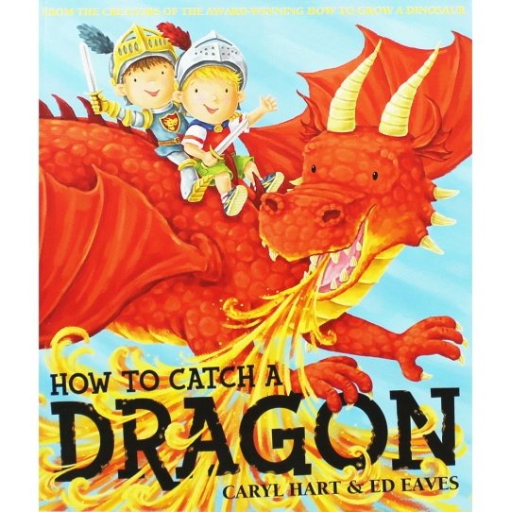**Let the adventures begin...**

**Literacy**

This term Reception will be continuing with short daily RWinc sessions to secure their recognition of all sounds which they have learnt so far. We will be emphasising the importance of learning ‘red’ words which the children cannot read using their phonics skills. We will be continuing with learning how to structure sentences and apply our knowledge to writing them.

Reception will continue to take home reading books to share at home along with their RWInc phonic formation cards and word cards to practise reading.

Nursery will start to take home a picture book which we encourage you to take the time to discuss each page with them and ask questions about what is happening.

In Nursery there will be a focused RWInc session for them which will include identifying the initial sound in words and what words rhyme.

We will be promoting independent mark making and making sure the children understand the different purposes of writing/mark making. For example, labelling their dragon and describing their castle.

We will also be looking closely at Non-fiction books about castles and how they are different to the fiction stories which we are used to sharing. We will be using lots of power words and adjectives to describe the dragons and castle.

A big thank you to parents/legal guardians for supporting your child with their reading, phonics cards and mark making at home.

Please continue to do so as this has been shown to have a positive impact on your child’s learning.

**Mathematics**

We are following the White Rose maths scheme along with the fantastic Numberblocks programme. The Reception children have enjoyed meeting numbers 1-20 so far. Remembering to look at the place value of the numbers ie 21 is 2 tens and 1 one. We have enjoyed learning about a variety of 2D and 3D shapes and remembering their properties.

Reception have been learning their number bonds to 10 so please continue to help them at home with these.

This term Reception will be securing their knowledge of numbers to 20 and shapes.

We will be learning about comparing heights, weights and capacity of various objects, along with measuring short periods of time. We will also be exploring money in our pretend shop.

In Nursery they will be securing recognising numbers to 10 and counting backwards and forwards. Learning lots of nursery rhymes to support their fluency in counting like 10 green bottles, 5 little ducks and 5 little speckled frogs. Please ensure if they are counting at home that they are counting accurately by pointing/touching one object at a time and saying a number. In Nursery we will also be exploring shapes and describing them using words like big, curved etc.

**Understanding the World**

We will be learning about different types of castles and how living in a castle is different to our houses today. We will be discussing the different features of a castle and who would have lived in them. We will look at the different types of dragons there were and where they lived in the world. We will look the role of a knight and what their job was along with princesses and how these roles have changed. We will be looking at different materials and exploring which are the best to make a castle. We will also be making a knight’s suit of armour. The children will continue to attend forest school weekly. We will be exploring the different words used to describe places like path, road, moat, turret etc.

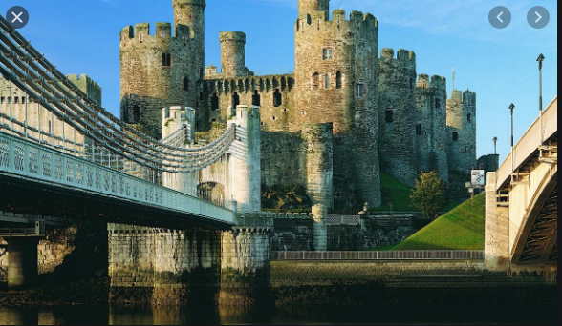

**Personal, Social, Emotional Development**

These skills are promoted at all times and we work on these attributes in everything we do in Early Years as they are very important. However this term we will be particularly focussing on:

* Taking steps to resolve conflicts through finding a compromise.
* Building confidence to talk to other children when playing.
* Understanding their emotions and how they can affect others.

**Communication and Language**

We will be learning some stories and rhymes of by heart. We will explore creating our own stories to act out. The children will be developing their listening skills to be able to follow multiple instructions. We will be continuing to develop a wide range of vocabulary based on our new topic. In Reception they will be continuing to listen to the new sounds in RWI. In Nursery they will be focusing on hearing the initial sounds in words. When reading stories to the children we will be discussing what might happen next and encouraging the children to ask questions about what is happening in the story.

**Physical Development**

Throughout the early years environment we have many activities set up which promote the children’s gross and fine motor skills. With the weather improving we will be going outside a lot more and focusing on throwing and catching, avoiding obstacles and running. We will be looking at how to hold scissors correctly and making snips in paper.

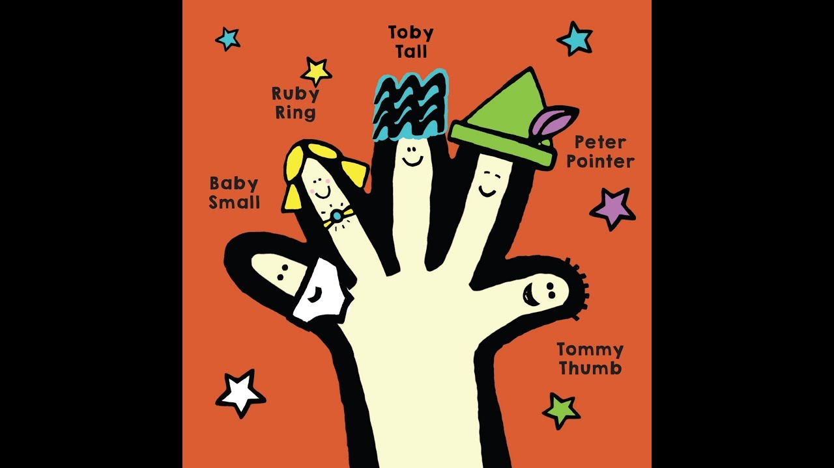

Nursery and Reception will be working on pencil control and using the correct pencil grip. In Nursery and Reception we will be working very hard to make sure we are correctly forming all of the letters in our name. We will be reminding children about the correct starting position for each letter. Some of us will be beginning to think about the size of our writing and begin to write along a line. In Reception we will be forming words and sentences.

We will be promoting independent toileting at all times and will continue to spend a lot of time working on this. We will also be revisiting hand washing to make sure the children are effectively washing their hands.

**Expressive Art and Design**

We will be promoting independent use of the craft and painting areas. We hope the children will create their own work and have their own independent ideas. The children will be experimenting and working out what we can use to cut and stick and attach items together. We will be promoting construction for a purpose like building a castle, designing an outfit for a knight or princess and creating a coat of arms.

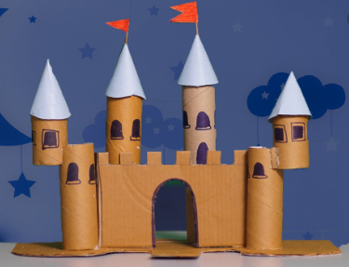

**SRE**

As part of our statutory SRE curriculum this half term we will be thinking about ‘Myself and Others’. We will be identifying some feelings and recognising how to express them, recognising how feelings can influence friendships and realising that our behaviour can affect other people.

**RE**

This half term Reception will take part in RE sessions to understand Christianity and will focus on ‘God’. Reception will talk about special times, take part in special worships and learn about special festivals and celebration such as Shrove Tuesday and St Patricks day.

Thank you again for your continued support and we hope to have another fantastic term in Early Years. If you have any questions please don’t hesitate to contact myself, Miss Armstrong or Mrs Manners