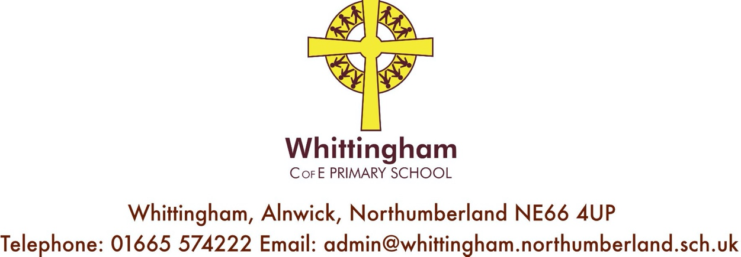

Website: www.whittinghamprimaryschool.co.uk
Tuesday 14th July 2020

Back to School September 2020
Dear Parents/Carers,

As you know, since Monday 23rd March, we have only been able to open to specific groups of children, having to remain closed to a number of pupils since then.
The government are currently planning for schools to open fully after the Summer Holidays on Thursday 3rd September.
Following these guidelines staff and governors have met to discuss how we can safely accommodate more children on our school site whilst ensuring the best possible provision enabling children (and families) to feel safe and secure, not worried and anxious.
We have therefore decided the following schedule for our children using government guidance, our own
knowledge of the children and our school site and also adhering to a stringent and comprehensive Risk
Assessment using Northumberland County Council and Government guidelines.

Please see further details below:

School Organisation from Thursday September 3rd 2020
We will re-open on Thursday 3rd September to all pupils. (Parents of children new to school in September please see separate letter).
The children will learn, work, eat and play in their own class ‘bubble’ using their classroom independently. They
will enter and exit using their own door and have sole access to handwashing/ sanitising and toilet facilities. We
are also following stringent additional cleaning procedures. They will also have safe access to outside
points throughout the day.

This will be under constant review following up to date Government, PHE and NCC guidelines and we will keep

you informed whenever changes in policies and procedures mean that we need to make significant changes.

School Routines -
Reception to Year 6 children’s school times will be-
Buses drop off staggered from 8.40a.m. – 8.55a.m. (school transport will be contacting you).

8.55a.m – 9.00a.m. –- Parents/Legal Guardians drop off point for children in Reception to Year 6 who do not use school transport. Please help us to enable social distancing at the school gate and PLEASE DO NOT arrive before 8.55a.m and UNTIL BUSES HAVE LEFT THE CARPARK.

Drop off points will be easily identified with signage and markings and we will be using area outside the school gates and our staff carpark for this so as per guidelines we are limiting people on the school site.

Beginning and end of day arrangements-
Nursery Parents/Carers drop off time will be 9.00 a.m. Once again, there will be clear signage. PLEASE DO NOT ARRIVE UNTIL THE BUSES HAVE LEFT THE CARPARK.
Nursery pick up times will be 11.55 for 12.00 for the morning session only children. 2.50 pick up for a prompt departure before 3.00 for Community Powers and 30 hours entitlement children.

Buses will begin to collect children in groups from 3p.m. to enable us to adhere to social distancing.
Please could parents of children in Reception to Year 6 therefore not come onto their allocated pick up
point UNTIL BUSES HAVE LEFT THE CARPARK. This will most likely be 3.10p.m. for a 3.15p.m. pick up.
School Lunches-
We intend to provide school lunches for those who wish for their child to have one priced at £2.20 per day payable through School Money. Please provide your child with a water bottle(s) with water (not juice) inside. We will not be re-filling bottles at school and the water machine will be out of use to avoid any cross contamination. If your child has a packed lunch, please note we cannot store packed lunches separately or refrigerated and they need to be packed in a disposable bag kept within your child’s own school bag and area.

School Milk and Free Fruit for Early Years and Class One -
We are awaiting guidance to see if these schemes will continue and will let you know as soon as we do.

Uniform and Kit list -
We are proud of our school identity and how smart the children look and therefore expect the children to wear full school uniform. We will be contacting you further about PE as we may ask your child to come to school dressed in their PE things on the days, they do PE to avoid changing in classrooms or small spaces.
Please do ensure that your child has trainers with them.
For children in Early Years and Class 1 it may be beneficial for you to provide a change of clothes in your child’s bag as we are unable to provide any changes of clothes from school, and if your child was unable to change into their own clothes, we would have to contact you to bring clothes to school. They should also have their own sun hat or cap as we cannot provide spares.
If your child is younger it is imperative that they have a complete change (s) of clothes including underwear or pull ups and wipes/ nappy sacks in their bag.

Please ensure that ALL children come to school wearing sun cream on sunny days.

Please could all children bring the following items in their reading folder or small bag to be kept at school –
Change of clothes/ nappies etc if needed.
Packet of tissues with child’s name on them.
Year 1 upwards –
Pencil case, writing and colouring pencils, rubber, pencil sharpener and ruler
Trainers – school cannot provide spares.

Please could your child bring to school each day –
Packed lunch (if needed as we will be providing school dinners), jacket, sunhat/cap, water bottle(s), fruit or
vegetable snack only if required to be kept in your child’s reading folder if they are in Early Years or Class 1 or
small bag if they are in Class 2 or 3 (please keep school bags to a minimum size so they can be stored safely).

School Office –
Please help us to keep each other safe by contacting the office through telephone or email wherever possible. Please try to avoid any changes to end of day arrangements and for safety reasons please do not make appointments which mean your child needs to be dropped off late or picked up early.

PPE -
School staff have been given the option to wear PPE and will do so if they need to change nappies or administer first aid. If staff decide at a later point to wear PPE more regularly, or government guidelines change we will let you know so that you can discuss this with your child. Following NCC guidelines we ask that children do not wear PPE, in particular home-made masks.

Remote Learning –
If your child is off for a sustained period of time, they will be expected to access online learning through School
360 or any of the resources mentioned throughout the last term. Please see School 360 for further details or
contact your class teacher directly.

If your child is ill and COVID 19 -
Please do not send your child into school if they are unwell in any way. If they are not going to be in school,
please contact the school office before 9 a.m. If your child displays COVID 19 symptoms, please contact school
immediately. You will then be able to access a test. Please do not come into school until the results are known
and a negative result is given. Please contact school immediately upon receiving a test result and we will be
able to guide you further according to current government guidelines.
If your child displays symptoms at school, we would need to isolate them (the school library is being used for this purpose) and a member of staff would contact you to pick up your child. Your child would wait with a member of staff wearing full PPE. We would then follow current guidance and contact families as necessary whilst following current protocols.

Finally, I would like to say a big THANK YOU to the amazing staff team who have been working hard to ensure
that the children who have attended school since 23rd March have remained safe, well and most of all happy
and we will continue to care for your children as they return to school in September.

Thank you for your ongoing support; it’s really appreciated during these tricky times. Best wishes,
Belinda Athey, Headteacher.

