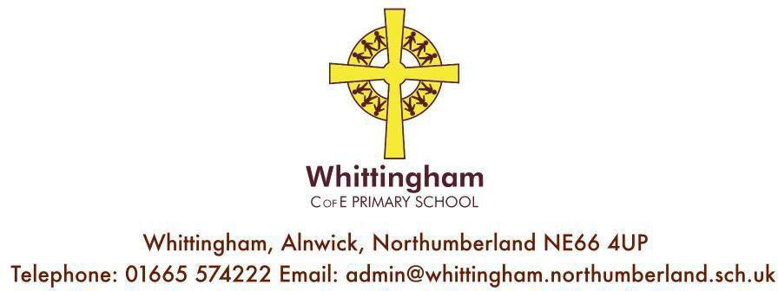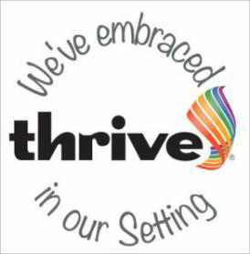

Website: www.whittinghamprimaryschool.co.uk

Friday 14th July 2023.

Annual Reports Feedback

Dear Parents/Carers,

I hope you have all enjoyed reading your child’s annual report. I would like to thank staff for taking the time beyond the school day to write the report so that you can get a formal record of your child’s achievements across the year in addition to parents evenings.

Because such a great deal of time is spent on these each year, we want to make sure they are fit for purpose and would appreciate your input so we can see what is working well and what needs to be improved.

It would be helpful if you could complete the questions below and add any further comments. Please return to school by Wednesday 19th July.

Best wishes,

Belinda Athey – Headteacher.

……………………………………………………………………………………………………………………………….

Year group of child ……………………………..

Positive elements of the current report are:

Areas which could be improved are:

Any comments to be passed on to the class teacher:

