Curriculum Intent Statement

The aim at Whittingham C of E Primary School is to provide curriculum opportunities which help children to develop as independent, confident, successful learners with high aspirations who know how to make a positive contribution to their community and the wider world. There is a focus on developing children’s moral, spiritual, social and cultural understanding. At Whittingham C of E Primary school we aim to ensure that children are well prepared for life in modern Britain.

Our broad and balanced curriculum provides pupils with the skills, knowledge and understanding, across all subjects, needed to become resilient, respectful and responsible individuals, who are well rounded and able to make well informed decisions and choices.

The curriculum is language rich and provides pupils with the opportunity to read and write in a range of contexts, for different purposes and in response to a wide and varied range of exciting first hand experiences, including well planned educational visits, visitors and theme days which make the most of our geographical location, historical importance and cultural heritage. Through these experiences pupils explore people and events which have influenced our local area, the UK and the wider world so providing them with inspirational examples which they can aspire to. The curriculum is also flexible enough to take into account the interests and needs of all children and important local, national and international events and developments. It provides pupils with memorable experiences, in addition to diverse and rich opportunities from which children can learn and develop a range of transferable skills. An important focus of our curriculum is to raise aspirations, encourage a sense of personal pride in achievement, provide a purpose and relevance for learning and ultimately to help every child to find their strengths and interests.

The cross curricular approach which we have developed enables our pupils to apply their Maths, English and Science skills across the whole curriculum and reinforces mastery in these subjects as children appreciate the importance of these skills and how they apply to real life situations.

Our curriculum is planned in a two-year cycle which allows for in-depth study and progression through a well-planned sequence of skills and knowledge and ensures that we have full coverage of the national Curriculum.

Subject leaders play an important part in the success of the curriculum by leading a programme of monitoring, evaluation and review. The curriculum design ensures that the needs of individual and small groups of children can be met within the environment of quality teaching, supported by targeted, proven interventions where appropriate. Enjoyment of the curriculum promotes achievement, confidence and good behaviour. Children feel safe to try new things.

 | AUTUMN | SPRING | SUMMER
Following on from EYFS In Year 1 (and in Y2 as appropriate) we also use Read, Write Inc. phonics and from Year 2 we use the Read Write Inc. spelling programme.
From this we also plan from a variety of high-quality resources such as Literacy Shed so that plans and resources cover all aspects of English, including SPaG, within the context of a wide range of fiction, non-fiction and poetry genres, such as traditional tales, recounts and performance poem.
In addition to this we use Accelerated Reader to enhance our reading curriculum. We also ensure that a high quality story/ poem is shared with the children daily. We use book lists such as Pie Corbett’s Book Spine for stories and poetry to ensure quality and progression.
We teach different genres across the year so that children have a broad breadth of inspiration for writing. We use Knowledge Organisers to help us ensure that we have good coverage. The knowledge organisers can be found on our shared drive and should be used as a basis for all planning.
NB All planning should be used alongside English progression and assessment grids.

English | Genres to be covered this term (2 per half term):  Labels, lists and captions  Postcard/ recount  Poems on a theme  Instructions  SPaG focus | Genres to be covered this term (2 per half term):  What am I? poems  Diary Entry  Letter  Newspapers (recount)  SPaG focus | Genres to be covered this term:  Information text  Setting description  Character description  Non-chronological report  Adventure story  SPaG focus
English | Grammar/ Punctuation focus (for more detail please refer to Grammar and Punctuation progression grid and RWI planning):  Year 1  1. Write, leaving spaces between words.  2. Begin to punctuate sentences using a capital letter and a full stop, a question or exclamation mark.  3. Begin to use ‘and’ or ‘but’ or ‘or’ to join sentences.  4.Use capital letters for proper names.  Year 2  1. Learn how to use punctuation correctly, incl. capital letters, full stops, question or exclamation marks  2. Learn how to use sentences with different forms: statement, question, exclamation, command.  3. Co-ordination: use conjunctions (and, or, but) to join simple sentences.  4 Use expanded noun phrases to describe and specify, e.g. adjectives to describe nouns.  5. Use commas in lists  6. Use apostrophes for contractions  Spelling focus:  Please use RWI Phonics and Spellings Progression whilst also teaching from the Common Exception Word List for Year 1 and 2 | Grammar focus/ Punctuation focus (for more detail please refer to Grammar and Punctuation progression grid and RWI planning) :  Year 1  1.Punctuate sentences using a capital letter and a full stop, a question or exclamation mark.  2. Use capital letters for the names of people, places, the days of the week and the personal pronoun I  3. Begin to use ‘and’ or ‘but’ or ‘or’ to join sentences.  4. Demarcate sentences using capital letters, full stops, exclamation and question marks.  Year 2  1. Learn how to use punctuation correctly, incl. capital letters, full stops, question or exclamation marks. Also use commas in lists.  2.Use expanded noun phrases to describe/ specify e.g adjectives to describe nouns.  3. Co-ordination: use conjunctions (and, or, but) to join simple sentences.  4.Use conjunctions (when, if, because, …) to join subordinate clauses.  5. Learn how to use sentences with different forms: statement, question, exclamation, command.  6. Use apostrophes for contractions and possessive singular.  7. Write sentences with different forms: statement, question, exclamation, command  Spelling focus: Please use RWI Phonics and Spellings Progression whilst also teaching from the Common Exception Word List for Year 1 and 2. | Grammar focus Punctuation focus ( for more detail please refer to Grammar and Punctuation progression grid):  Year 1  1. Revise the grammar taught for Year 1, using both familiar and new punctuation correctly.  2. Join words and clauses using and, then, also.  3. Punctuate sentences using a capital letter and a full stop, a question or exclamation mark.  Year 2  1. Learn how to use the past tense correctly and consistently, including the progressive form and also including question marks, commas for lists).  2. Use some features of written Standard English.  3. Learn the grammar for Year 2.  4.Use sentences with different forms: statement, question, exclamation, etc.  5. Use subordination (using when, if, that, or because) and coordination (using or, and, or but).  6. Expand noun phrases to describe and specify  7. Consistently use punctuation correctly including question marks and commas for lists.  Spelling focus:  Please use RWI Phonics and Spellings Progression whilst also teaching from the Common Exception Word List for Year 1 and 2

Maths | Here at Whittingham C of E Primary School, we use the National Curriculum for Maths itself as our basis for all maths, ensuring that we provide all of its content and beyond. This is supported through the use of WRMH (White Rose Maths Hub) plans and resources as well as CGP textbooks, NFER and other quality-assured and appropriate maths resources to ensure the teaching and learning across all year groups and abilities. Through taking part in the NNKIN (Nurturing Number Knowledge In Northumberland) programme, we are striving to ensure that fundamental maths knowledge is taught well and embedded for all children to give them a great platform for maths and beyond.  We also use CGP maths workbooks to provide responsive and effective weekly homework and consolidation tasks for Y1-Y6 that are directly linked to the work being done for each year group. In addition to this, we use the TTRS (Times Tables Rock Stars) to enhance our curriculum further and help pupils with their times tables. Through these resources, teachers can set work that is appropriate to each child and provides parents/ carers the ability to engage and assist their child(ren) in their learning in a collaborative manner.  Overviews of planning and calculation approaches are provided on the school’s webpage and a link is available here: https://www.whittinghamprimaryschool.co.uk/maths  
Teachers plan their Geography medium term plans from a variety of sources to take account of the objectives as our curriculum is bespoke, making the most of our local geography and does not fit easily within a purchased scheme of work.
Please use alongside Geography progression and assessment grids.
Geography | Our Wonderful World (Our Local Environment)  Looking at and creating a map to school from your own house.  Trip ideas: See Science  - Use simple and observational skills to study the geography of the school and its grounds.  - Use simple fieldwork and observational skills to study the geography of their school and its grounds and the key human and physical features of its surrounding environment.  - Understand how some places are linked to others e.g. roads, trains.  - Describe seasonal weather changes.  - Identify seasonal and daily weather patterns in the UK and the location of hot and cold areas of the world (Africa/Antarctica compare) in relation to the equator and north and south poles.  Use basic geographical vocabulary to refer to key human features including; city, town, village, factory, farm, house, office, port, harbour and shop.  Key Questions/ I can statements:  I can explain the difference between a physical and human feature.  I can describe seasonal and daily weather patterns in the UK and compare this to Antarctica or Africa. | Famous People (Columbus focus)  Looking at how Columbus explored the world.  Trip ideas: See History  - Use locational language (e.g. near, far, left and right) to describe the location and features of routes.  - Make simple maps and plans e.g. pictorial places in a story.  - Use simple compass directions (North, South, East and West) and locational and directional language to describe the location of features and routes on a map.  - Name and locate the worlds 7 continents and 5 oceans.  - Understand geographical similarities and differences through studying the human and physical geography of a small area of the UK and of a small area in a contrasting non-European country (West Indies/South America)  As children move and progress through the school this South American study links with LKS2 Rainforest study and UKS2 study of South America – providing a thread of learning and progression through the school.  Key Questions/ I can statements:  I can name and locate the worlds 7 continents and 5 oceans.  I know where Columbus sailed and why this was important.  I can compare and contrast an area within the West Indies/ South America to our local area and give at least 1 similarity or difference. | Coasts  Locate Northumberland and Farne Islands, Bamburgh, Amble and Tynemouth on a map.  Trip ideas: see History  - Name, locate and identify characteristics of the four countries and capital cities of the UK.  - Name, locate and identify characteristics of the seas surrounding the United Kingdom.  - Use world maps, atlases and globes to identify the UK and its countries as well as the countries, continents and oceans studied at this key stage.  - Use basic geographical language to refer to physical features including; beach, cliff, coast, forest, hill, mountain, sea, ocean, river, soil, valley, vegetation, season and weather.  - Ask simple geographical questions e.g. what is it like to live in this place?  - Use simple maps of the local area e.g. large scale print, pictorial etc.  - Use aerial photographs and plan perspectives to recognise landmarks and basic human and physical features; devise a simple map; and use and construct symbols in a key.  As children move and progress through the school this links with LKS2 topic on coasts where they study coasts in more detail.  Key Questions/ I can statements:  I know what a coast is and name some of the beaches around our local coastline.  I can locate Northumberland, Farne Islands, Bamburgh and Amble on a map.
Teachers plan their History medium term plans from a variety of sources to take account of the objectives and key questions we want the children to answer as our curriculum is bespoke to us, using the great history of our local area and does not necessarily fit easily within a purchased scheme of work. Where possible we use ‘Key Stage History’ and are currently developing our key questions to align with this.
Please use this document alongside History progression and assessment grids.
History | Grace Darling  Looking at the changes in the coastguard and lifeboats over time.  Trip ideas: Grace Darling Museum and resting place, Bamburgh, RNLI  - Use common words and phrases relating to the passing of time (chronological understanding)  - Understand key features of events (understanding of events, people and changes)  - Identify some similarities and differences between ways of life in different periods (understanding of events, people and changes)  - Show an awareness of the past, using common words and phrases relating to the passing of time  - Describe changes within living memory  - Discuss the lives of significant individuals in the past who have contributed to national and international achievements and use some to compare aspects of life in different periods (Grace Darling).  - Describe significant historical events, people and places in their own locality (Grace Darling)  Key Questions:  Why did Grace Darling act the way she did? | The first aeroplane flight  - Place known events and objects in chronological order (timeline of the people/events)  - Find answers to some simple questions about the past from some simple sources of information (historical enquiry)  - Speak about how he/she found out about the past.  - Record what they have learned by drawing or writing  - Describe where the people and events they have studied fit within chronological framework and identify similarities and differences between ways of life in different periods.  - Describe changes within living memory and aspects of change in national life  - Describe events beyond living memory that are significant nationally or globally  - Discuss the lives of significant individuals in the past who have contributed to national and international achievements and use some to compare aspects of life in different  - Describe significant historical events, people and places in his/her own locality (Emily Davison)  Key Questions:  Who invented the first aeroplane?  How has transport in the air changed? | Queen Elizabeth 1  - Place known events and objects in chronological order (timeline of the people/events)  - Find answers to some simple questions about the past from some simple sources of information (historical enquiry)  - Speak about how he/she found out about the past.  - Record what they have learned by drawing or writing  - Describe where the people and events they have studied fit within chronological framework and identify similarities and differences between ways of life in different periods.  - Describe changes within living memory and aspects of change in national life  - Describe events beyond living memory that are significant nationally or globally  - Discuss the lives of significant individuals in the past who have contributed to national and international achievements and use some to compare aspects of life in different  - Describe significant historical events, people and places in his/her own locality (Emily Davison)  Key Questions:  Who was Elizabeth 1?  What was Queen Elizabeth 1 like?

Science | Teachers plan their Science medium term plans from a variety of sources to take account of the objectives as our curriculum is bespoke to us and does not necessarily fit easily within a purchased scheme of work. However, following Science being a priority on the SDP 2021-22 we now supplement our planning with PLAN Primary Science.  Please use alongside Science progression and assessment grids.  Science Ongoing Objectives  ∙ Ask simple questions and recognise that they can be answered in different ways (Year 1 focus)  ∙ Use simple equipment to observe closely (Year 1 focus)  ∙ Perform simple tests (Year 1 focus)  ∙ Identify and classify (Year 1 focus)  ∙ Use his/her observations and ideas to suggest answers to questions (Year 1 focus)  ∙ Gather and record data to help in answering questions (Year 1 focus)  - Ask simple questions and recognise that they can be answered in different ways including use of scientific language from the national curriculum (Year 2 focus)  ∙ Use simple equipment to observe closely including changes over time (Year 2 focus)  ∙ Perform simple comparative tests (Year 2 focus)  ∙ Identify, group and classify (Year 2 focus)  ∙ Use his/her observations and ideas to suggest answers to questions noticing similarities, differences and patterns (Year 2 focus)  ∙ Gather and record data to help in answering questions including from secondary sources of information (Year 2 focus)
Science | Animals including humans  Focusing on animals which live on and in our local coastlines and seas.  Trip ideas: (Amble lobster hatchery – experience the life cycle of a lobster and possibly release some into rock pools)  ∙ Identify and name a variety of common animals including fish, amphibians, reptiles, birds and mammals  ∙ Identify and name a variety of common animals that are carnivores, herbivores and omnivores  ∙ Describe and compare the structure of a variety of common animals (fish, amphibians, reptiles, birds and mammals, including pets)  ∙ Identify, name, draw and label the basic parts of the human body and say which part of the body is associated with each sense  ∙ Understand that animals, including humans, have offspring which grow into adults  ∙ Describe the basic needs of animals, including humans, for survival (water, food and air)  ∙ Describe the importance for humans of exercise, eating the right amounts of different types of food, and hygiene  Explore and compare the differences between things that are living, dead, and things that have never been alive  ∙ Identify that most living things live in habitats to which they are suited and describe how different habitats provide for the basic needs of different kinds of animals and plants, and how they depend on each other  ∙ Identify and name a variety of plants and animals in their habitats, including micro-habitats  ∙ Describe how animals obtain their food from plants and other animals, using the idea of a simple food chain, and identify and name different sources of food  Key Questions / I can statements:  What are the basic needs of animals?  What is a herbivore, omnivore and carnivore?  What animals live in the local area and why? | Materials and their uses (Rockets).  Neil Armstrong links, rockets.  Trip ideas: Planetarium, Centre for life.  ∙ Distinguish between an object and the material from which it  is made  ∙ Identify and name a variety of everyday materials, including wood, plastic, glass, metal, water, and rock  ∙ Describe the simple physical properties of a variety of everyday materials  ∙ Compare and group together a variety of everyday materials on the basis of their simple physical properties  - Identify and compare the suitability of a variety of everyday materials, including wood, metal, plastic, glass, brick, rock, paper and cardboard for particular uses  ∙ Describe how the shapes of solid objects made from some materials can be changed by squashing, bending, twisting and stretching  Key Questions/ I can statements:  What materials are good to make a rocket transporter?  I can explain the difference between reversible and non-reversible changes. | Plants and seasonal changes  Looking at the different plants and animals in our wonderful world.  Trip ideas: Northumberland Zoo, Ingram Valley (river dipping, looking at local plants et.)  - Identify and name a variety of common wild and garden plants, including deciduous and evergreen trees  ∙ Identify and describe the basic structure of a variety of common flowering plants, including trees  - Observe and describe how seeds and bulbs grow into mature plants  ∙ Find out and describe how plants need water, light and a suitable temperature to grow and stay healthy  - Observe changes across the four seasons  ∙ Observe and describe weather associated with the seasons and how day length varies  Runner bean experiment (because EYFS grow cress) – grow a bean in different environments with different necessities including hydroponics.  Key Questions/ I can statements:  I can explain the conditions needed for plants to grow.  I understand and can explain the changes across the 4 seasons.
RE | We use the Northumberland Agreed Syllabus and Understanding Christianity for our RE teaching.  Recommendations from the Agreed Syllabus It is strongly recommended that the following religions and beliefs are taught: Key stage one: Christianity, Islam and Judaism. Buddhism, Hinduism, Sikhism and a secular world view such as humanism are optional. Key stage two: Christianity, Hinduism and Judaism. Buddhism, Islam, Sikhism, the Bahai faith and a secular world view such as humanism are optional.  The Understanding Christianity framework explores the overarching story of the Bible, focusing on how Christians believe God’s relationship with humanity is restored through Jesus. It emphasises the eight key Christian concepts (God, Creation, Fall, People of God, Incarnation, Gospel, Salvation, and Kingdom of God) showing how these shape concepts Christian belief, worship, and daily life. At its heart, it aims to help learners see Christianity as a living faith that connects past events, present experience, and future hope.  The BIG Frieze in Understanding Christianity is a visual timeline that illustrates the overarching “BIG story” of the Bible — from creation to the promise of a renewed world. Its core purpose is to help learners see how individual biblical events and themes connect to eight key Christian concepts which are God, Creation, Fall, People of God, Incarnation, Gospel, Salvation, and Kingdom of God. By placing stories within this wider narrative, it encourages a coherent understanding of Christian belief and how these ideas interrelate across the whole biblical story.  Each school year as part of our start the year by looking once again at the timeline and creating our own visual representation of this for within our own classrooms to enable the children to have a good understanding of the timeline.  BIG Questions. Each area of learning is built upon a BIG question which the lessons develop week by week enabling the children to answer the questions and become critical thinkers. This also helps us to assess their understanding, address misconceptions and to broaden thinking along the way.  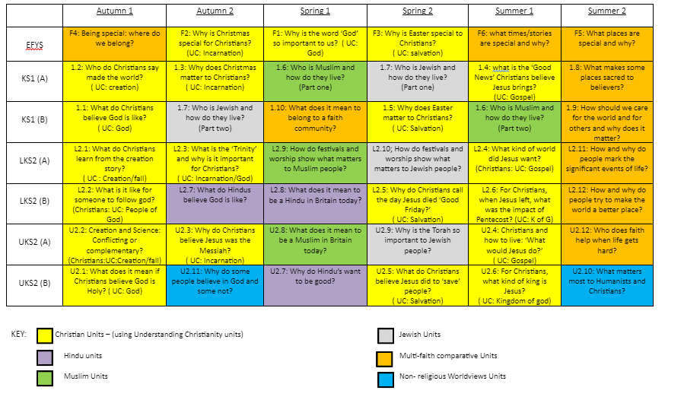
Computing  and | Whittingham C of E Primary School – Computing LTP 2026-27. Cycle A  We are currently further developing this subject as we reach the second cycle A since it was updated.  We are using the Kapow Scheme of Work as a spine with further resources from School 360, BBC, NCC and  For online safety also see- Online Safety Support as well as PSHE / Pol Ed resources and planning.  Please also refer to vocabulary progression - Computing (New) 2025 - - New Staff Shared Drive - Google Drive and our Intent, Impact and Implementation statement -
Computing  and
  Term: | EYFS: | KS1:  Online Safety 1 lesson per half term as well as PSHE | LKS2:  Online Safety 1 lesson per half term as well as PSHE | UKS2:  Online Safety 1 lesson per half term as well as PSHE
  Autumn 1: | Continuous provision:  Interactive Whiteboard - Busy Things and Create a Builder  Programming 1: All about instructions | Continuous provision:  Y1 Laptops (make sure all can log on and have a School 360 account)  Y2 Using TTRS/ Spelling Shed AR  Computing Systems and Networks: Improving Mouse / trackpad skills  Using the interactive whiteboard plus laptops, School 360 drag and drop activities such as create a builder, dress Barnaby Bear, Design a Bear’s Face, Build a House etc. | Programming: Scratch Year 3 and Further programming with Scratch Year 4  See also School 360 for a suite of scratch resources and for children to practice their skills out of the lesson and at home.  Further enrichment - Intelino from NCC loans  Also using IT to develop learning- AR TTRS and Spelling Shed | Computing systems and networks 1 and 2  Year 5 - Search Engines - quick refresh in one lesson  Year 6 - Bletchley Park and the history of computers  Also using IT to develop learning- AR TTRS and Spelling Shed
  Autumn 2: | Continuous provision:  Interactive Whiteboard - School 360 - Busy Things and Dress Barnaby Bear  Programming 2: Programming Bee Bots | Continuous provision:  Y1Developing last half terms skills independently.  Y2 Using TTRS/ Spelling Shed / AR  Programming 1: Commands unplugged (1 or 2 weeks) then Programming 2: Bee Bots  Could also Introduce J2E from School 360 and Indi Sphero from NCC loans | Computing Systems and Networks 1 - Year 3  Then how to use google docs and slides - own planning a word processing project linked to a curriculum subject  Also using IT to develop learning- AR TTRS and Spelling Shed | Programming 2: BBC micro:bit  Planning to be found:  Micro:bit Educational Foundation | micro:bit  Then teacher own planning - link with cross curriculum using chromebooks - google docs and slides  Also using IT to develop learning- AR TTRS and Spelling Shed
  Spring 1: | Continuous provision:  Interactive Whiteboard -School 360 Dress Barnaby Bear and Design a Bears face  Computing systems and networks 1: Using a computer  Set of ipads on loan from NCC - list apps you want downloaded - timetable out across the school | Continuous Provision:  Y1 Developing skills within School 360 J2E  Y2 Using TTRS/ Spelling Shed / AR  Skills Showcase: Rocket to the moon also use School 360 JIT  Set of ipads on loan from NCC - list apps you want downloaded - timetable out across the school | Creating media: Video trailers (Previously called ‘Digital literacy’)Year 3 option 1 or 2 (without or with ipads)  Set of ipads on loan from NCC - list apps you want downloaded - timetable out across the school | Data-handling: Mars Rover 1  Skills showcase: Mars Rover 2  Also using IT to develop learning- AR TTRS and Spelling Shed  Set of ipads on loan from NCC - list apps you want downloaded - timetable out across the school - if required swap Spring 1 and 2
  Spring 2: | Continuous provision:  Interactive Whiteboard - School 360 Make a Dinosaur and make a space scene  Computing systems and networks 2: Exploring hardware  Rugged Robots -programming -loan from NCC share with class 1 | Continuous Provision:  Y1 Developing skills within School 360 J2E  Y2 Using TTRS/ Spelling Shed / AR  Programming 1: Algorithms and debugging ( Year 1)  Rugged Robots -programming -loan from NCC share with class 1 | Creating media: Option 2 Google -Website design  Also using IT to develop learning- AR TTRS and Spelling Shed | Stop motion animation using option 1 or 2  Also using IT to develop learning- AR TTRS and Spelling Shed
  Summer 1: | Continuous provision:  Interactive Whiteboard - School 360 Join the dots, The little red ship and the pirate ship  Data handling: Introduction to data | Continuous Provision:  Y1 Developing skills within School 360 J2E  Y2 Using TTRS/ Spelling Shed / AR  Creating Media - Digital Imagery 1  Data Handling 1 - International Space Station | Computing systems and networks 2: Emailing -option 2 using google | Computing systems & networks: Exploring AI  Data Handling Big Data 1
  Summer 2: | Continuous provision:  Interactive Whiteboard - School 360 -JIT Turtle and any of the school 360 games that have been used this year.  Introduction to online safety | Continuous Provision: Digital Imagery  Data Handling 1 - International Space Station contd if needed  Computing systems and networks 2: Word processing | Programming 2: Computational thinking - Ozobots | Data Handling 2  Programming - Exploring Python

D&T | Textiles: puppets  Key question:  What types of joining methods work for fabrics?  -Select from and use a range of tools and equipment to perform practical tasks [for example, cutting, shaping, joining and finishing].  -Explore and evaluate a range of existing products.  -Design purposeful, functional, appealing products for themselves and other users based on design criteria.  -Generate, develop, model and communicate their ideas through talking, drawing, templates, mock-ups and – where appropriate – ICT.  -Select from and use a wide range of materials and components, including construction materials, textiles and ingredients, according to their characteristics.  -Evaluate their ideas and products against design criteria. | Structures: constructing a windmill  Key question:  How do sails on a windmill move?  -Design purposeful, functional, appealing products for themselves and other users based on design criteria.  -Select from and use a range of tools and equipment to perform practical tasks [for example, cutting, shaping, joining and finishing].  -Explore and evaluate a range of existing products.  -Evaluate their ideas and products against design criteria.  -Build structures, exploring how they can be made stronger, stiffer and more stable. | Cooking and nutrition: smoothies  Key question: How can I prepare fruits and vegetables to make smoothies?  -Understand where foods come from.  -Use the principles of a healthy and varied diet to prepare dishes.  -Select from and use a range of tools and equipment to perform practical tasks.  -Select from and use a wide range of materials and components, including construction materials, textiles and ingredients, according to their characteristics.  -Evaluate their ideas and products against design criteria.
 | Our Forest Schools area and the learning that comes from this is one of our highly valued and unique resources where a number of important DT skills can be taught and practiced. Therefore, we are working to develop how these subjects can be combined across the year.
Art & Design | We are currently looking to showcase the commitment we have as a school to The Arts and are preparing to show this through the Arts Mark process therefore events and opportunities may be planned in addition to the planning below across the year and will be added in accordingly.  Drawing: Making Your Mark  To understand and use different line types and mark making techniques in drawing.  - Use drawing, painting and sculpture to develop and share their ideas, experiences and imagination.  - Learn about the work of a range of artists, craft-makers and designers, describing the differences and similarities between different practices and disciplines and making links to their own work.  - Develop a wide range of art and design techniques in using colour, pattern, texture, line, shape, form and space.  Key questions/ learning points:  -Who is Bridget Riley?  -I can make choices about which materials to use to create an effect.  -I can describe and compare features of my own work and others’ artwork. | We are currently looking to showcase the commitment we have as a school to The Arts and are preparing to show this through the Arts Mark process therefore events and opportunities may be planned in addition to the planning below across the year and will be added in accordingly.  Painting and mixed media: Colour Splash  To learn about primary and secondary colours, colour mixing techniques and applying these skills in painting and printing.  - Develop a wide range of art and design techniques in using colour, pattern, texture, line, shape, form and space.  - Use drawing, painting and sculpture to develop and share their ideas, experiences and imagination.  - Learn about the work of a range of artists, craft-makers and designers, describing the differences and similarities between different practices and disciplines and making links to their own work.  - To use a range of materials creatively to design and make products.  Key questions/ learning points:  Who was Jasper Johns?  I can mix secondary colours.  I can choose to paint with colours that look good next to each other.  I can describe my plate and compare it to others. | We are currently looking to showcase the commitment we have as a school to The Arts and are preparing to show this through the Arts Mark process therefore events and opportunities may be planned in addition to the planning below across the year and will be added in accordingly.  Sculpture and 3D: Clay Houses  To understand how to shape and decorate clay, create a pinch pot and design and create a lighthouse.  - Use materials creatively to design and make products.  - Use drawing, painting and sculpture to develop and share their ideas, experiences and imagination.  - Develop a wide range of art and design techniques in using colour, pattern, texture, line, shape, form and space.  - Learn about the work of a range of artists, craft makers and designers, describing the differences and similarities between different practices and disciplines, and making links to their own work.  Key questions/ learning points:  Who is Rachel Whiteread?  I can use my design to guide my clay-work.  I can use both pressing in and joining clay techniques.

Music | 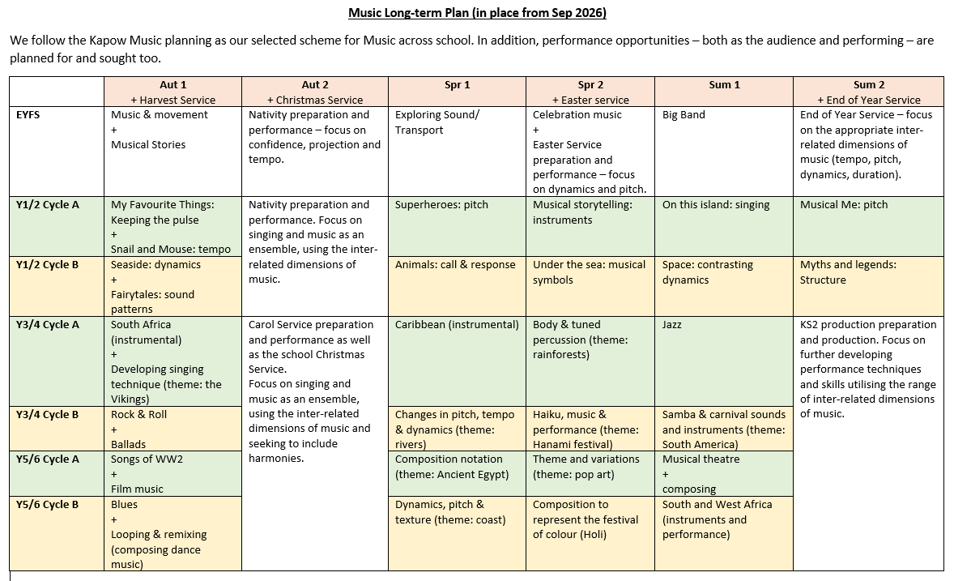

PE |   Whittingham C of E Key Stage 1 – PE Year 1 and 2 Long Term Plan Cycle A School Year 2026-7  Using Get Set 4 PE planning and assessment grids unless stated differently.
  Autumn 1 | Autumn 2 | Spring 1 | Spring 2 | Summer 1 | Summer 2
  Daily Mile | Daily Mile | Daily Mile | Daily Mile | Daily Mile | Daily Mile
  Fundamentals – EC/EM Thursday Reception Y 1 and 2  Using Year 1 lessons weeks 1-6. This year group has been chosen to accommodate ability. Consolidation / extension can still happen  Week 7 - Assessment week / intra class house competition | Sending and Receiving – EC/EM Thursday Reception Y1 and 2  Using Year 1 lessons in the first instance for weeks 1-6.  Week 7- Assessment week/ intra competition. | Gymnastics – EC/EM  Thursday Reception Y1 and 2  Using Year 2 lessons – Weeks 1-7 | Target Games – EC/EM  Thursday Reception Year 1 and 2  Using Y2 lessons  6 lessons | Net / Wall Games -EC/EM Thursday R Y1 and 2  – Y2 lessons and using LTA resources’ to support the skills and delivery needed to support an intra competition | Striking and Fielding EC/EM Thursday R Y1 and 2  Using Y2 lessons and intra competition if possible
  Fitness – CC  Year 1 and 2  Using Year 2 lessons weeks 1-6.  Week 7 - Assessment week / intra class house competition or assessment of fitness – progress from first session to final session ie how many laps of the Daily Mile track can be run at the start within a given time compared to the number of laps at the end with the same time. | Ball Skills – CC Year 1 and 2  Using Y2 lessons  6 lessons will be spread over 7 weeks as each week there will need to be a taught 10 minute session with a throwing and catching element as this has been identified as an area to improve across the school. ( Use Y1 target games planning as a basis for this teacher directed task. | Dance – CC (potentially swap lesson with class teacher as has dance specialism)  Using Year 1 lessons 1-8 | Yoga - CC  Using Y2 lessons but moved to break up the term of gymnastics following review from last time  Gymnastics –  Using Year 2 lessons-  Weeks 8-12 and using School Games Gymnastics Competition pack for assessment week. | Athletics – CC  Using Y2 lessons | Forest Schools –  See separate planning

PSHE/ RHE | 