

Relationship and Health Education (RHE) policy
Whittingham C of E Primary School

Approved by: | Policy Committee | Date: TBC
Last reviewed on: | Summer FGB meeting (9.7.26)
Next review due by: | Summer term 2027

Contents
1. Aims 3
2. Statutory requirements 3
3. Policy development 5
4. Definition 5
5. Curriculum 5
6. Delivery of RSE 6
7. Use of external organisations and materials 7
8. Roles and responsibilities 8
9. Parents’ right to withdraw 9
10. Training 10
11. Monitoring arrangements 10
Appendix 1: Curriculum map 11
Appendix 2: By the end of primary school pupils should know 12
Appendix 2: By the end of secondary school pupils should know 14
Appendix 3: Parent form: withdrawal from sex education within RSE 17

1. Aims
Our RHE curriculum (Part of our PSHE curriculum) is rooted in our ethos and values of:
‘Hand in hand together we are kind, collaborative and courageous citizens of our community and the wider world.’

At Whittingham C of E Primary School, we understand our responsibility to deliver a high-quality, age appropriate and evidence-based relationships, sex and health curriculum for all of our pupils. This policy sets out the framework for our relationships, sex and health curriculum providing clarity on how it is informed and delivered, in developing this policy we have followed the principles in the Church of England Charter for faith sensitive and inclusive relationships education, relationships and sex education (RSE) and health education (RSHE).
The school is committed to making reasonable adjustments wherever possible to promote accessibility and inclusivity of the curriculum. The school understands that pupils with SEND or other needs (such as those with social, emotional or mental health needs) are entitled to learn about relationships, sex and health education and the programme will be designed to be inclusive of all pupils.

The aims of relationships and health education (RHE) at our school are to:
- Provide a framework in which sensitive discussions can take place
- Prepare pupils for puberty, and give them an understanding of physical and emotional development and the importance of health and hygiene
- Help pupils develop feelings of self-respect, confidence and empathy
- Create a positive culture around issues of their physical and emotional health and well-being as well as their relationships
- Teach pupils the correct vocabulary to describe themselves and their bodies

2. Statutory requirements
As a maintained primary school, we must provide relationships education to all pupils under section 34 of the Children and Social Work Act 2017.
We are not required to provide sex education, but we do need to teach the elements of sex education contained in the science curriculum (i.e. reference and study of offspring, reproduction, evolution and genetic traits). Within PSHE, to meet with the requirements of the RHE curriculum, our Year 5 pupils have their ‘Health Talk’ session, which teaches them about the physical and emotional developments that they and others will go through during puberty.
In teaching RHE, we must have regard to guidance issued by the secretary of state, as outlined in section 403 of the Education Act 1996.
We must also have regard to our legal duties set out in:
- Sections 406 and 407 of the Education Act 1996
- Part 6, chapter 1 of the Equality Act 2010
- The Public Sector Equality Duty (as set out in section 149 of the Equality Act 2010). This duty requires public bodies to have due regard to the need to eliminate discrimination, advance equality of opportunity and foster good relations between different people when carrying out their activities
At Whittingham Co f E Primary School, we teach RHE as set out in this policy.

3. Policy development
This policy has been developed in consultation with staff, pupils and parents/carers. The consultation and policy development process involved the following steps:
- Review – the PSHE Lead (which incorporates RHE) pulled together all relevant information including relevant national and local guidance.

- Staff consultation – all school staff were given the opportunity to look at the policy and make recommendations.

- Parent/stakeholder consultation – parents/carers and any interested parties were invited to attend a meeting about the policy

- Pupil consultation – we investigated what exactly pupils want from their RHE.

- Ratification – once amendments were made, the policy was shared with governors and ratified.

4. Definition
RHE is about the emotional, social and cultural development of pupils, and involves learning about relationships, emotional and physical health, sexuality, healthy lifestyles, diversity and personal identity.
RHE involves a combination of sharing information, and exploring issues and values.

5. Curriculum
Our RHE curriculum is set out as per Appendix 1, but as developments in the requirements of the curriculum occur, we may need to adapt it as and when necessary.
We have developed the curriculum in consultation with parents/carers, pupils and staff, and taking into account the age, developmental stage, needs and feelings of our pupils. If pupils ask questions outside the scope of this policy, teachers will respond in an appropriate manner so that pupils are fully informed and don’t seek answers online.
We will share all curriculum materials with parents and carers upon request.
Primary sex education is not compulsory in primary schools. As a school, we have decided that this level of education is not required within our circumstances or context. However, as part of ensuring that our pupils are educated and prepared, we do teach about puberty. This is done as part of our Year 5 ‘Health Talk’. Other aspects, as noted above are incorporated within Science lessons as part of the Science curriculum.
Our Primary health education will focus on:
- Preparing boys and girls for the physical changes that puberty brings,
- Preparing boys and girls for the emotional changes that puberty brings,
- We use the BBC’s Operation Ouch special programme on puberty for the Year 5 ‘Health Talk’ https://www.bbc.co.uk/iplayer/episode/b0759l4k/operation-ouch-specials-dont-panic-about-puberty

For more information about our curriculum, see our curriculum map in Appendix 1.

6. Delivery of RHE
- RHE-related topics will be taught within our PSHE curriculum.
- All pupils in lessons, regardless of their ability or special educational needs and/or disability (SEND) will be supported and receive high-quality teaching. Where needed, staff will make adaptations so that every pupil can access and progress with their learning.
- The Year 5 ‘Health Talk’ will be delivered within either Spring 2 or Summer 1 half-terms. This is to allow further maturity and understanding with being later in the academic year yet balances this with the likelihood of some pupils starting puberty and benefiting from these sessions by then.

RHE is taught within the personal, social, health and economic (PSHE) education curriculum. Biological aspects of RHE are taught within the science curriculum at the age-appropriate level, and other aspects are included in Religious Education (RE).

Relationships education focuses on teaching the fundamental building blocks and characteristics of positive relationships including:
- Families and people who care for me
- Caring friendships
- Respectful relationships
- Online relationships
- Being safe
For more information about our RSE curriculum, see Appendices 1 and 2.

These areas of learning are taught within the context of family life, taking care to make sure that there is no stigmatisation of children based on their home circumstances (families can include single parent families, LGBTQ+ parents, families headed by grandparents, adoptive parents and foster parents/carers, amongst other structures), along with reflecting sensitively that some children may have a different structure of support around them (for example, looked-after children or young carers).
We will also be mindful of the law and legal requirements, taking care not to condone or encourage illegal political activity, such as violent action against people, criminal damage to property, hate crime, terrorism or the illegal use of drugs.

  - Inclusivity
We will teach about these topics in a manner that:
- Considers how a diverse range of pupils will relate to them
- Is sensitive to all pupils’ experiences
- During lessons, makes pupils feel:
  - Safe and supported
  - Able to engage with the key messages
We will also:
- Make sure that pupils learn about these topics in an environment that’s appropriate for them, for example in:
  - A whole-class setting
  - Small groups or targeted sessions
  - 1-to-1 discussions
  - Digital formats
- Give careful consideration to the level of differentiation needed

  - Use of resources
We will consider whether any resources we plan to use:
  - Are aligned with the teaching requirements set out in the statutory RHE guidance
  - Would support pupils in applying their knowledge in different contexts and settings
  - Are age-appropriate, given the age, developmental stage and background of our pupils
  - Are evidence-based and contain robust facts and statistics
  - Fit into our curriculum plan
  - Are from credible sources
  - Are compatible with effective teaching approaches
  - Are sensitive to pupils’ experiences and won’t provoke distress

7. Use of external organisations and materials
We will make sure that an agency and any materials used are appropriate and in line with our legal duties around political impartiality.
The school remains responsible for what is said to pupils. This includes making sure that any speakers, tools and resources used don’t undermine the fundamental British values of democracy, the rule of law, individual liberty, and mutual respect and tolerance of those with different faiths and beliefs.
We will:
- Make appropriate checks and engage with external agencies to make sure that their approach to teaching about RSE is balanced, and it and the resources they intend to use:
  - Are age-appropriate
  - Are in line with pupils’ developmental stage
  - Comply with:
    - This policy
    - The Teachers’ Standards
    - The Equality Act 2010
    - The Human Rights Act 1998
    - The Education Act 1996
- Only work with external agencies where we have full confidence in the agency, its approach and the resources it uses
- Make sure that any speakers and resources meet the intended outcome of the relevant part of the curriculum
- Review any case study materials and look for feedback from other people the agency has worked with
- Be clear on:
  - What they’re going to say
  - Their position on the issues to be discussed
- Ask to see in advance any materials that the agency may use
- Know the named individuals who will be there, and follow our usual safeguarding procedures for these people
- Conduct a basic online search and address anything that may be of concern to us, or to parents and carers
- Check the agency’s protocol for taking pictures or using any personal data they might get from a session
- Remind teachers that they can say “no” or, in extreme cases, stop a session
- Make sure that the teacher is in the room during any sessions with external speakers
- Share all external materials with parents and carers
We won’t, under any circumstances:
- Work with external agencies that take or promote extreme political positions
- Use materials produced by such agencies, even if the material itself is not extreme

8. Roles and responsibilities
8.1 The governing board
The governing board will approve the RSE policy, and hold the Headteacher to account for its implementation.
8.2 The Headteacher
The Headteacher is responsible for ensuring that RHE is taught consistently across the school, for sharing resources and materials with parents and carers, and for managing requests to withdraw pupils from non-statutory components of RHE (see section 9).
8.3 Staff
Staff are responsible for:
- Delivering RSE in a sensitive way
- Modelling positive attitudes to RSE
- Monitoring progress
- Responding to the needs of individual pupils
- Responding appropriately to pupils whose parents/carers wish them to be withdrawn from the non-statutory components of RHE.
Staff do not have the right to opt out of teaching RHE. Staff who have concerns about teaching RHE are encouraged to discuss this with the Headteacher.
8.4 Pupils
Pupils are expected to engage fully in RHE and, when discussing issues related to RHE, treat others with respect and sensitivity.

9. Parents’ right to withdraw
Parents/carers do not have the right to withdraw their child from relationships education.
Parents/carers have the right to withdraw their child from the non-statutory components of sex education within RHE – puberty education (the Year 5 ‘Health Talk’).
Requests for withdrawal should be put in writing using the form found in Appendix 3 of this policy and addressed to the Headteacher.
Alternative school work will be given to pupils who are withdrawn from puberty education.

10. Training
Staff are trained on the delivery of RHE as part of their induction and it is included in our continuing professional development calendar.
The Headteacher will also invite visitors from outside the school, such as school nurses or other health professionals, to provide support and training to staff teaching RHE as necessary.

11. Monitoring arrangements
The delivery of RHE is monitored by Belinda Athey (Headteacher) and Neil Charlton (Deputy Headteacher) through:
-staff training as identified and required (linking staff voice and observations of lessons – both formal and informal).
-Parental/ caregiver links, such as workshops and information sharing.
-Pupil progress through activities such as but not limited to learning walks, lesson observations, book scrutiny/ ‘book looks’, and pupil voice.
-Assessment data analysis.
Pupils’ development in RSE is monitored by class teachers as part of our internal assessment systems.

This policy will be reviewed by Neil Charlton (Deputy Headteacher) annually. At every review, the policy will be approved by the Governing Board and Headteacher.

Appendix 1: Curriculum map
Relationships and health education curriculum map

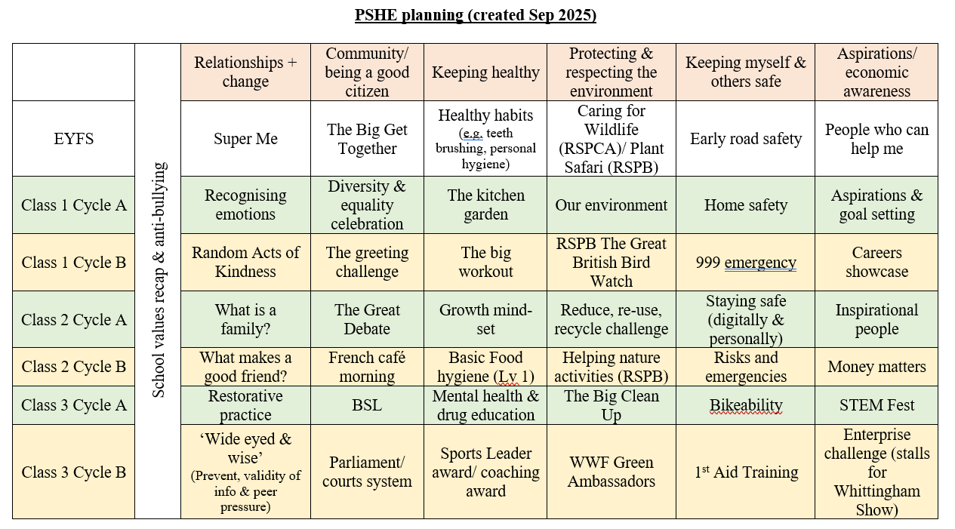
https://www.whittinghamprimaryschool.co.uk/goto/600185

Appendix 2: By the end of primary school pupils should know
Topic | Pupils should know
Families and people who care about me | - That families are important for children growing up because they can give love, security and stability  - The characteristics of healthy family life, commitment to each other, including in times of difficulty, protection and care for children and other family members, the importance of spending time together and sharing each other’s lives  - That others’ families, either in school or in the wider world, sometimes look different from their family, but that they should respect those differences and know that other children’s families are also characterised by love and care  - That stable, caring relationships, which may be of different types, are at the heart of happy families, and are important for children’s security as they grow up  - That marriage represents a formal and legally recognised commitment of two people to each other which is intended to be lifelong  - How to recognise if family relationships are making them feel unhappy or unsafe, and how to seek help or advice from others if needed
Caring friendships | - How important friendships are in making us feel happy and secure, and how people choose and make friends  - The characteristics of friendships, including mutual respect, truthfulness, trustworthiness, loyalty, kindness, generosity, trust, sharing interests and experiences and support with problems and difficulties  - That healthy friendships are positive and welcoming towards others, and do not make others feel lonely or excluded  - That most friendships have ups and downs, and that these can often be worked through so that the friendship is repaired or even strengthened, and that resorting to violence is never right  - How to recognise who to trust and who not to trust, how to judge when a friendship is making them feel unhappy or uncomfortable, managing conflict, how to manage these situations and how to seek help or advice from others, if needed
Respectful relationships | - The importance of respecting others, even when they are very different from them (for example, physically, in character, personality or backgrounds), or make different choices or have different preferences or beliefs  - Practical steps they can take in a range of different contexts to improve or support respectful relationships  - The conventions of courtesy and manners  - The importance of self-respect and how this links to their own happiness  - That in school and in wider society they can expect to be treated with respect by others, and that in turn they should show due respect to others, including those in positions of authority  - About different types of bullying (including cyberbullying), the impact of bullying, responsibilities of bystanders (primarily reporting bullying to an adult) and how to get help  - What a stereotype is, and how stereotypes can be unfair, negative or destructive  - The importance of permission-seeking and giving in relationships with friends, peers and adults
Online relationships | - That people sometimes behave differently online, including by pretending to be someone they are not  - That the same principles apply to online relationships as to face-to face relationships, including the importance of respect for others online including when we are anonymous  - The rules and principles for keeping safe online, how to recognise risks, harmful content and contact, and how to report them  - How to critically consider their online friendships and sources of information including awareness of the risks associated with people they have never met  - How information and data is shared and used online
Being safe | - What sorts of boundaries are appropriate in friendships with peers and others (including in a digital context)  - About the concept of privacy and the implications of it for both children and adults; including that it is not always right to keep secrets if they relate to being safe  - That each person’s body belongs to them, and the differences between appropriate and inappropriate or unsafe physical, and other, contact  - How to respond safely and appropriately to adults they may encounter (in all contexts, including online) whom they do not know  - How to recognise and report feelings of being unsafe or feeling bad about any adult  - How to ask for advice or help for themselves or others, and to keep trying until they are heard  - How to report concerns or abuse, and the vocabulary and confidence needed to do so  - Where to get advice e.g. family, school and/or other sources

Appendix 3: Parent/carer form: withdrawal from puberty education (Year 5’s ‘Health Talk’) within RHE

To be completed by parents/CARERS
Name of child |  | Class
Name of parent/carer |  | Date
Reason for withdrawing from puberty education within relationships and health education
Any other information you would like the school to consider
Parent signature

To be completed by the school
Agreed actions from discussion with parents/carers

