
Personal, social, health and economic (PSHE) education policy
Whittingham C of E Primary School

Approved by: | Policy Committee | Date: TBC
Last reviewed on: | Summer FGB meeting (9.7.2026)
Next review due by: | By the end of Summer term 2027

Version | Revision date | revision description | revised by
Contents
1. Aims 3
2. Statutory requirements 3
3. Content and delivery 4
4. Roles and responsibilities 4
5. Monitoring arrangements 5
6. Links with other policies 5

1. Aims
Our PSHE curriculum is rooted in our ethos and values of:
‘Hand in hand together we are kind, collaborative and courageous citizens of our community and the wider world.’

The aims of personal, social, health and economic (PSHE) education in our school are to help pupils:
- To provide an open, secure and welcoming Christian environment for each pupil. This is expressed through daily worship which acknowledges the presence of God in our lives.
- To further develop and value the partnership that exists between school and the local churches, in particular, through sharing weekly worship and to encourage an appreciation of the Christian faith and a familiarity with the local Christian heritage.
- To care for each pupils’ safety, happiness and well-being.
- To value our pupils as individuals, developing their ability to take responsibility for themselves and their actions, promoting confidence and self-esteem, and respect for others and their environment.
- To equip our pupils with the knowledge to make informed choices about having a safe and healthy lifestyle.
- To offer opportunities for our pupils to become involved in the daily life of the school and to prepare them to play an active role as citizens locally and in the wider world.
- To provide a learning environment, which is challenging and stimulating yet ordered and disciplined.
- To provide a broad and balanced curriculum, setting realistic targets for each pupil.
- To extend and reinforce our pupils learning, making expectations clear, and raising achievement levels.

2. Statutory requirements
PSHE is a non-statutory subject. However, there are aspects of it that we are required to teach.
- We must teach relationships education under the Children and Social Work Act 2017, in line with the terms set out in statutory guidance
- We must teach health education under the same statutory guidance
- Pupils are expected to learn personal, social and emotional development (PSED) under the Early Years Foundation Stage (EYFS) statutory framework

This policy also complies with the terms of our funding agreement.

3. Content and delivery
3.1 What we teach
As stated above, we are required to cover the content for relationships education, and health education, as set out in the statutory guidance (linked to above).
Refer to our relationships education policy for details about what we teach, and how we decide on what to teach, in this subject. This can be found on our school website: https://www.whittinghamprimaryschool.co.uk/pshe_rhse_mental_health_and_wellbeing

For other aspects of PSHE, including health education, see the attached curriculum map below for more details about what we teach in each year/ mixed-age class.
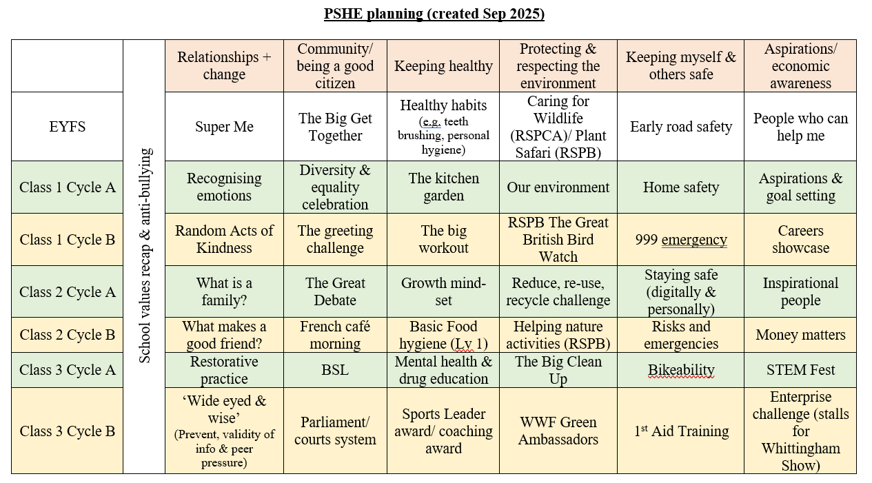
https://www.whittinghamprimaryschool.co.uk/goto/600185

3.2 How we teach it
- PSHE lessons take place weekly in each class.
- All classes follow the PSHE planning document.
- Certain aspects of the PSHE curriculum overlap and are complemented by other subject areas, such as our RE curriculum, Collective Worship, PE, Science and Computing Curriculum in particular.
- Where possible, we will always look to link school trips with our units where applicable and appropriate to give our children as many opportunities to real life, first-hand experiences.
- For the vast majority of our PSHE curriculum, it will be taught by the Class Teachers. In certain circumstances, sessions may be led by expert/ specialist staff, e.g. Bikeability will be led by external, accredited cycling staff. Other units of work such as ‘999 emergency’ and STEM Fest will be led by school staff but supported and facilitated by accredited organisations.
- All pupils in lessons, regardless of their ability or special educational needs and/or disability (SEND) will be supported and receive high-quality teaching. Where needed, staff will make adaptations so that every pupil can access and progress with their learning.
- Within the PSHE curriculum, there are units that contain controversial topics or difficult questions from pupils. We ensure that staff don’t let their personal beliefs and attitudes influence teaching and adhere to guidance and policies.
- Should any member of staff have any concerns about their ability to teach certain areas of the curriculum without letting their personal beliefs and attitudes affect them, they should speak to SLT who will seek to clarify the concerns with empathy and understanding and yet will be resolute in finding a way to ensure that the children receive unrelenting, high-quality teaching and learning.
- As shown in the PSHE planning document, there are resources that have been identified as being high-quality sources that can be used for the teaching of each unit of work. Sources that are used readily include Pol Ed and BBC Bitesize – all of which are quality-assured and purposeful.
- Progress in PSHE will be reported to parents/ caregivers in our usual methods: parents’ meetings and end of year reports. In addition, staff will also speak to parents/ caregivers as deemed appropriate and necessary throughout the academic year.
- To meet the early learning goals (ELGs) set out in the EYFS statutory framework, we incorporate EYFS in our PSHE planning. This takes into account the areas of learning for EYFS.

4. Roles and responsibilities
4.1 The governing board
The governing board will approve the PSHE policy and hold the headteacher to account for its implementation.
4.2 The headteacher
The headteacher is responsible for ensuring that PSHE is taught consistently across the school.
4.3 Staff
Staff are responsible for:
- Delivering PSHE in a sensitive way
- Modelling positive attitudes to PSHE
- Monitoring progress
- Responding to the needs of individual pupils
- The PSHE Lead is Neil Charlton. They will support staff across school to plan, deliver and assess high-quality teaching and learning of PSHE.
4.4 Pupils
Pupils are expected to engage fully in PSHE and, when discussing issues related to PSHE, treat others with respect and sensitivity.

5. Monitoring arrangements
The delivery of PSHE is monitored by the PSHE Lead, Neil Charlton, through:
-Planning and sequencing of units.
-staff training as identified and required (linking staff voice and observations of lessons – both formal and informal).
-Parental/ caregiver links, such as workshops and information sharing.
-Pupil progress through activities such as but not limited to learning walks, lesson observations, book scrutiny/ ‘book looks’, and pupil voice.
-Assessment data analysis.

This policy will be reviewed by the PSHE Lead annually. At every review, the policy will be approved by the Headteacher and the Governing Body.

6. Links with other policies
This policy links to the following policies and procedures:
- Relationships and health education (RHE) policy
- Early Years Foundation Stage (EYFS) policy
- Behaviour policy
- Anti-bullying Policy

