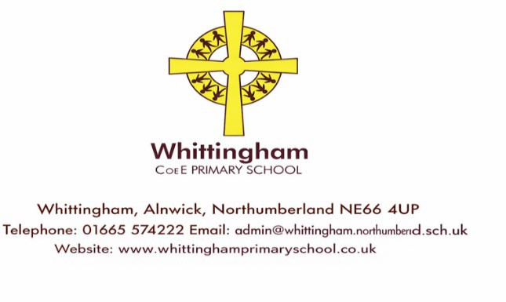
Newsletter Week 24.
Friday 13th March 2026.
Dear Parents/ Caregivers,
I hope everyone who attended Class 2’s Community Café enjoyed themselves and I am sure you will agree that the children and staff team were excellent.
We look forward to seeing you at our Easter Service Wednesday 1st April (poster to follow)
There is Parents Evening on Monday 23rd and Tuesday 24th March
Walking bus and Toddly Play on Wednesdays
Babes in the Wood Easter special 31st March
Non-Uniform Day and Easter Bingo 27th March
Mrs Arkle’s Party! (poster attached) Thursday 2nd April – please can the children wear non-uniform on this day.
There is also a poster from the Church inviting families to contribute to a Spring display!
Exciting News for Early Years - On behalf of the EY team I would like to thank everyone who has responded with offers of equipment for our exciting 2-year-old provision which is starting after the Easter Holidays we cannot wait to show it to everyone when it is ready! So that you do not miss out I have sent out on a previous email our 3-year-old nursery application form (black writing) and 2 year old provision application form (blue writing) both attached and complete if you have, or know someone who has young babies or toddlers so that you/ they do not miss out on a place for our highly acclaimed provision.
Reminders- This has been mentioned in previous newsletters but just a reminder incase you have missed it:
School Dinner Money should be paid on Mondays in advance for the week ahead. We cannot carry over debts of more than 2 weeks so please do pay promptly or see me if support is needed.
Please do not drive onto the Memorial Hall carpark while I am still out on morning welcome duty for safety reasons.
Our new school website should be ready to share with you next week.
Thank you for your support.
Best wishes, Belinda Athey - Headteacher

