

Class Teacher – Mr Charlton
Supported by Mrs Chisholm during management and PPA times & by Ms Coxon for intervention work.
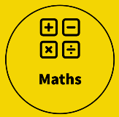  Arithmetic (revision)  - The four operations (addition, subtraction, multiplication and division)  - Place value knowledge  - Percentages  - Decimals  - Identifying & comparing fractions.  - Calculating with fractions.  Fractions  - Calculating fractions of amounts (the part)  - Calculating fractions of amounts (the whole)  - Problem-solving with fractions  Decimals  - Place value of tenths, hundredths and thousandths  - Ordering decimal numbers  - Rounding decimal numbers  - Writing fractions as decimals  Percentages  - Identifying percentages  - Calculating fractions of amounts  - Writing fractions as percentages  - Writing decimals as percentages  - Calculating percentage increases and decreases  Please note: ALL children MUST know their times tables up to 12 times 12, and be able to recall quickly. TTRS (Times Tables Rock Stars) is used across school, is part of our homework approaches and should be used to develop speed and fluency.  Key vocabulary:  Place value, digit, tenth, hundredth, thousandth, rounding, inverse, equivalent, numerator, denominator, improper fraction, proper fraction, mixed number fraction, convert, percentage, decimal place. | 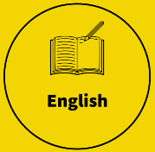  In this half-term, we will explore the award-winning Percy Jackson series by Rick Riordan. These books are not only highly regarded but also link to our topic of Greek mythology in our History unit for this half-term. Mortal Engines by Philip Reeve. These books will be used in both our guided reading and writing sessions throughout this half-term.  Our first genre of writing within this half-term will be to create a newspaper. We will study examples first to identify their structure and unique features before practising varied sentence structures, such as parenthesis and quotes, before then writing one of our own.  Next, we will study diaries and how the tone and informality is able to be explored whilst maintaining control of the content so that it is still effective to the reader. This will again link to our History unit where we will create our own diary entries from the point of view of both Greek and Trojan soldiers.  Finally, we will look at non-chronological writing. We will compare and contrast this genre to others and their variance in structural layouts that can be used as well as discuss the importance and effect of bias within an author’s tone.  We will continue to develop our reading comprehension skills through our guided reading sessions and use of Accelerated Reader, as well as increasing understanding of written grammar through writing analysis.  Please hear your child read daily and write a message/ sign/ initial your child’s Reading Record book.  Key vocabulary:  Word class, colon, semi-colon, parenthesis, fronted adverbial, relative clause, relative pronoun, subordinate clause, simile, metaphor, personification, parenthesis, fact opinion, statistics, quotes, reported/ direct speech, emotive language, formal & informal language, technical vocabulary, structure.
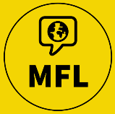  This half-term sees us develop our speaking, writing and reading of French with further study of:  - Describing lessons  - Giving opinions  - Place names in a town  - Directional & prepositional phrases. | 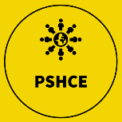  In our PSHE work we will be finishing our study of understanding where and how laws are created as well as then moving into undertaking sports leader training as part of our ‘healthy living’ topic. This will enable us to not only learn to live healthier and its importance but also provides us with an opportunity to develop our skills as sports leaders (communication, teamwork, empathy and problem-solving skills through relationships).
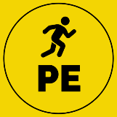  Children will be taking part in daily exercise each day through our ‘daily mile’.  Key taught sessions during this half-term will include dodgeball and multiskills.  Key vocabulary:  Stretch, muscles, ligaments, tendons, core muscles, respect, tenacity, teamwork, communicating, anticipation, formation, vision, throw, catching, positioning, blocking, evasion. |  | 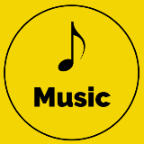  In preparation for a large-scale performance in the summer term, we will be studying the structures and inter-related dimensions of music involved in both composition and performance. This will involve appraising famous examples of film and tv music as well as using this to compose our own.  The children will not only learn to read and write music in various methods, but also learn to play both as an individual and as an ensemble.  Key vocabulary:  Rhythm, beat, pulse, dynamics, pitch, timbre, texture, tempo, duration, projection, tone, characterisation, polyrhythms, syncopation, reverb, structure, verse, chorus.
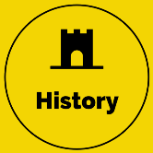  During this half-term, we will be exploring the myths and legends of the Ancient Greeks. Our overarching question will be ‘can we believe a myth/ legend?’ Through studying various Ancient Greek myths/ legends and comparing them to others from other times and eras, we will seek to answer the following:  Key questions/ learning points:  - What is a myth/ legend?  - What was life like for the Ancient Greeks?  - How can we validate historical evidence?  Key vocabulary:  Myth, legend, hero/ heroine, philosophy, democracy, architecture, historical evidence, artefacts, bias, reliable, validity, persuasion and embellishment. |  | 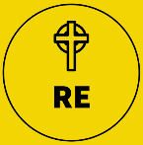  We use the Northumberland County Council Agreed Syllabus for Religious Education and will be looking at the key overriding question for this half-term: Why do Hindus want to be good?  Within this unit, the children will study:  - The origins of Hinduism,  - Some of the Hindu stories relating to the religious mindset of Hinduism,  - The stages of life in Hinduism (ashramas),  - The value of karma.  Key vocabulary:  Sanatan Dharma, Brahman, atman, karma, samsara, moksha, ashramas, duty, reincarnation, eternal.
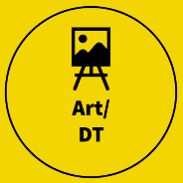  Art/DT – We will be developing a range of skills in our unit for this half-term: portraits. The children will not only study some examples of portraits in various forms, but then also develop the following artistic skills:  - Proportioning  - scaling  - sketching techniques  - collage  - texture  - depth  Key vocabulary:  Sketch, outline, light source, shading, hatching, cross-hatching, stippling, light source, depth, texture, proportions, abstract, evaluate, structure. |  | 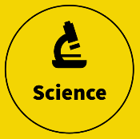  In Science, we will be finishing off iur unit on light by looking at convex and concave lenses and their uses in everyday objects (glasses & telescopes).  We will then move into the unit of electricity. This will involve us studying the following:  - identifying electric symbols,  - comparing parallel and series circuits,  - observing the effects of variance in components,  - solving circuit problems,  - being creative to build briefed circuits.  We will also be creating our own investigations and creating thorough scientific reports.  Key vocabulary:  Cell, light, buzzer, motor, wire, circuit, switch, resistance, series, parallel, component, amps, voltage, potential difference.
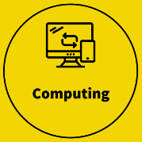
Our computing unit for this half-term will see the children explore the history and use of computing systems. This includes the following:
- computer coding
- the importance of passwords
- the evolution of computers
- designing a future computer
- creating an audio advert
Key vocabulary:
Coding, system, input, output, password, security, hacking, intercept, design, audio, visual, data, cause, effect, response, evaluate.
REMINDERS:
Homework will be given out on a Friday and due in for the following Friday. It will comprise of:
-spellings via the use of Ed Shed (the children have their login details within their reading records),
-times-tables through the use of TTRS (times tables rock stars),
-Accelerated Reader (an average of at least 5 times per week),
-a maths task linked to the recent learning/ revision (CGP books),
-an English task that is linked to recent learning/ revision CGP books).

As ever, myself and everyone at school are here to support. If there are ever any concerns, queries or things to celebrate, just let us know either in person, via our Class Dojo or the school office.
In our classroom, we have a ‘Wow wall’ where I display achievements of the children. If your child would like to share an achievement (this could be as a certificate, rosette or photo) then please feel free to message me on Class Dojo or email.
Please note that I will monitor and respond to Class Dojo message between the hours of 08:30-17:30. It is absolutely fine to message me outside of these times but you won’t get a response until I’m within working hours of the day again.

