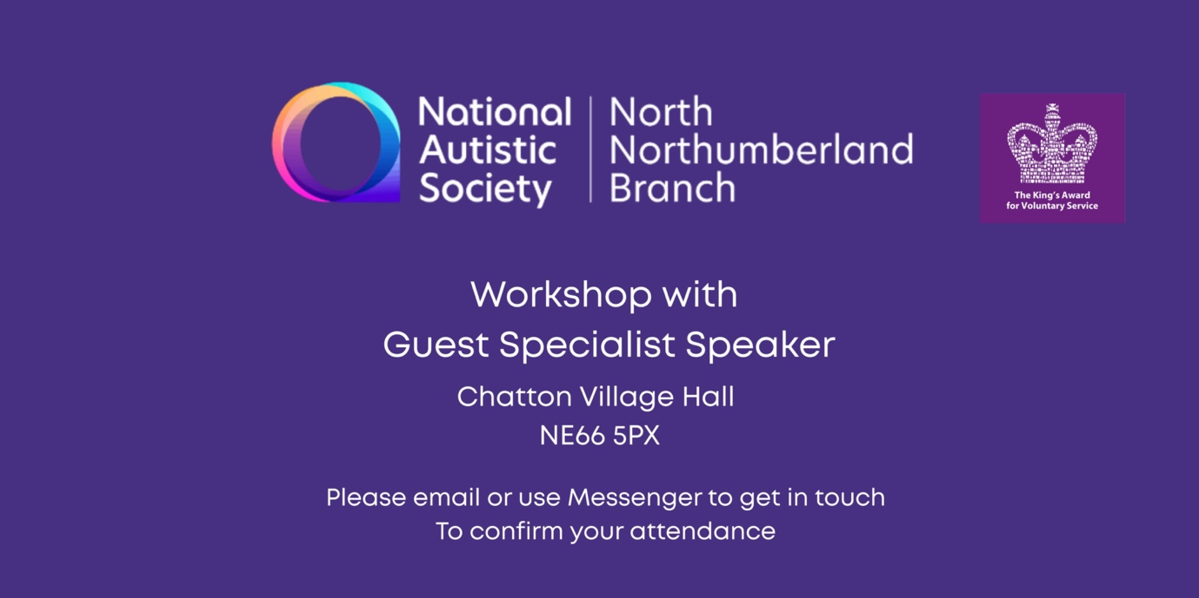

Monday October 13th 2025 – Chatton Village Hall NE66 5PX
6.30 - 8pm
LIFE PLANNING GUIDANCE for PARENTS & CARERS
of
DISABLED CHILDREN & ADULTS
Presented by Mandy Cheung

This is the second in our series of Life Planning sessions, this one will focus on health and welfare in relation to capacity, deputyship, POA & wills, etc.
Mandy Cheung is a solicitor practising with EMG Solicitors, Gosforth.

You can find more information about the branch and its services on
https://www.facebook.com/nasnorthnorthumberlandbranch

To help us ascertain numbers for the refreshments, it would be helpful
if you could email to confirm your attendance by messaging:

Helen Sutherland at
northnorthumberland.branch@nas.org.uk

