
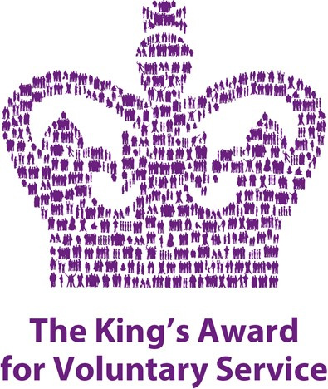
SUMMER DATES

Tuesday 29th July 12-3pm
Autism Friendly Forest School
Clarty Commandos, Howick Hall Gardens, NE66 3LB

Thursday 7th August 1.30-3pm
Craft Group,
Chatton Village Hall, NE66 5PX

Sunday 17th August 1-5pm
Bamburgh Tea/Tombola Fundraiser
Bamburgh Pavilion, NE69 7DB
Baking/Tombola Items Welcome

Thursday 28th August 10am – 2pm
Picnic, Aerial Rigg and Movement Day
Chatton Village Hall, NE66 5PX

