KS1 Maths Calculation Policy



**Addition** - **Year 1**

**Number Line** – counting on.

Always start with the largest number – initially use a ‘full’ number line.

A ‘full’ or annotated number line is used for counting on.

**For example *5 + 3 =***

|  |  |
| --- | --- |
|  |  |

0 1 2 3 4 5 6 7 8 9 10

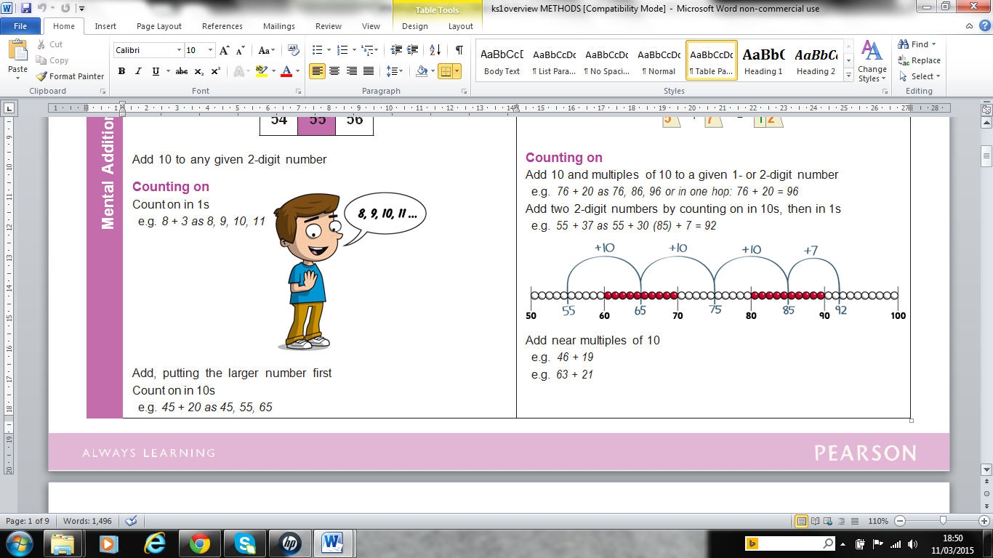

**Counting on**

Count on in 1s

e.g. *8 + 3 as 8, 9, 10, 11*

Add, putting the larger number first.

Count on in 10s

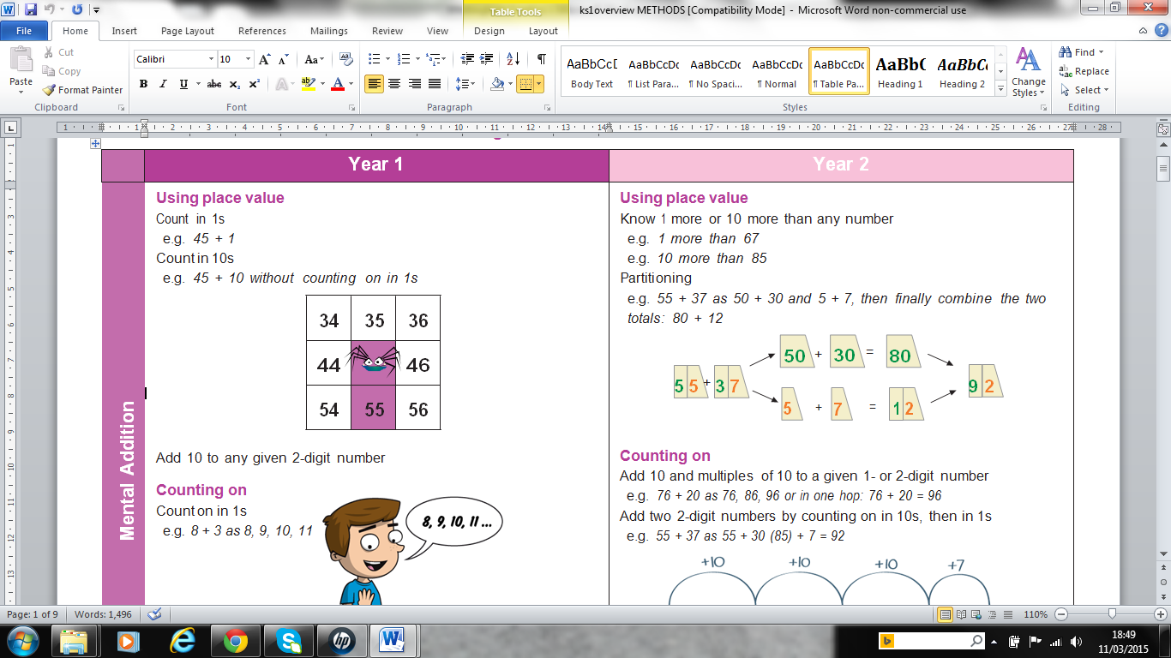e.g. *45 + 20 as 45, 55, 65*

**Using place value**

Count in 1s

Eg. *45 + 1*

Count in 10s

Eg. *45 + 10* without counting on in 1s



Add 10 to any given 2-digit number

**Using number facts (number bonds)**

‘Story’ of 4, 5, 6, 7, 8 and 9

e.g. *7 = 7 + 0, 6 + 1, 5 + 2, 4 + 3*

Number bonds to 10

e.g. *5 + 5, 6 + 2, 7 + 3, 8 + 2, 9 + 1, 10 + 0* 4 + 6 = 10

Use patterns based on known facts when adding e.g. *4 + 3 = 7 so we know 24 + 3, 44 + 3, 74 + 3*

**Addition – Year 2**

**Counting on**

Add 10 and multiples of 10 to a given 1- or 2-digit number e.g. *76 + 20 as 76, 86, 96 or in one hop: 76 + 20 = 96*

Add two 2-digit numbers by counting on in 10s, then in 1s e.g. *55 + 37 as 55 + 30 (85) + 7 = 92*

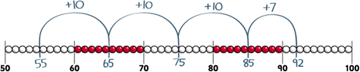

Add near multiples of 10

*e.g. 46 + 19*

*e.g. 63 + 21*

**Using place value**

Know 1 more or 10 more than any number

e.g. 1 more than 67

e.g. 10 more than 85

Partitioning

e.g. 55 + 37 as 50 + 30 and 5 + 7, then finally combine the two

totals: 80 + 12

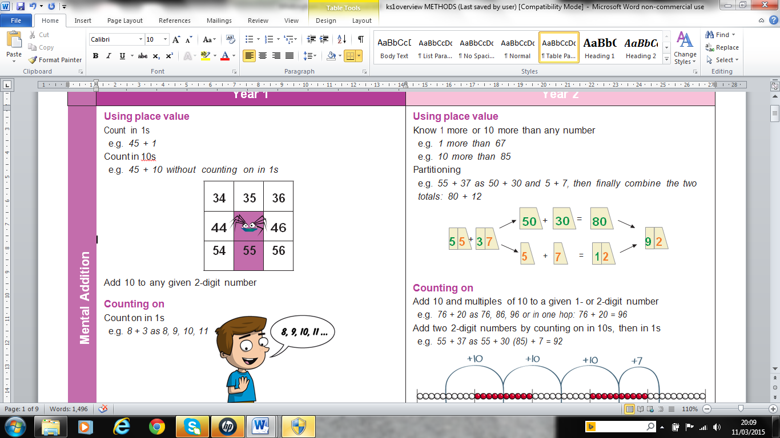

**Using number facts**

Know pairs of numbers which make the numbers up to and including 12

e.g. 8 = 4 + 4, 3 + 5, 2 + 6, 1 + 7, 0 + 8

e.g. 10 = 5 + 5, 4 + 6, 3 + 7, 2 + 8, 1 + 9, 0 + 10

Use patterns based on known facts when adding

e.g. 6 + 3 = 9, so we know 36 + 3 = 39, 66 + 3 = 69, 56 + 3 = 59

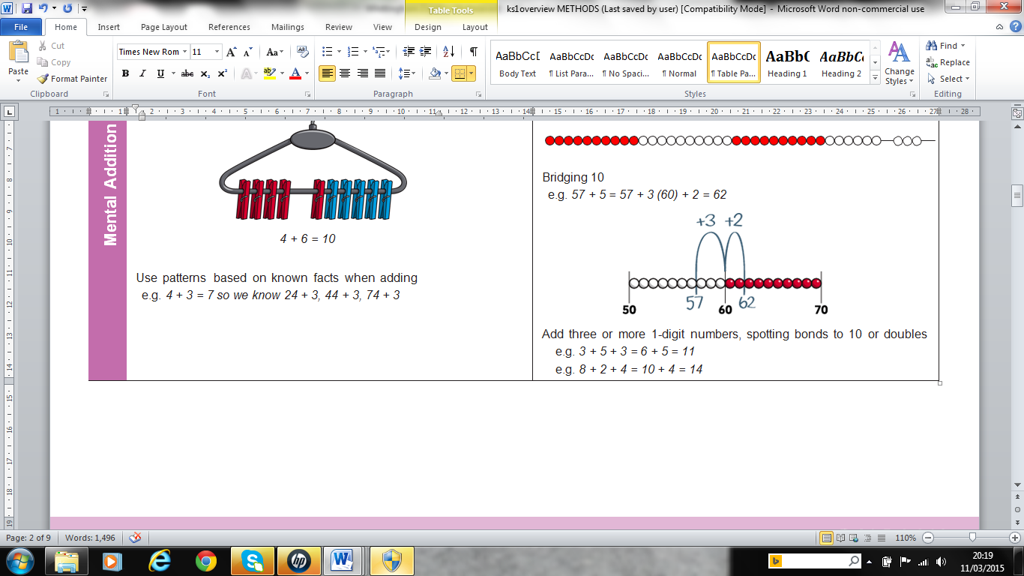

**Bridging 10**

*e.g. 57 + 5 = 57 + 3 (60) + 2 = 62*

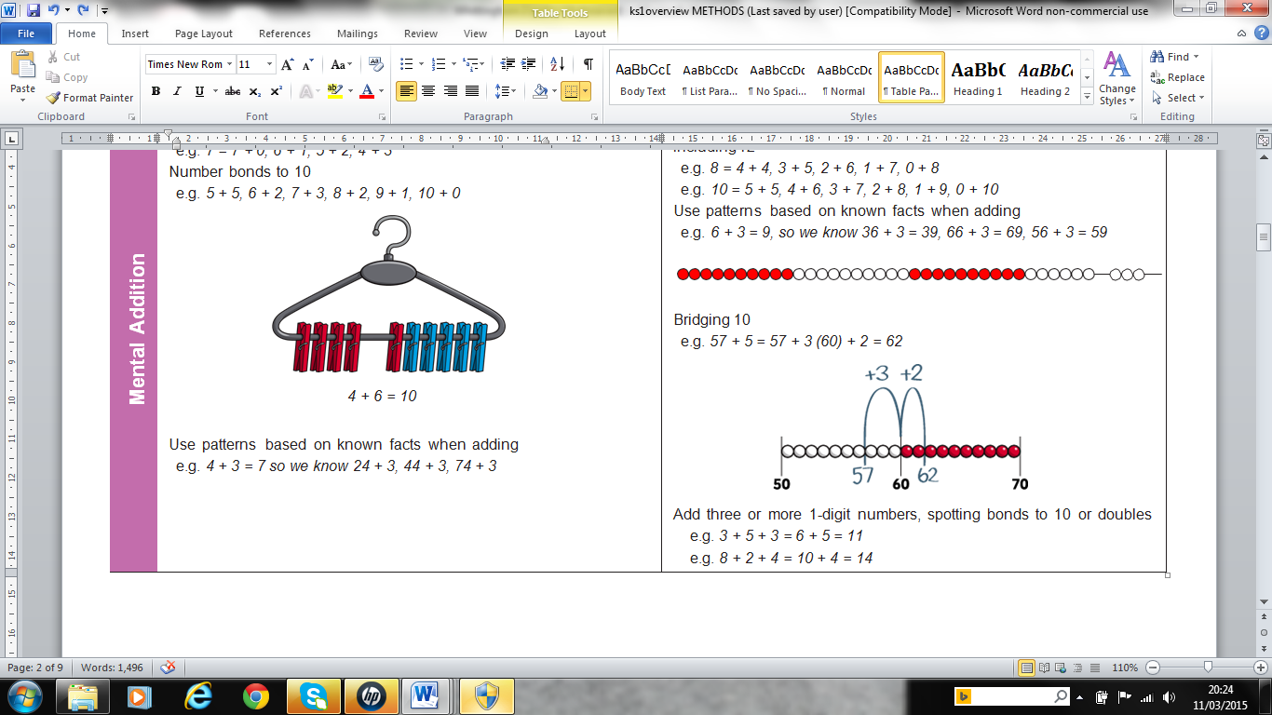

Add three or more 1-digit numbers, spotting bonds to 10 or doubles e.g. *3 + 5 + 3 = 6 + 5 = 11*

e.g. *8 + 2 + 4 = 10 + 4 = 14*

**Subtraction - Year 1**

**Number Line** – single digit counting back.

For example 9 – 4 =

|  |
| --- |
|  |



0 1 2 3 4 5 6 7 8 9 10

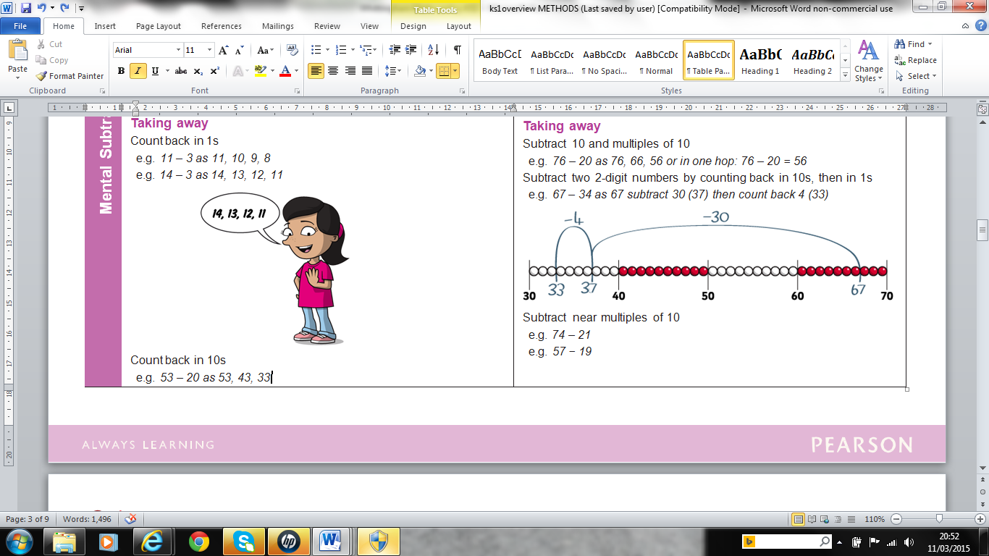

**Taking away**

Count back in 1s

*e.g. 11 – 3 as 11, 10, 9, 8*

*e.g. 14 – 3 as 14, 13, 12, 11*

*Count back in 10s*

*e.g. 53 – 20 as 53, 43, 33*

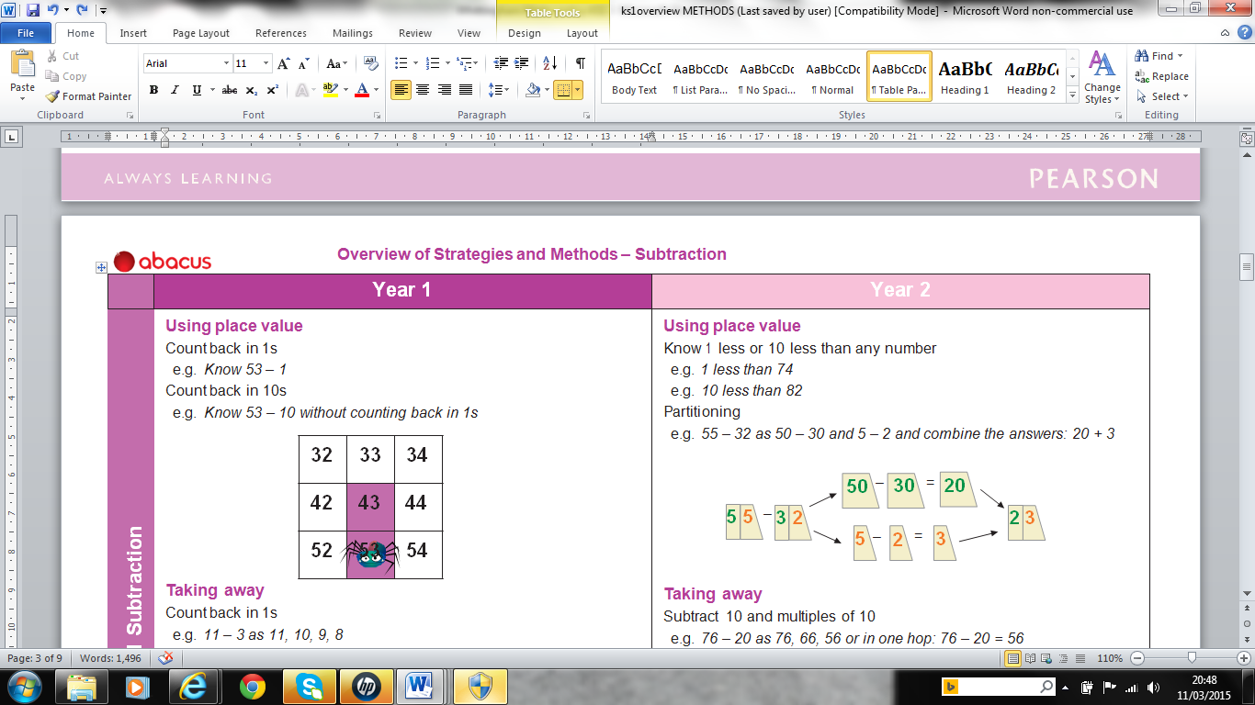

**Using place value**

Count back in 1s

e.g. Know 53 – 1

Count back in 10s

e.g. Know 53 – 10 without counting back in 1s

**Using number facts**

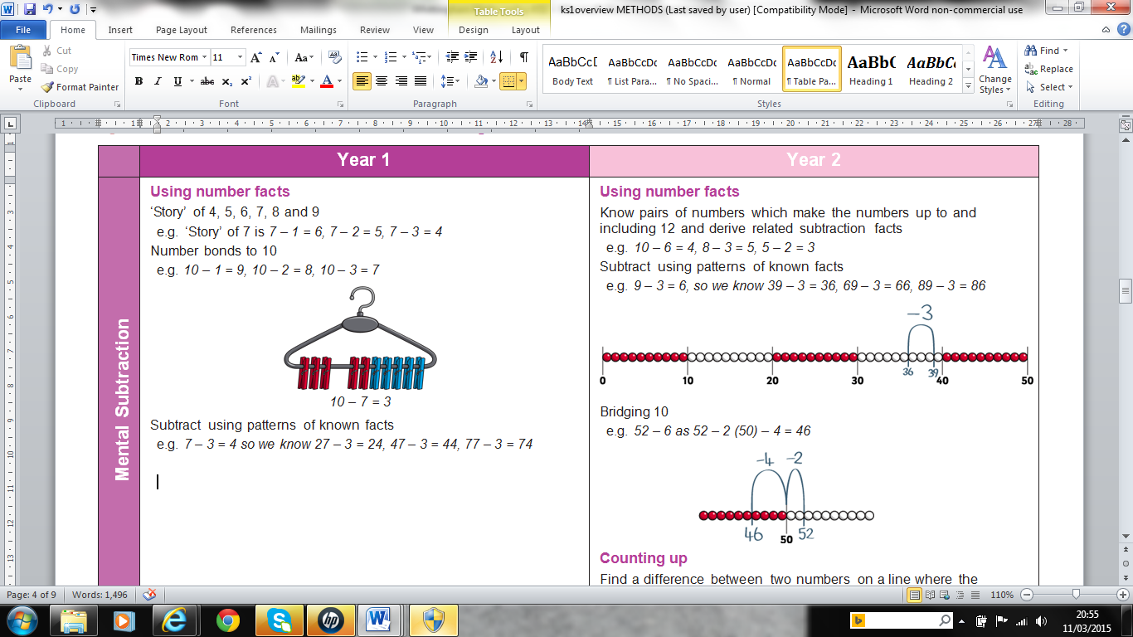*‘Story’ of 4, 5, 6, 7, 8 and 9*

*e.g. ‘Story’ of 7 is 7 – 1 = 6, 7 – 2 = 5, 7 – 3 = 4*

*Number bonds to 10*

*e.g. 10 – 1 = 9, 10 – 2 = 8, 10 – 3 = 7*

**Subtraction – Year 2**

**Taking away**

Subtract 10 and multiples of 10

e.g. *76 – 20 as 76, 66, 56 or in one hop: 76 – 20 = 56*

Subtract two 2-digit numbers by counting back in 10s, then in 1s

e.g. *67 – 34 as 67 subtract 30 (37) then count back 4 (33)*

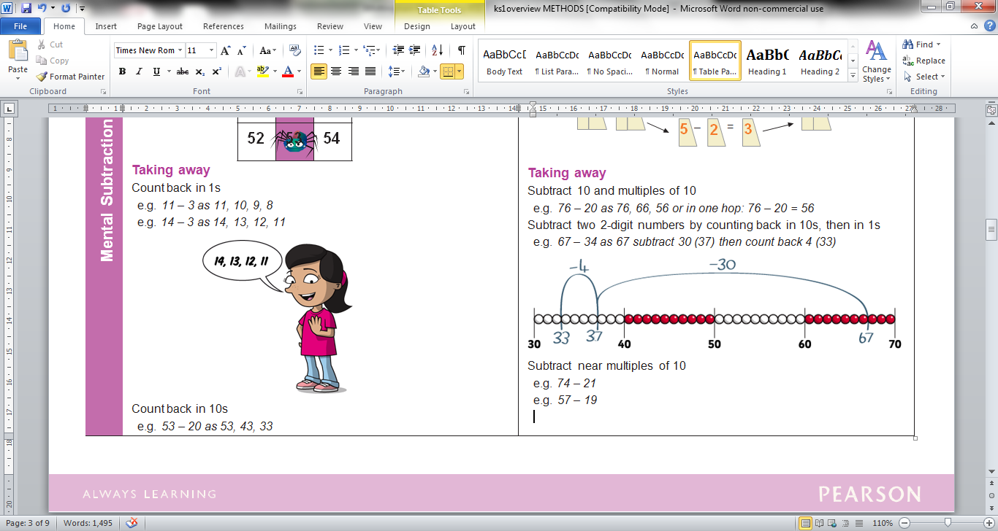

Subtract near multiples of 10

e.g. 74 – 21

e.g. 57 – 19

**Using place value**

Know 1 less or 10 less than any number

e.g. 1 less than 74

e.g. 10 less than 82

Partitioning

e.g. 55 – 32 as 50 – 30 and 5 – 2 and combine the answers: 20 + 3

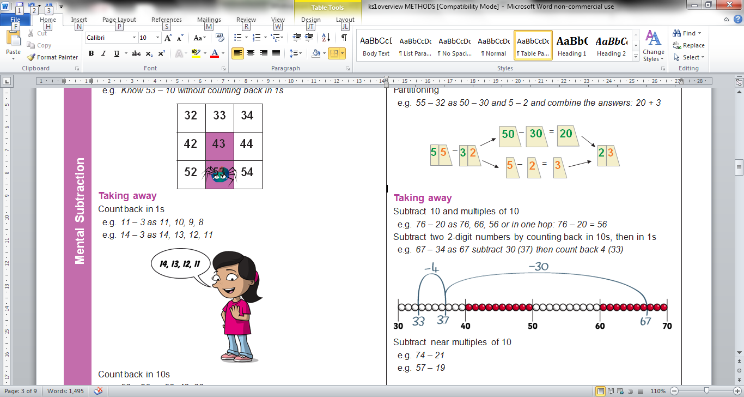

**Using number facts**

Know pairs of numbers which make the numbers up to and including 12 and derive related subtraction facts

e.g. *10 – 6 = 4, 8 – 3 = 5, 5 – 2 = 3*

Subtract using patterns of known facts

e.g. *9 – 3 = 6, so we know 39 – 3 = 36, 69 – 3 = 66, 89 – 3 = 86*

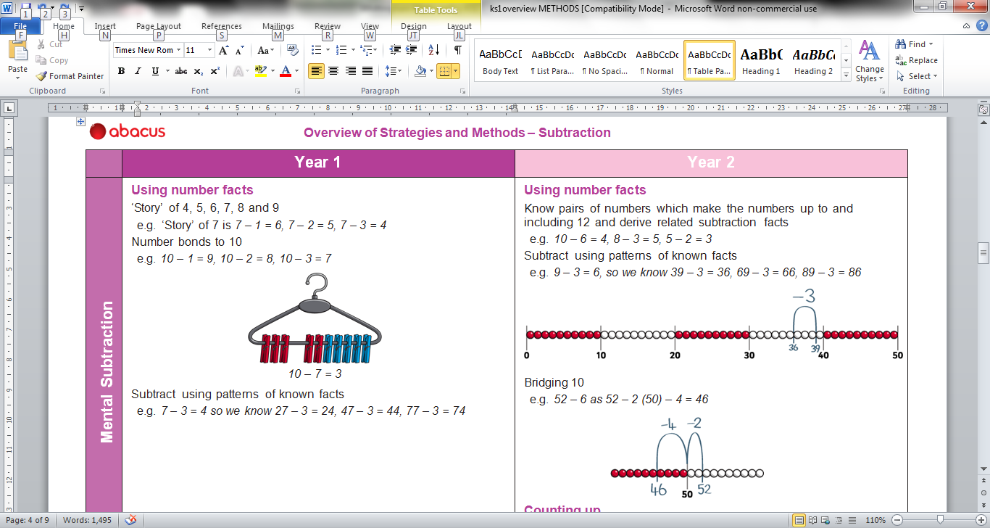**Bridging 10**

e.g. 52 – 6 as 52 – 2 (50) – 4 = 46

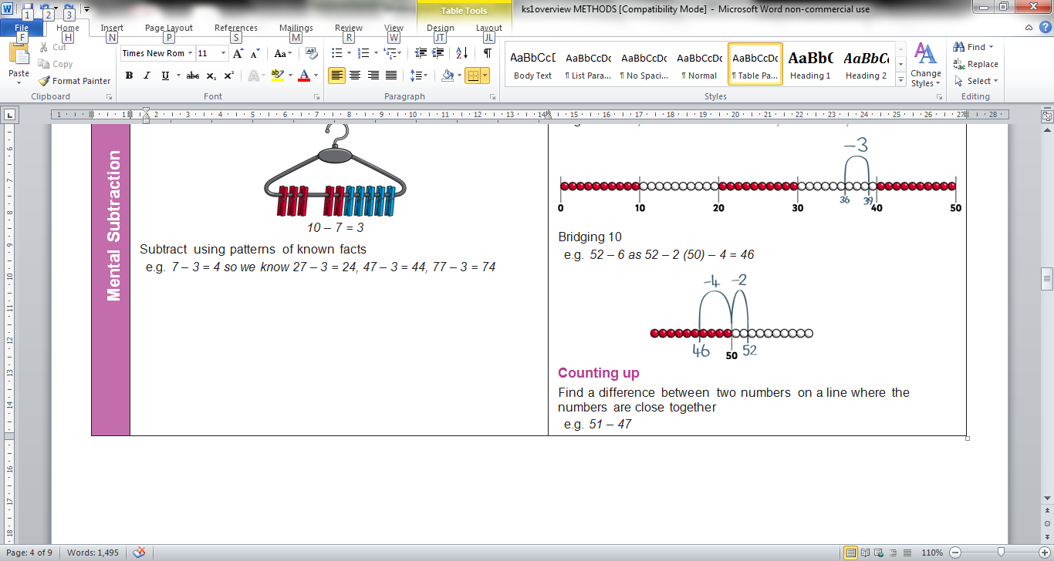

**Counting up**

Find a *difference* between two numbers on a line where the numbers are close together. Start at the smaller number and count up to the bigger number.

e.g. 21 – 17

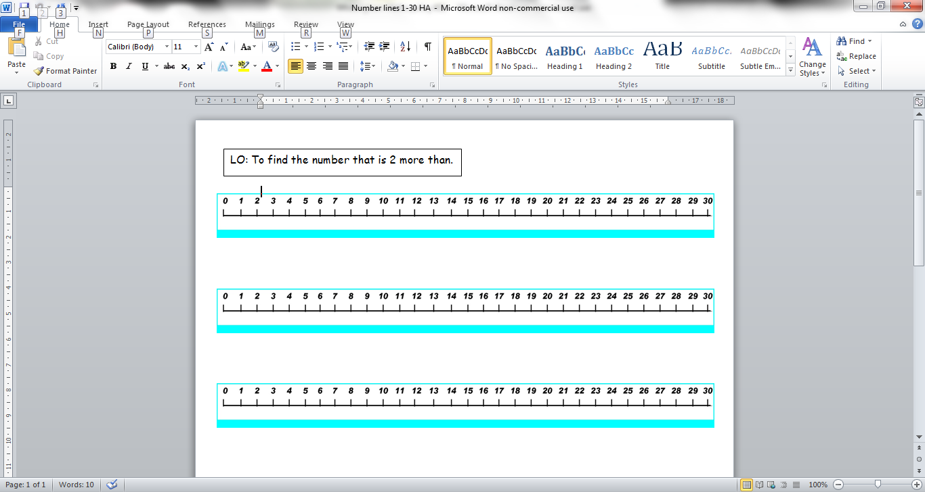

**Multiplication - Year 1**

Counting in steps (‘clever’ counting)

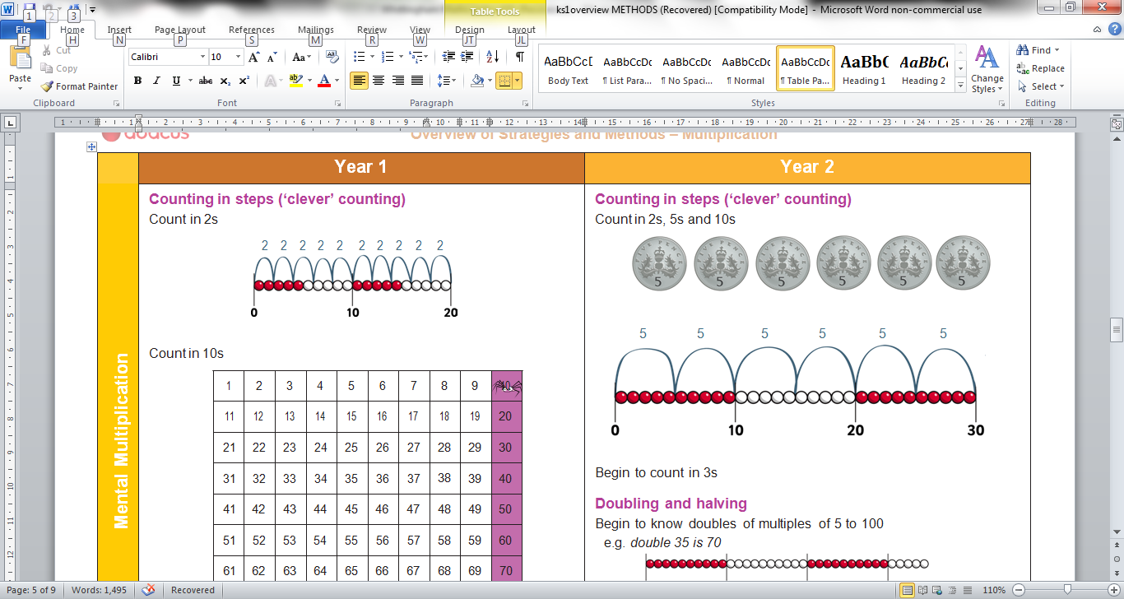Count in 2s

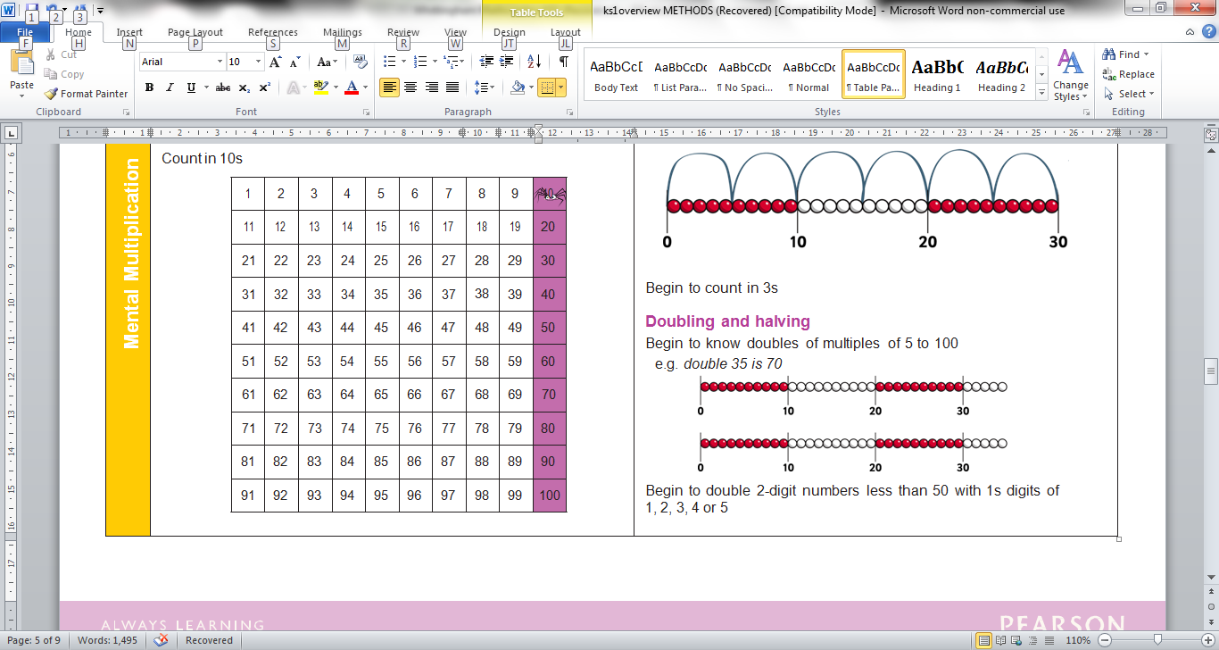Count in 10s

**Doubling and halving**

Find doubles to double 5 using fingers

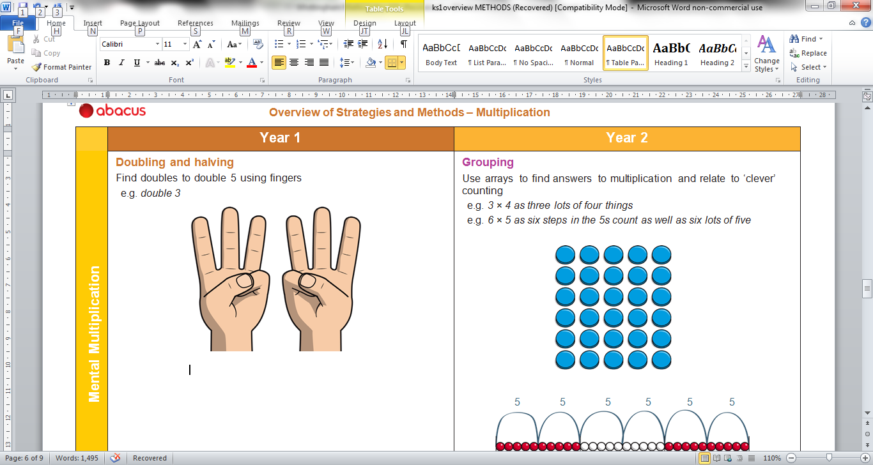e.g. double 3

Doubling facts are just the two times table:

3 + 3 = 6

**3 x 2 = 6**

**Grouping**

Begin to use visual and concrete arrays and sets of objects to find the answers to ‘three lots of four’ or ‘two lots of five’









2 groups of 5 = 10

2 x 5 = 10

(Double 5 is 10, 5 + 5 = 10)

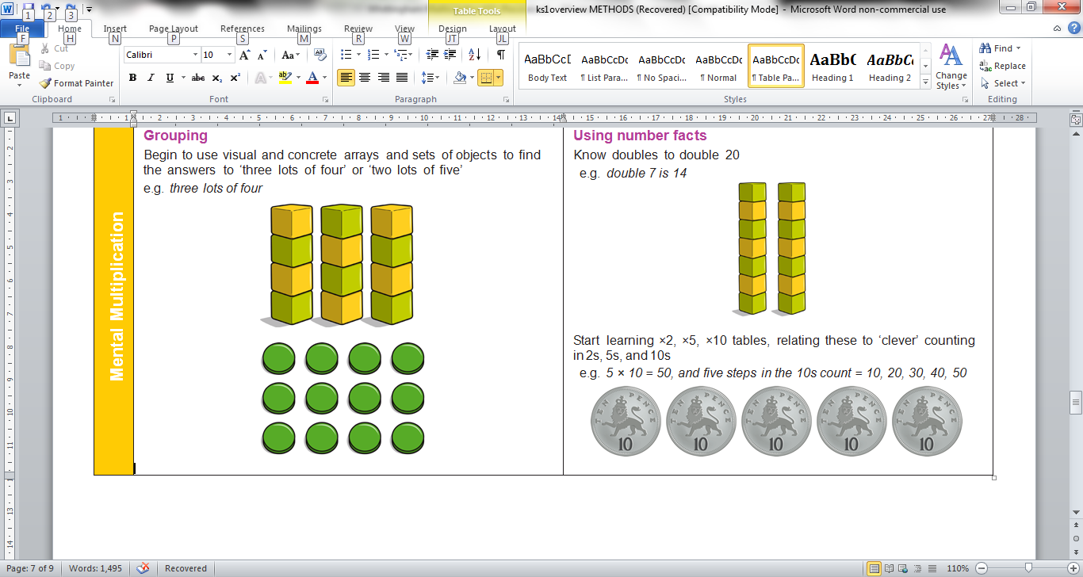

e.g. three lots of four

3 x 4 = 12

4 x 3 = 12

**Multiplication – Year 2**

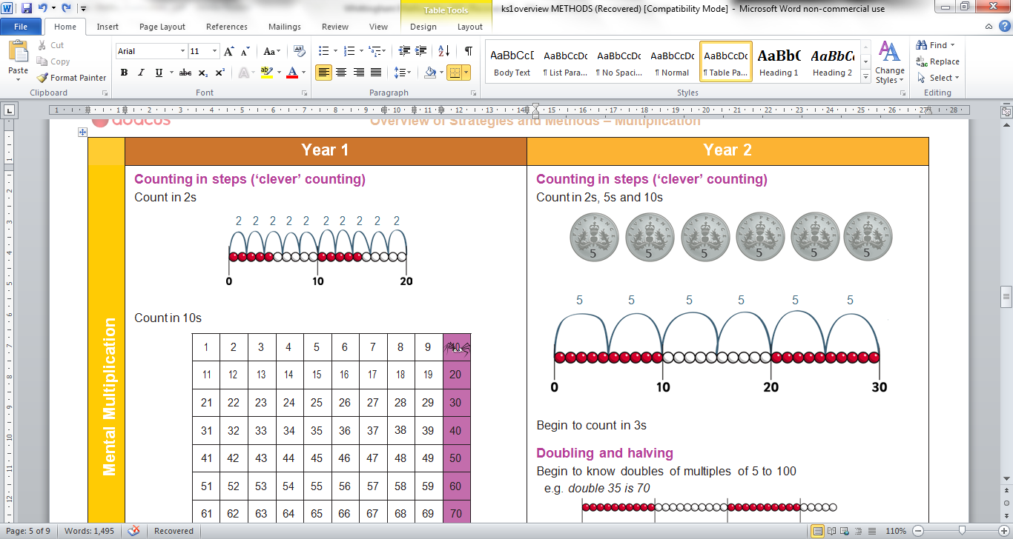

**Counting in steps** (‘clever’ counting)

To be secure with counting in 2s, 5s and 10s

Begin to count in 3s

**Doubling and halving**

Begin to know doubles of multiples of 5 to 100

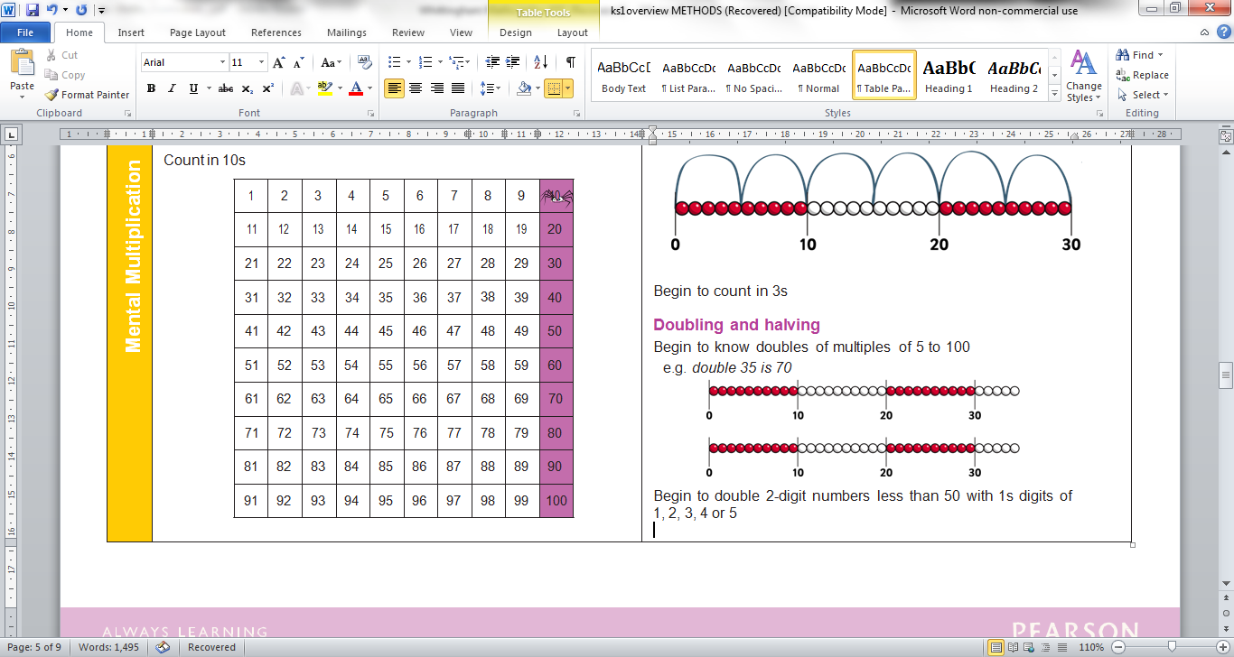e.g. double 35 is 70

Begin to double 2-digit numbers less than 50 with 1s digits of 1, 2, 3, 4 or 5

**Grouping**

Use arrays to find answers to multiplication and relate to ‘clever’ counting

e.g. 3 × 4 as three lots of four things

e.g. 6 × 5 as six steps in the 5s count as well as six lots of five

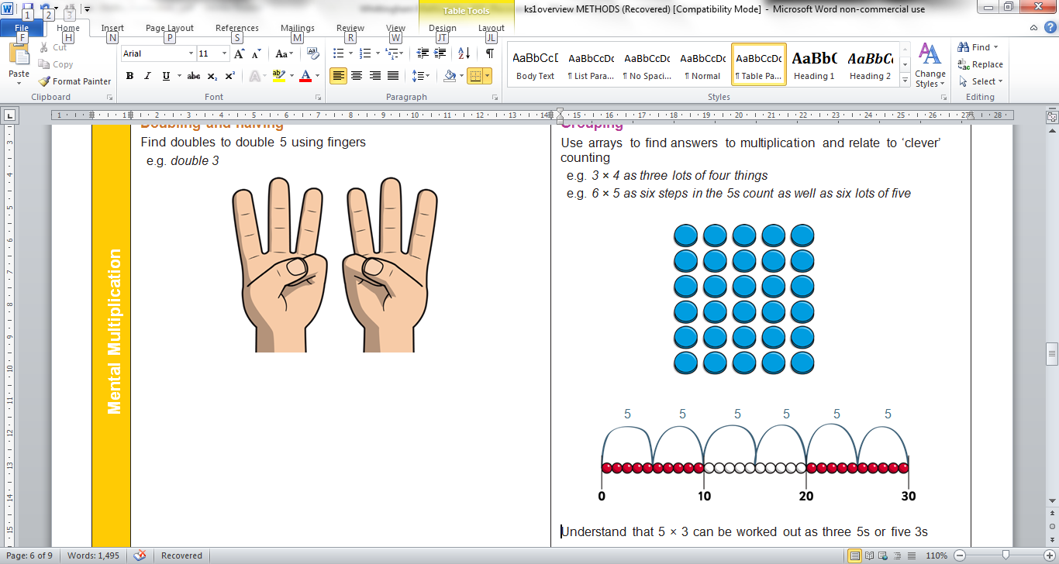

Understand that 5 × 3 can be worked out as three 5s or five 3s

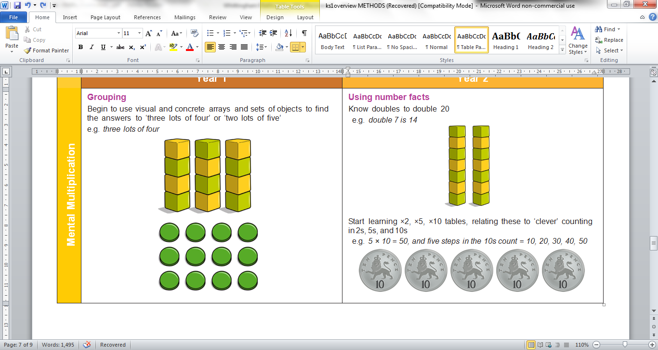**Using number facts**

Know doubles to double 20

e.g. double 7 is 14

Start learning ×2, ×5, ×10 tables, relating these to ‘clever’ counting in 2s, 5s, and 10s

e.g. 5 × 10 = 50, and five steps in the 10s count = 10, 20, 30, 40, 50

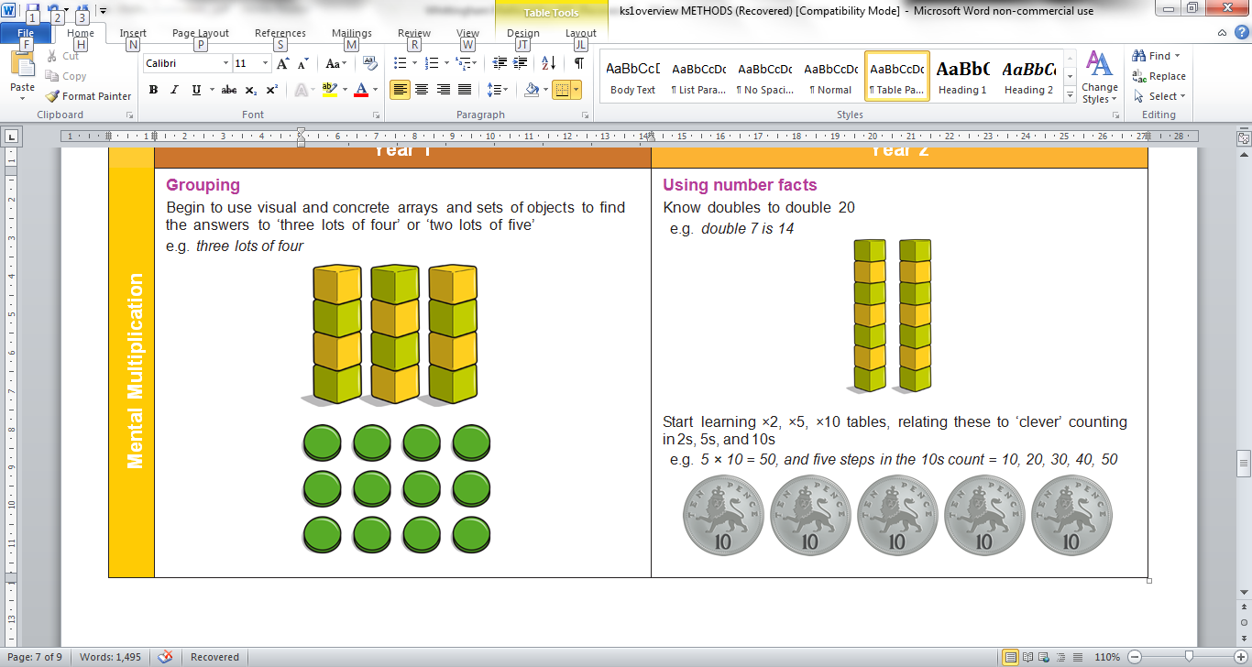

**Division - Year 1**

Counting in steps (‘clever’ counting)

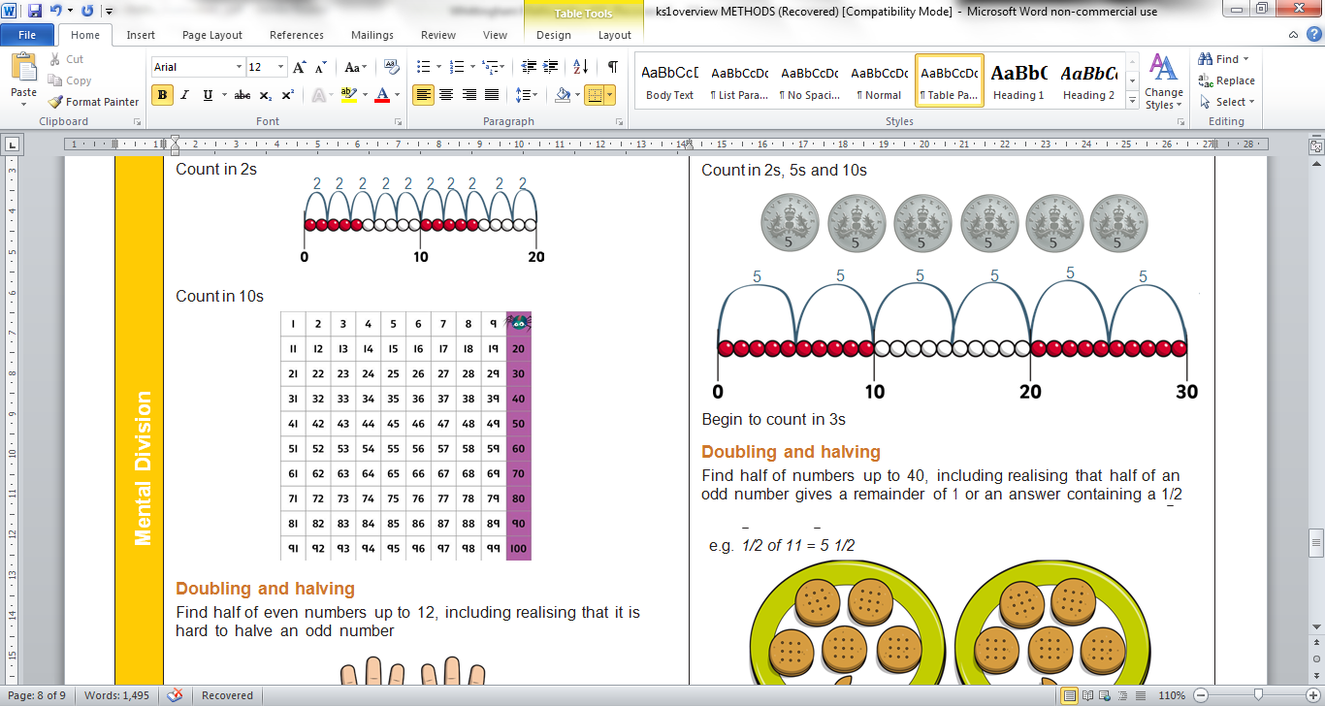Count in 2s



Count in 10s

**Doubling and halving**

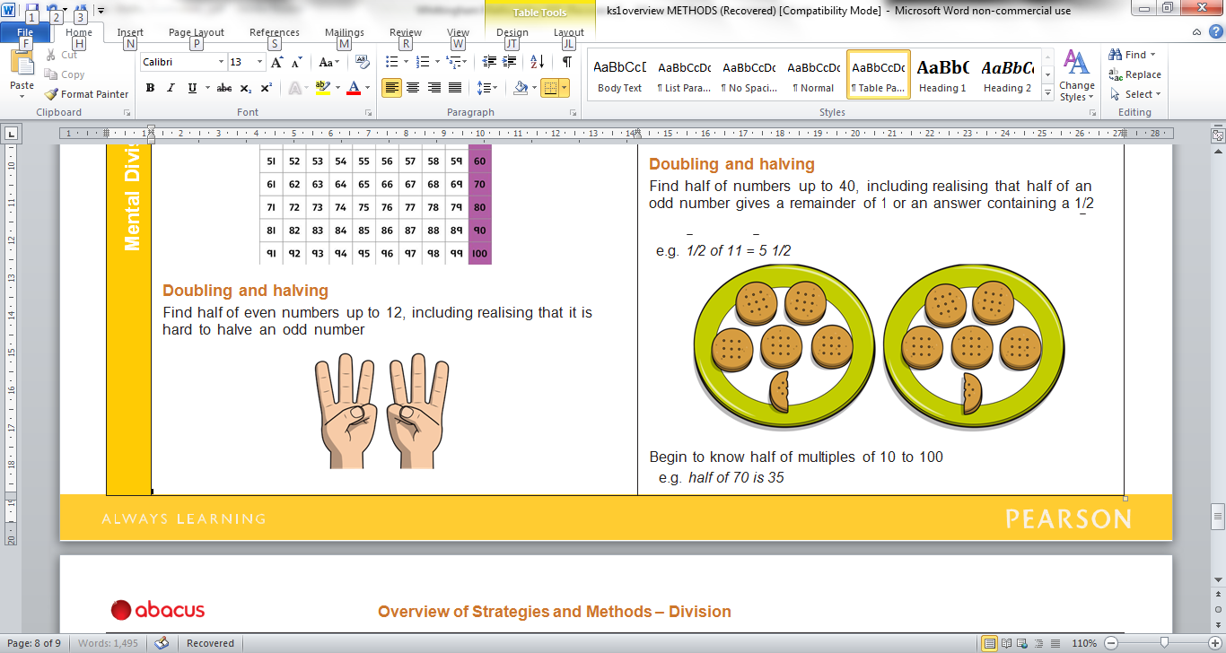Find half of even numbers up to 12, including realising that it is hard to halve an odd number

**Grouping**

Begin to use visual and concrete arrays and ‘sets of’ objects to find the answers to questions such as ‘How many towers of three can I make with twelve cubes?’

**Sharing**



Begin to find half of a quantity using sharing

e.g. find half of 12 Smarties by giving one each

repeatedly to two children

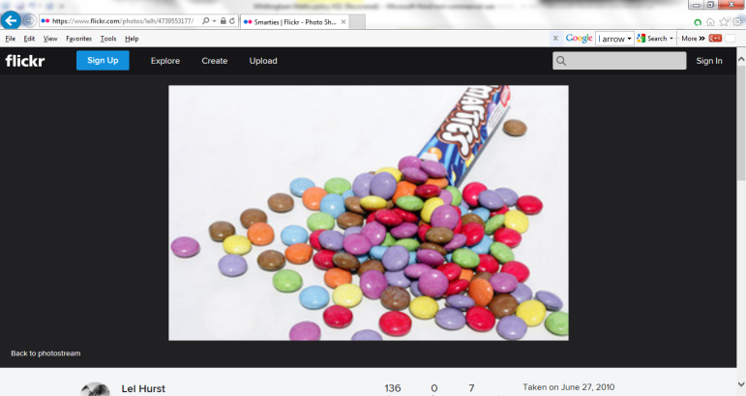

 12 ÷ 2 = 6



**Division – Year 2**

Counting in steps (‘clever’ counting)

To be secure with counting in 2s, 5s and 10s

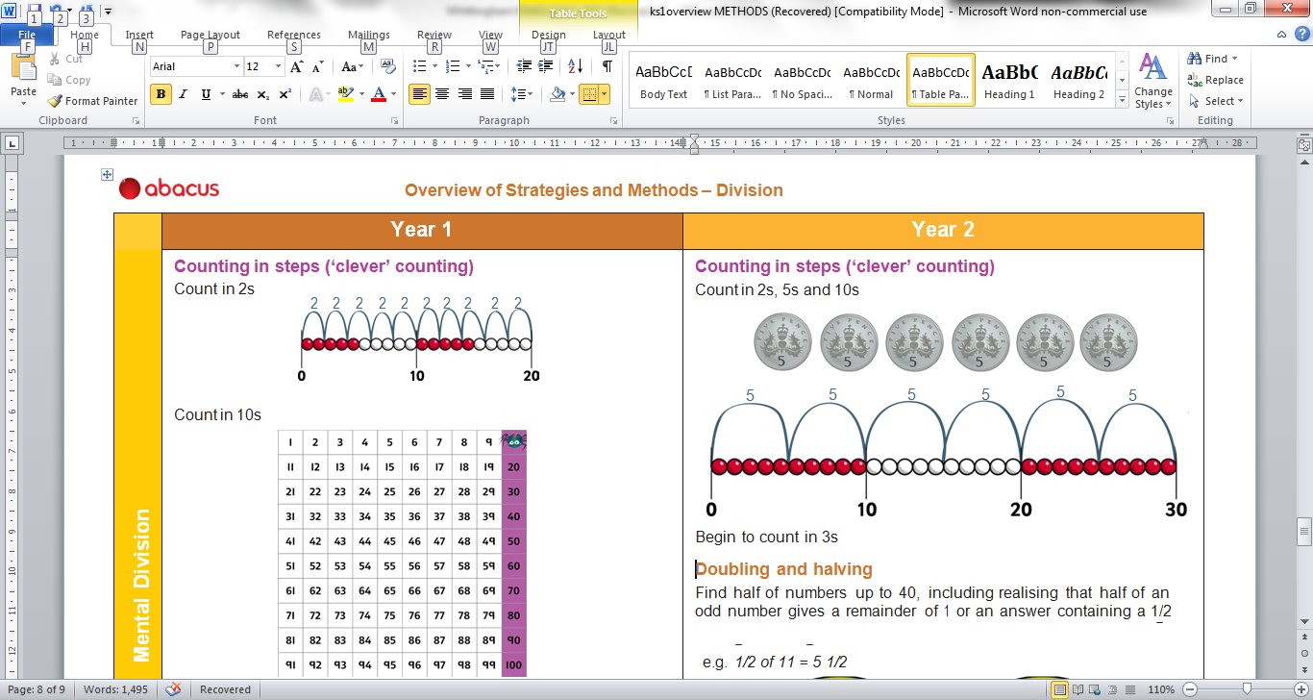

Begin to count in 3s

**Doubling and halving**

Find half of numbers up to 40, including realising that half of an odd number gives a remainder of 1 or an answer containing a 1/2

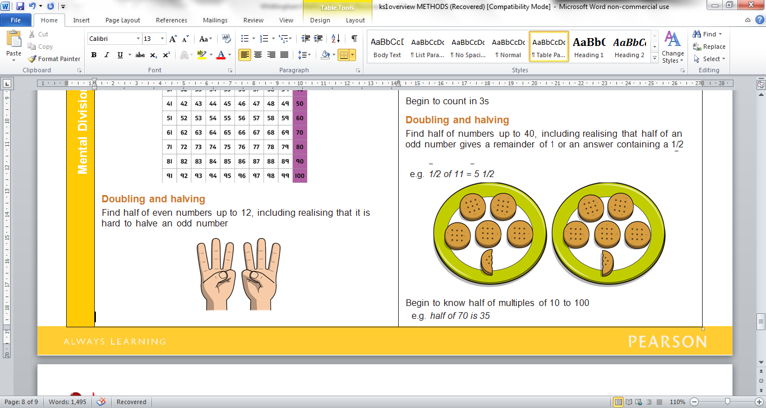e.g. 1/2 of 11 = 5 1/2

Begin to know half of multiples of 10 to 100

e.g. half of 70 is 35

**Grouping**

Relate division to multiplication by using arrays or towers of cubes to find answers to division

e.g. ‘How many towers of five cubes can I make from twenty cubes?’ as _ × 5 = 20 and also as 20 ÷ 5 = _

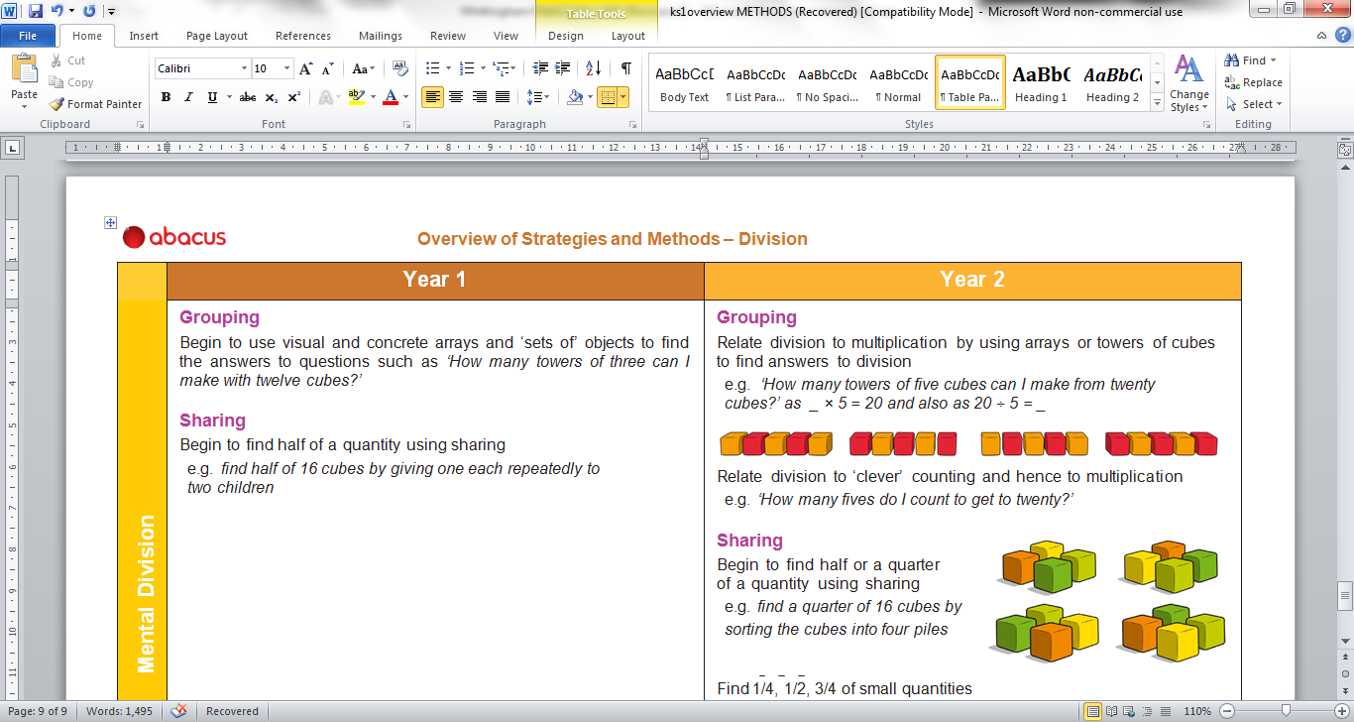

**Sharing**

Begin to find half or a quarter of a quantity using sharing

e.g. find a quarter of 16 cubes by sorting the cubes into four piles

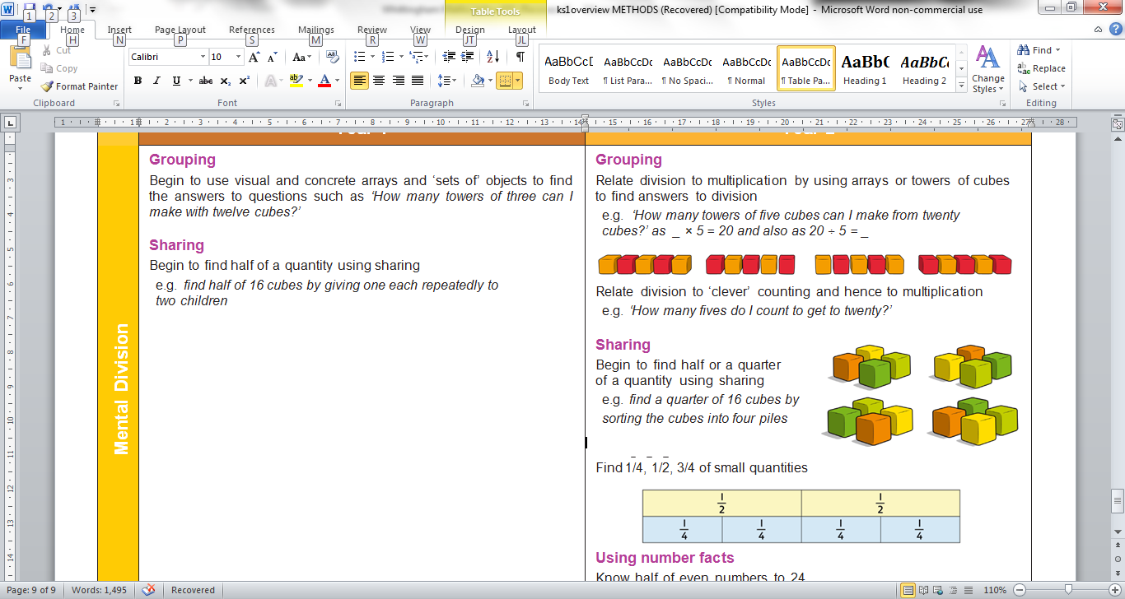

Find 1/4, 1/2, 3/4 of small quantities

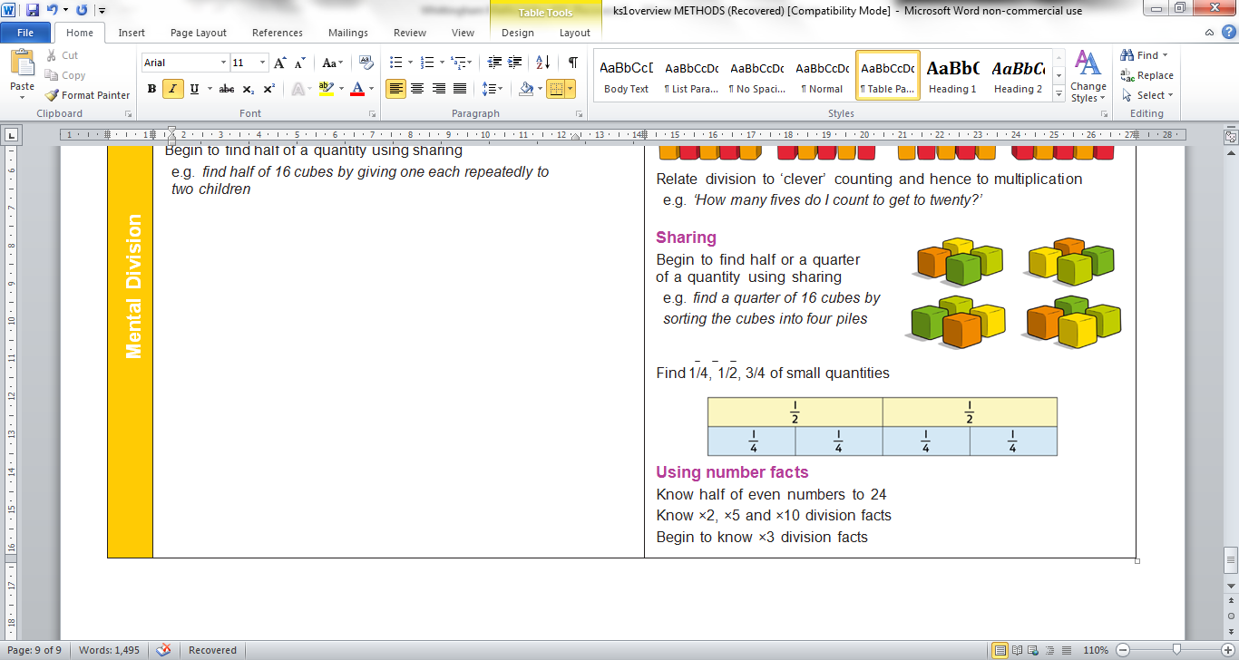

½ of 6 = 3

**Using number facts**

Know half of even numbers to 24

Know ×2, ×5 and ×10 division facts

Begin to know ×3 division facts

½ of 12 = 6

12 ÷ 2 = 6

(6 x 2 = 12)