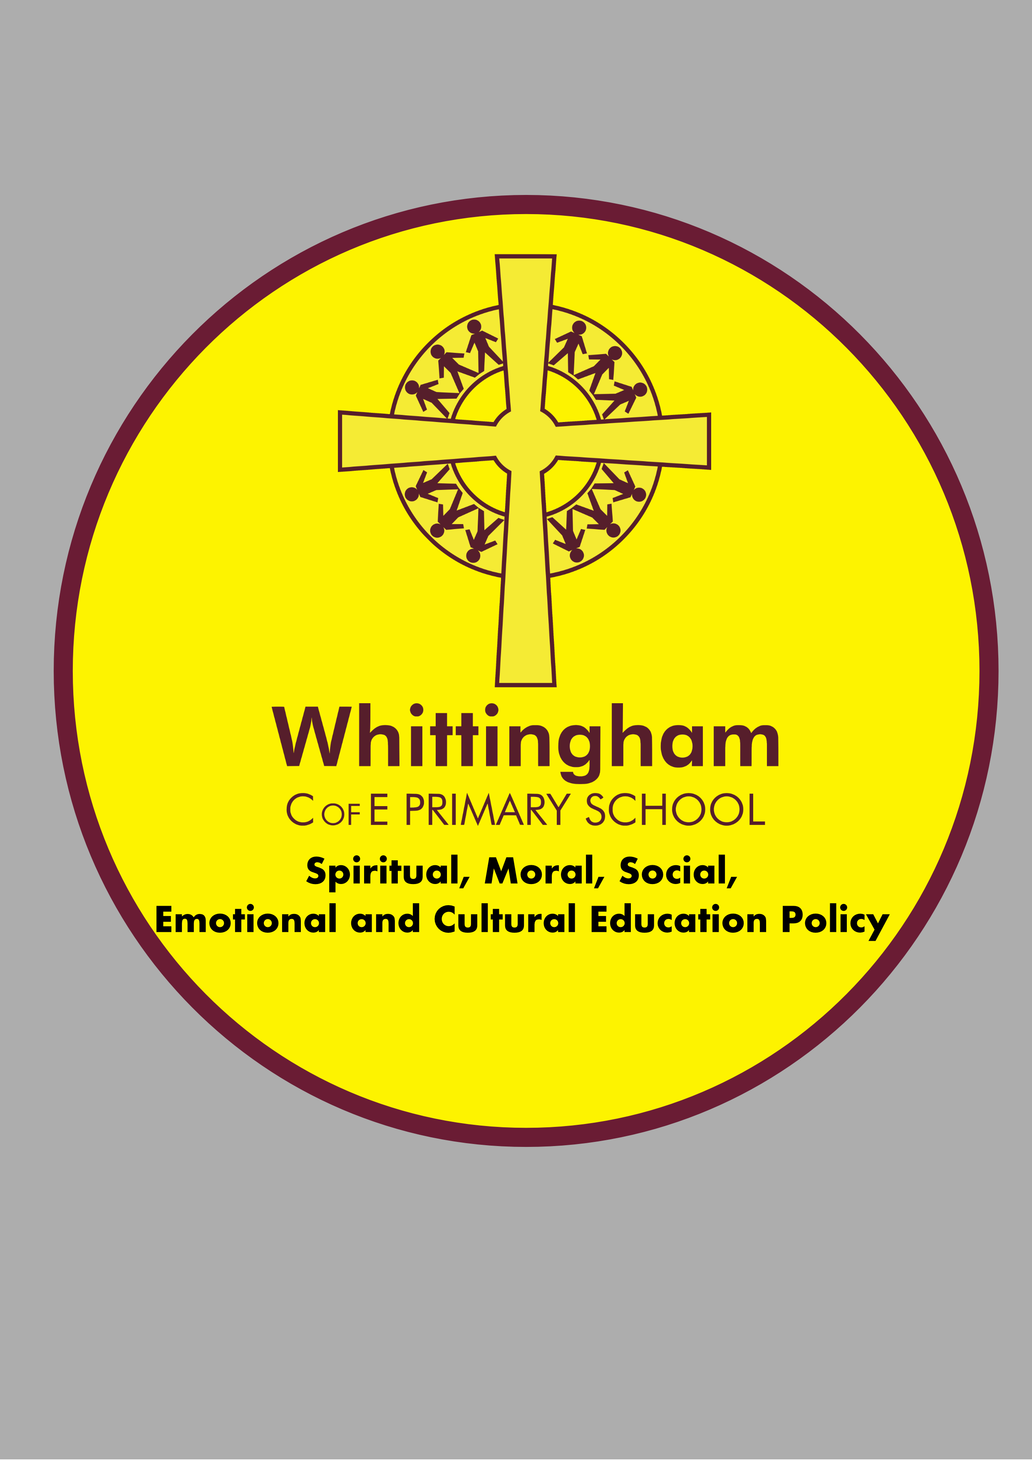

Date Last Reviewed: November 2014

Review Date: June 2019

To be Ratified : July 2019

Date Next Review Due: June 2020

Spiritual, Moral, Social, Emotional ( including mental health and well-being) and Cultural Development Policy

Our School Vision
The children know these as the 3R’s:
‘Hand in hand together we will become resilient, respectful and responsible citizens of our community and the wider world.’
Bible references linked to our vision.
Resilience - I am able to do all things through Him who strengthens me. Philippians 4:13

Respect - In your hearts, set apart Christ as Lord. Always be prepared to give an answer to everyone who asks you to give the reason for the hope that you have. But do this with gentleness and respect. Peter 3:15
Responsibility- Parable of the Talents Matthew 25: 14-30.
Our School Aims and Values
• To provide an open, secure and welcoming Christian environment for each pupil. This is expressed through daily worship which acknowledges the presence of God in our lives.
• To further develop and value the partnership that exists between school and the local churches, in particular, through sharing weekly worship and to encourage an appreciation of the Christian faith and a familiarity with the local Christian heritage.
• To care for each pupils’ safety, happiness and well-being.
• To value our pupils as individuals, developing their ability to take responsibility for themselves and their actions, promoting confidence and self-esteem, and respect for others and their environment.
• To equip our pupils with the knowledge to make informed choices about having a safe and healthy lifestyle.
• To offer opportunities for our pupils to become involved in the daily life of the school and to prepare them to play an active role as citizens locally and in the wider world.
• To provide a learning environment, which is challenging and stimulating yet ordered and disciplined.
• To provide a broad and balanced curriculum, setting realistic targets for each pupil.
• To extend and reinforce our pupils learning, making expectations clear, and raising achievement levels.
• To develop and maintain a mutually supportive partnership between home and school.

Rationale

Whittingham C of E Controlled Primary School aims to preserve and develop its religious character in accordance with the principles of the Church of England and in partnership with the Church at or local Parish and Diocesan level.
We serve the community by providing an education of the highest quality within the context of Christian belief and practice. It encourages an understanding of the meaning and significance of faith, and promotes Christian values (the values of respect, responsibility and resilience are at the heart of all that we do) through the experience it offers to all its pupils.

Our school is distinctively different to non-Church schools, as a result of the importance placed on the social, emotional ( including mental health and well-being), moral and spiritual life of all members of the school community – pupils, teachers, governors and non-teaching staff. The careful planning and delivery of the R.E. curriculum, and the quality of the worship offered in school make a significant contribution to the all round development of everyone in our school community. Our relationships within school allow children to see themselves as being unique and special individuals. Such an understanding encourages children to relate one with another in a responsible and respectful manner.

Introduction:
This policy is carried out within the context and spirit of the school’s Vision and Values. It supports and reinforces the aims of Whittingham C of E. Primary School, valuing all children equally and as individuals and promoting everyone to be the best they possibly can be. The staff, pupils, parents and governors work together to create a happy, challenging, stimulating and caring environment in which pupils can enjoy their time at school and celebrate their own special achievements.
The spiritual, moral, social and cultural development of the child is recognised as being of fundamental importance for the education of all children in our school. Of particular importance in promoting spiritual, moral, social, emotional and cultural development (SMSEC) is the example set by adults in the school, the quality of relationships and the standard of daily collective worship and how valued all are who visit or learn here.

At Whittingham C of E Primary School spiritual, moral, social, emotional and cultural development is taught through all areas of the curriculum and in particular RE and PSHE as well as individual and group ‘Thrive’ sessions which are led by the headteacher who is a qualified Thrive Practitioner. It supports all areas of learning and can contribute to the child’s motivation to learn. The family atmosphere within the school encourages children to support others and help less able or younger children. This atmosphere ensures children do not support bullying. School sanctions encourage reflection on how situations can be improved.

It is recognised that such development will be most successful when the values and attitudes promoted by the staff provide a model of behaviour for the children.

Rationale:
The Education Reform Act (1988) requires the curriculum of a maintained school to ‘promote the spiritual, moral, cultural, mental and physical development of pupils at the school’:
- Provision for SMSEC development will be inspected by both OFSTED and SIAMS inspectors.
- All maintained schools-including church schools – must provide a daily act of Collective Worship for all registered pupils.
- The connection between good results in the curriculum and high standards in SMSEC development is widely acknowledged and is evident in our School Advisor Note of Visits, Ofsted 2018 and last SIAMS inspection.
- The SMSEC aspects of education concentrate on the development of the pupil as an individual and as a personality, aiming to enrich and extend the human existence of each child in relation to the values, attitudes, beliefs and consequent behaviour acquired during school years.

Definitions:
What is Spiritual, Moral, Social, Emotional and Cultural Development?

Spiritual development
We strive to support the children in the development of their spiritual life so that through reflection, they will acquire insights and attribute meaning and purpose to personal existence.

Children’s spiritual development involves the growth of their sense of self, their unique potential, their understanding of their strengths and weaknesses, and their will to achieve. As their curiosity about themselves and their place in the world increases, they try to answer for themselves some of life’s fundamental questions. They develop the knowledge, skills, understanding, qualities and attitudes they need to foster their own inner lives and non-material well being.

We believe that this begins with a personal, experiential encounter with the living Christ and that once experienced needs to be fostered and developed through:

  - Personal and community prayer
  - A sense of God’s presence permeating the life of the school
  - A curriculum that creates a sense of awe and wonder
  - The ability to listen and be still with quiet times of reflection

Objectives for Spiritual Development:
  - To develop the skill of being physically still, yet alert.

  - To develop the skill of being mentally still, concentrating on the present moment
  - To develop the ability to use all ones senses.
  - To promote an awareness of and enjoyment in using ones imaginative potential and to develop curiosity and a questioning approach – discussing issues and themes
  - To encourage quiet reflection during a lesson or time together, reflecting on good things and what can be improved
  - To reflect on own behaviour and situations which may be troubling them
  - To consider the mystery of God and the wonder of his world with particular respect to our school and outside natural environment
  - To promote self image and develop reslience, respect for themselves and an understanding of taking responsibility for their actions and to find an inner confidence and peace
  - To have the opportunity to develop their own personal beliefs and be confident to share them
  - To explore the opportunity to pray
  - To know own strengths and acknowledge that if we follow our 3 R’s we can be the best we can be

Moral development

At the heart of the Church’s and the school’s moral teaching lies the understanding that we love because we are first loved by God. We are called to reflect God’s love for us in our relationships with others and, since His love is unconditional and freely given, we have been given the freedom to respond to His love or reflect Him. How we understand and use this gift of freedom is crucial to our moral development.

Pupils’ moral development involves pupils acquiring an understanding of the difference between right and wrong and/or moral conflict, a concern for others and the will to do what is right. They are able and willing to reflect on the consequences of their actions and to learn how to forgive themselves and others. They develop the knowledge, skills, understanding, qualities and attitudes they need in order to make responsible moral decisions and to act on them.

Aims for Moral Development:

  - To understand that love is at the heart of the Christian understanding of morality
  - To be able to take moral decisions for themselves
  - To assume moral responsibility through belief and conviction.
  - To be able to distinguish between right and wrong. Objectives for Moral Development:
  - To respect honesty and fairness and to tell the truth
  - To respect the rights and property of others and themselves
  - To respect loyalty
  - To help those less fortunate or able than ourselves and be aware of other’s needs
  - To treat others as they would wish to be treated themselves
  - To respect and value other people and their feelings and act considerately towards others
  - To take responsibility for one’s own actions
  - To exercise self-discipline and control own behaviour and attitudes
  - To consider consequences of actions and effect on others
  - To develop positive attitudes and grow in understanding of what is right and what is wrong
  - To respect the environment and the world
  - To conform to rules and regulations for the good of all and become law abiding citizens
  - To consider moral dilemmas
  - To understand that consequences are followed through and there is a consistency of rules and expectations of behaviour and to take responsibility for own actions

Social development
We are proud of the excellent reputation we have in the local community and take this very seriously. Our strong relationships enable us to support pupils and their families in the formation of good social attitudes. Our school community will nurture our pupils to:

Aims for Social Development:
  - To relate positively to others and learn about the obligations, constraints and satisfaction that go with membership of a group or part of our community or wider world
  - To become aware of their own identity as individuals and to take account of the feelings of others
  - To participate fully and take responsibility in the classroom and in the school
  - To use appropriate behaviour, according to situations
  - To participate in a supportive way in group and school activities so as to develop co-operative skills that will help all to live with each other
  - To learn what it means to be a responsible citizen.

Objectives for Social Development:
- To share such emotions as love, joy, hope, anguish, fear, awe and wonder
- To show sensitivity to the needs and feelings of others
- To consider other people’s point of view
- To develop feelings of trust in others and to be able to be trusted themselves by ensuring a sense of responsibility where promises are fulfilled and commitments are followed through
- To work collaboratively as part of a group and develop the resilience to work to an end goal
- To interact positively with others through contacts outside school e.g. sporting activities, visits, church services, music festivals etc.
- To develop an understanding of citizenship and to experience being part of our whole school community in preparation for being future citizens of the wider world
- To show care and consideration for others by sharing and taking turns
- To respect other people and their differences
- To understand that saying sorry also needs to be accompanied by a change in behaviour and in turn that we should forgive, forget and move forwards
- To realise there are things each person can do well.
- To show politeness, cheerfulness, friendliness and actively want to do the right thing
- To develop skills to deal with conflict
- To develop a sense of resilience and to not give up
- To relate appropriately to people in different situations

Emotional development (including mental health and well-being) and The Thrive Approach - this is our first year of having a qualified Thrive Practitioner and it is only since Summer 2 this year that the Headteacher has been released from a full time teaching commitment to deliver these sessions for targeted children across the school so the aims are in draft at this point in time. This policy will be looked at on an annual basis initially and then on our 4 yearly cycle of policy review.
Initial Aims and Objectives for Emotional Development
- To develop healthy, happy, confident children who are ready and open to learning
- To work with children in ways that support optimal social and emotional development
- To enable children to develop resilience so that they are able to continue to strive to improve and to be strong enough to deal with the every day pressures of life
- To enable children to be extremely well prepared for their next stages in education as they move towards Secondary School.

Cultural development
Cultural development is the increasing understanding and command of those beliefs, values and customs, knowledge and skills which taken together form the basis of identity and cohesion in groups and societies. Cultures grow and change; features of the past influence the present and will shape its future form.

Aims for Cultural Development:
  - To be introduced to the values and customs held within our Anglican, Christian tradition
  - To develop a sense of belonging to pupils’ national culture and being proud of their cultural background
  - To respond to cultural events
  - To share different cultural experiences
  - To respect the values, customs and cultural heritage of people who belong to other faiths or ethnic cultures

Objectives for Cultural Development:
    - To be taught through a curriculum, which will enrich, deepen and broaden their experience of all cultural excellence whether aesthetic, mathematical, literal, technological, musical or scientific.
    - To develop a love of learning.
    - To provide children with good role models, and similarly, older children are expected to demonstrate good behaviour and support to younger children. All children are valued equally whatever their stage of development, and are entitled to maximum success. The ethos encourages safe, sensible behaviour incorporating good manners, consideration, courtesy and respect for others whilst encouraging imagination, inspiration and reflection.

Examples of Wider Contexts for Promoting Spiritual, Moral, Social, Emotional and Cultural Development in our School.

It is possible to identify different contexts where suitable opportunities for promoting SMSEC arise in many areas of school life. These may include:
- Religious Education
- Collective Worship
- National Curriculum Subjects
- Non Statutory subjects and aspects of PSHE / RSE
- Teaching and learning strategies
- The excellent quality of relationships between staff and pupils and between pupils
- Teachers and support staff as role models
- The ethos and values of the school
- Aspects such as visits, visitors and clubs.

