 | Year 3 | Year 4
Mental Addition | Using place value  Count in 100s  e.g. Know 475 + 200 as 475, 575, 675  350 375 425 450 475 525 550 575 625 650 675 725  400 500 600 700  Add multiples of 10, 100 and £1 e.g. 746 + 200  e.g. 746 + 40  e.g. £6·34 + £5 as £6 + £5 and 34p  Partitioning  e.g. £8·50 + £3·70 as £8 + £3 and 50p + 70p and combine the totals: £11 + £1·20  e.g. 347 + 36 as 300 and 40 + 30 and 7 + 6 and combine the  totals: 370 + 13 = 383  e.g. 68 + 74 as 60 + 70 and 8 + 4 and combine  the totals: 130 + 12 = 142  60 + 70 = 1 30  6 8 + 7 4 1 4 2  8 + 4 = 1 2 | Using place value  Count in 1000s  e.g. Know 3475 + 2000 as 3475, 4475, 5475  Partitioning  e.g. 746 + 40  e.g. 746 + 203 as 700 + 200 and 40 and 6 + 3  e.g. 134 + 707 as 100 + 700 and 30 and 4 + 7  Counting on  Add 2-digit numbers to 2-, 3- and 4-digit numbers by adding the multiple of 10 then the 1s  e.g. 167 + 55 as 167 + 50 (217) + 5 = 222  Add near multiples of 10, 100 and 1000  e.g. 467 + 199  e.g. 3462 + 2999  +  -1  400 500 600 700  Count on to add 3-digit numbers and money  e.g. 463 + 124 as 463 + 100 (563) + 20 (583) + 4 = 587  e.g. £4·67 + £5·30 as £9·67 + 30p

 | Year 3 | Year 4
Mental Addition | Counting on  Add two 2-digit numbers by adding the multiple of 10, then the 1s e.g. 67 + 55 as 67 + 50 (117) + 5 = 122  Add near multiples of 10 and 100  e.g. 67 + 39  e.g. 364 + 199  Add pairs of ‘friendly’ 3-digit numbers e.g. 548 + 120  Count on from 3-digit numbers  e.g. 247 + 34 as 247 + 30 (277) + 4 = 281  Using number facts  Know pairs which total each number to 20  e.g. 7 + 8 = 15  e.g. 12 + 6 = 18  Number bonds to 100  e.g. 35 + 65  e.g. 46 + 54  e.g. 73 + 27  Add to the next 10 and the next 100 e.g. 176 + 4 = 180  e.g. 435 + 65 = 500 | Using number facts  Number bonds to 100 and to the next multiple of 100 e.g. 288 + 12 = 300  e.g. 1353 + 47 = 1400  e.g. 463 + 37 = 500  400 500  Number bonds to £1 and to the next whole pound  e.g. 63p + 37p = £1  e.g. £3·45 + 55p = £4  Add to the next whole number e.g. 4·6 + 0·4  e.g. 7·2 + 0·8

 | Year 3 | Year 4
Written Addition | Build on partitioning to develop expanded column addition with two 3-digit numbers  e.g. 466 + 358  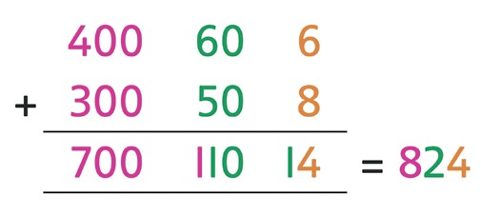  Use expanded column addition where digits in a column add to more than the column value  e.g. 466 + 358  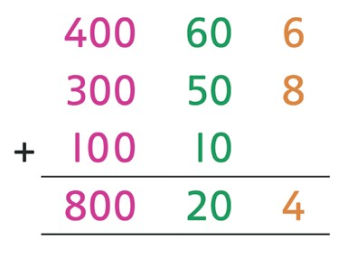  Compact column addition with two or more 3-digit numbers or towers of 2-digit numbers  e.g. 347 + 286 + 495  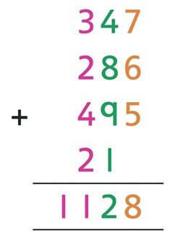  Compact column addition with 3- and 4-digit numbers Recognise like fractions that add to 1  e.g. 1/4 + 3/4  e.g. 3/5 + 2/5 | Build on expanded column addition to develop compact column addition with larger numbers  e.g. 1466 + 4868  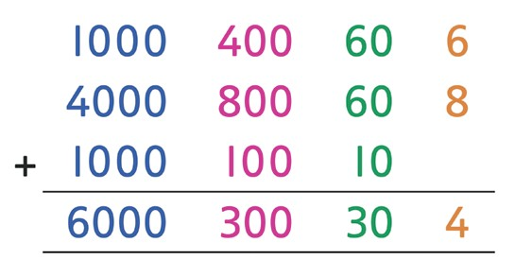  Compact column addition with larger numbers e.g. 5347 + 2286 + 1495  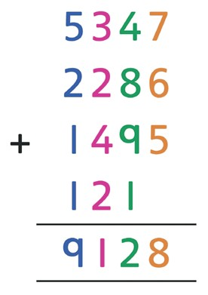  Use expanded and compact column addition to add amounts of money  Add like fractions  e.g. 3/8 + 1/8 + 1/8

10s | 1s | 0·1s | 0·01s
 | 0 | 5 | 1

0·1 | 0·2 | 0·3 | 0·4 | 0·5 | 0·6 | 0·7 | 0·8 | 0·9 | 1
1·1 | 1·2 | 1·3 | 1·4 | 1·5 | 1·6 | 1·7 | 1·8 | 1·9 | 2
2·1 | 2·2 | 2·3 | 2·4 | 2·5 | 2·6 | 2·7 | 2·8 | 2·9 | 3
3·1 | 3·2 | 3·3 | 3·4 | 3·5 | 3·6 | 3·7 | 3·8 | 3·9 | 4
4·1 | 4·2 | 4·3 | 4·4 | 4·5 | 4·6 | 4·7 | 4·8 | 4·9 | 5
5·1 | 5·2 | 5·3 | 5·4 | 5·5 | 5·6 | 5·7 | 5·8 | 5·9 | 6
6·1 | 6·2 | 6·3 | 6·4 | 6·5 | 6·6 | 6·7 | 6·8 | 6·9 | 7
7·1 | 7·2 | 7·3 | 7·4 | 7·5 | 7·6 | 7·7 | 7·8 | 7·9 | 8
8·1 | 8·2 | 8·3 | 8·4 | 8·5 | 8·6 | 8·7 | 8·8 | 8·9 | 9
9·1 | 9·2 | 9·3 | 9·4 | 9·5 | 9·6 | 9·7 | 9·8 | 9·9 | 10

 | Year 5 | Year 6
Mental Addition | Using place value  Count in 0·1s, 0·01s  e.g. Know what 0·1 more than 0·51 is  Partitioning  e.g. 2·4 + 5·8 as 2 + 5 and 0·4 + 0·8 and combine the totals: 7 + 1·2 = 8·2 | Using place value  Count in 0·1s, 0·01s, 0·001s  e.g. Know what 0·001 more than 6·725 is  Partitioning  e.g. 9·54 + 3·23 as 9 + 3, 0·5 + 0·2 and 0·04 + 0·03, to give 12·77  Counting on  Add two decimal numbers by adding the 1s, then the 0·1s/0·01s/0·001s  e.g. 6·314 + 3·006 as 6·314 + 3 (9·314) + 0·006 = 9·32  Add near multiples of 1 e.g. 6·345 + 0·999  e.g. 5·673 + 0·9  Count on from large numbers e.g. 16 375 + 12 003 as 28 375 + 3

 | Year 5 | Year 6
Mental Addition | Counting on  Add two decimal numbers by adding the 1s, then the 0·1s/0·01s e.g. 5·72 + 3·05 as 5·72 + 3 (8·72) + 0·05 = 8·77  Add near multiples of 1 e.g. 6·34 + 0·99  e.g. 5·63 + 0·9  Count on from large numbers e.g. 6834 + 3005 as 9834 + 5  Using number facts  Number bonds to 1 and to the next whole number  e.g. 5·7 + 0·3  e.g. 0·4 + 0·6  .  .  0 1  Add to the next 10 from a decimal number e.g. 7·8 + 2·2 = 10 | Using number facts  Number bonds to 1 and to the next multiple of 1 e.g. 0·63 + 0·37  e.g. 2·355 + 0·645 .  0 . 1  Add to the next 10 e.g. 4·62 + 5·38

 | Year 5 | Year 6
Written Addition | Expanded column addition for money leading to compact column addition for adding several amounts of money  e.g. £14·64 + £28·78 + £12·26  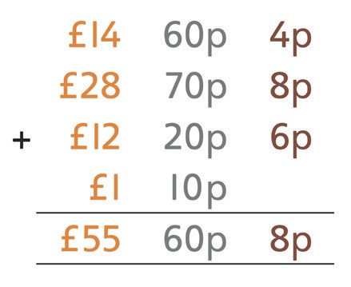  Compact column addition to add pairs of 5-digit numbers Continue to use column addition to add towers of several larger  numbers  Use compact addition to add decimal numbers with up to 2 decimal places  e.g. 15·68 + 27·86  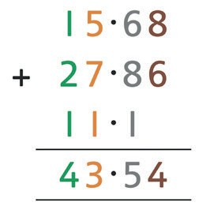  Add related fractions  e.g. 3/4 + 1/8 = 7/8 | Compact column addition for adding several large numbers and decimal numbers with up to 2 decimal places  Compact column addition with money e.g. £14·64 + £28·78 + £12·26  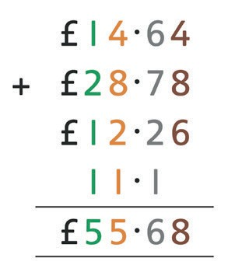  Add unlike fractions, including mixed numbers  e.g. 1/4 + 2/3 = 11/12  e.g. 2 1/4 + 1 1/3 = 3 7/12












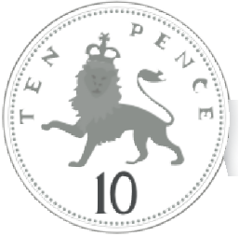





























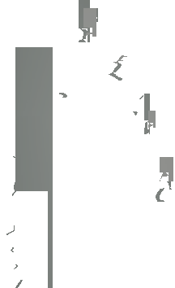






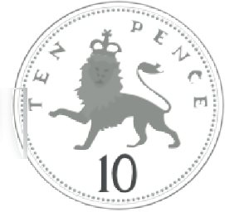









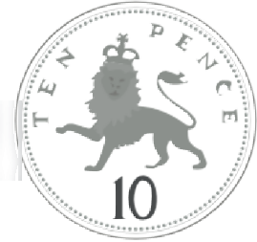












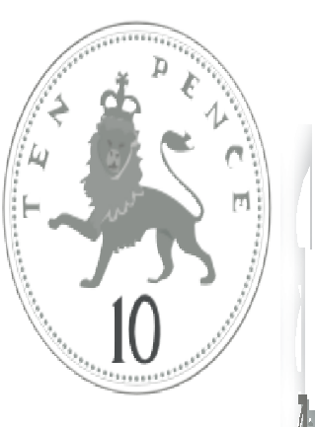













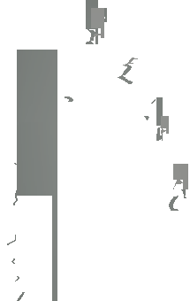








































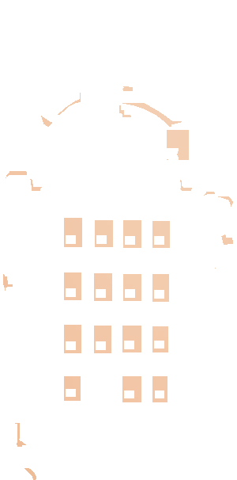



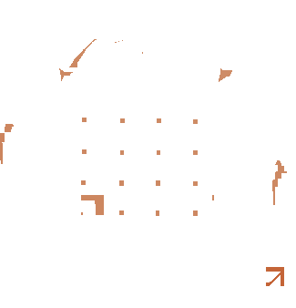





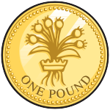












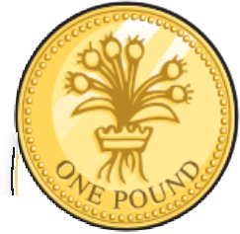












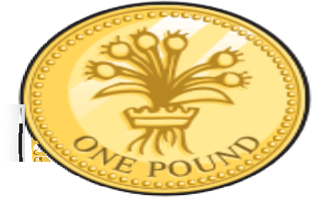









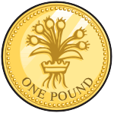







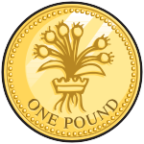




























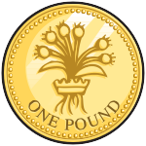
 Overview of Strategies and Methods – Subtraction
4 | 7 | 4

7 | 4 | 9

5 | 4 | 7

Mental Subtraction | Year 3 | Year 4
Mental Subtraction | Taking away  Use place value to subtract e.g. 348 – 300  e.g. 348 – 40 3 4 8  e.g. 348 – 8  Take away multiples of 10, 100 and £1 e.g. 476 – 40 = 436  e.g. 476 – 300 = 176  e.g. £4·76 – £2 = £2·76  Partitioning  e.g. 68 – 42 as 60 – 40 and 8 – 2  e.g. £6·84 – £2·40 as £6 – £2 and 80p – 40p | Taking away  Use place value to subtract  e.g. 4748 – 4000 8  Take away multiples of 10, 100, 1000, £1, 10p or 0·1 e.g. 8392 – 50  e.g. 6723 – 3000  e.g. £3·74 – 30p e.g. 5·6 – 0·2 Partitioning  e.g. £5·87 – £3·04 as £5 – £3 and 7p – 4p  e.g. 7493 – 2020 as 7000 – 2000 and 90 – 20
Mental Subtraction |  | 7 000 – 2 000
Mental Subtraction |  | 3 – 20 20 3
Mental Subtraction |  | 90 – 20
Mental Subtraction |  | Count back
Mental Subtraction |  | e.g. 6482 – 1301 as 6482 – 1000 (5482) – 300 (5182) – 1 = 5181
Mental Subtraction |  | Subtract near multiples of 10, 100, 1000 or £1
Mental Subtraction |  | e.g. 3522 – 1999
Mental Subtraction |  | e.g. £34·86 – £19·99

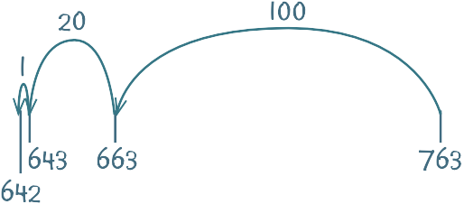
Mental Subtraction | Year 3 | Year 4
Mental Subtraction | Count back in 100s, 10s then 1s  e.g. 763 – 121 as 763 – 100 (663) – 20 (643) – 1 = 642  Subtract near multiples of 10 and 100 e.g. 648 – 199  e.g. 86 – 39  Counting up  Find a difference between two numbers by counting up from the smaller to the larger  e.g. 121 – 87  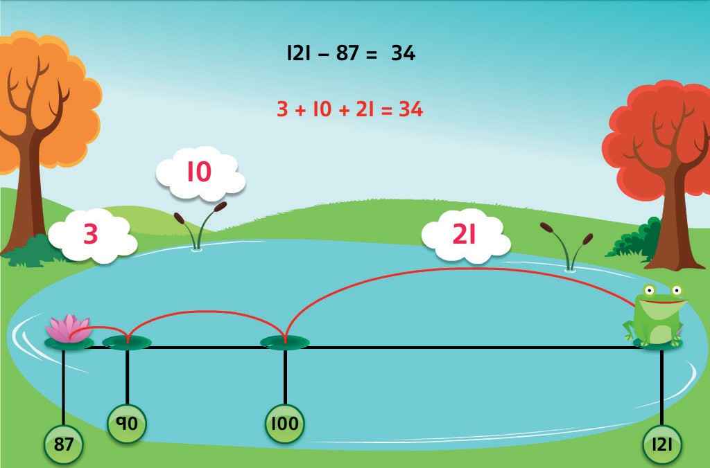 | Counting up  Find a difference between two numbers by counting up from the smaller to the larger  e.g. 506 – 387  e.g. 4000 − 2693  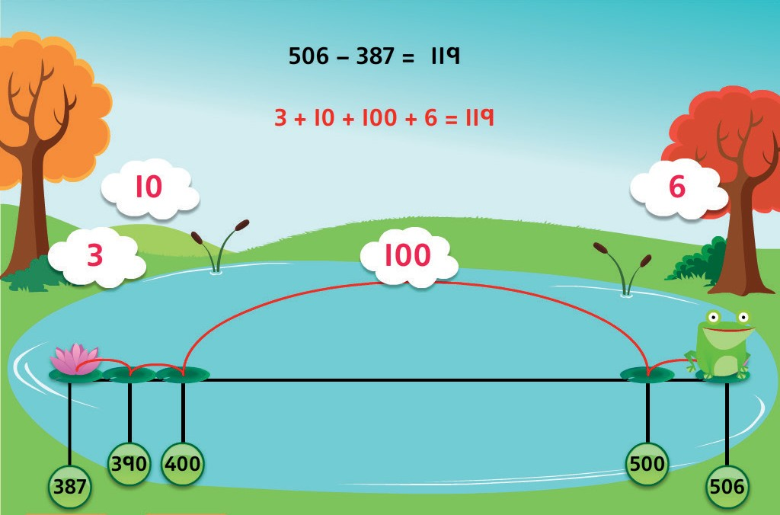

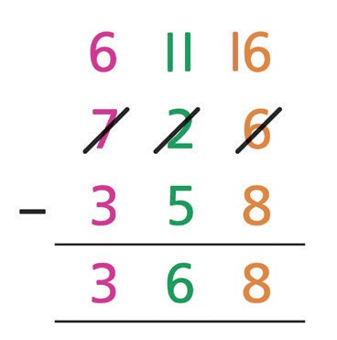
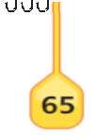
Mental Subtraction | Year 3 | Year 4
Mental Subtraction | Using number facts  Know pairs which total each number to 20 e.g. 20 – 14 = 6  Number bonds to 100 e.g. 100 – 48 = 52  e.g. 100 – 35 = 65  Subtract using number facts to bridge back through a 10 e.g. 42 – 5 = 42 – 2 (40) – 3 = 37 | Using number facts  Number bonds to 10 and 100 and derived facts e.g. 100 – 76 = 24  e.g. 1 – 0·6 = 0·4  0 1  Number bonds to £1 and £10 e.g. £1·00 – 86p = 14p  e.g. £10·00 – £3·40 = £6·60
Written Subtraction | Develop counting up subtraction e.g. 200 – 167  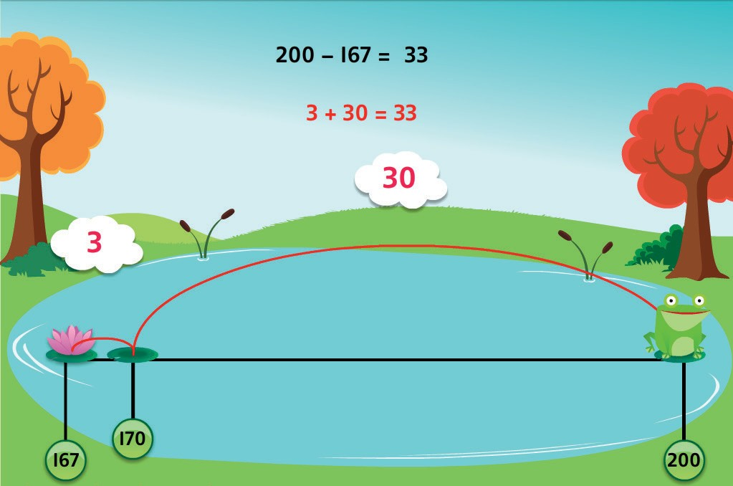 | Expanded column subtraction with 3- and 4-digit numbers e.g. 726 – 358  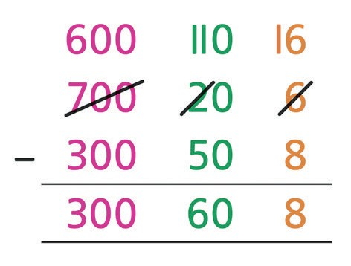  Begin to develop compact column subtraction e.g. 726 – 358

Written Subtraction | Year 3 | Year 4
Written Subtraction | Use counting up subtraction to find change from £1, £5 and £10 e.g. £10·00 – £6·84  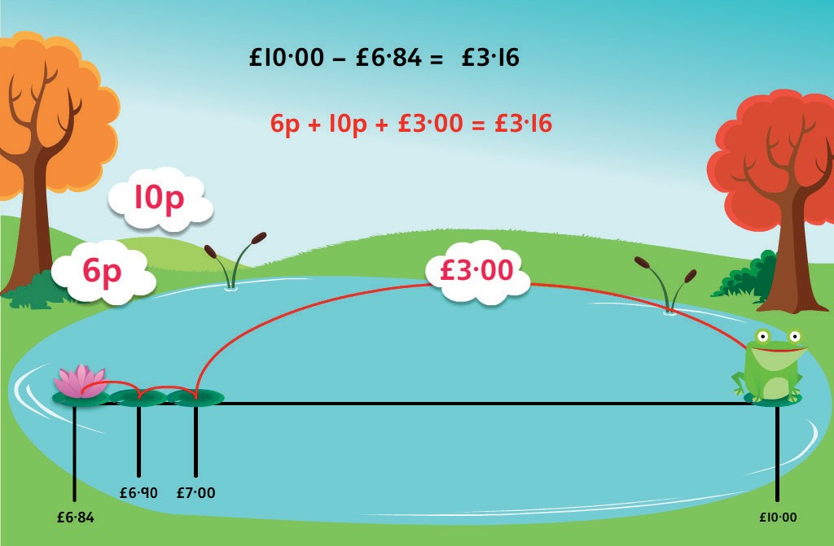  Recognise complements of any fraction to 1  e.g. 1 – 1/4 = 3/4  e.g. 1 – 3/5 = 2/5 | Use counting up subtraction to find change from £10, £20, £50 and  £100  e.g. Buy a computer game for £34·75 using £50  Subtract like fractions  e.g. 3/8 – 1/8 = 2/8

Mental Subtraction | Year 5 | Year 6
Mental Subtraction | Taking away  Use place value to subtract decimals e.g. 4·58 – 0·08  e.g. 6·26 – 0·2  Take away multiples of powers of 10 e.g. 15 672 – 300  e.g. 4·82 – 2 e.g. 2·71 – 0·5  e.g. 4·68 – 0·02  Partitioning or counting back  e.g. 3964 – 1051  e.g. 5·72 – 2·01  Subtract near multiples of 1, 10, 100, 1000, 10 000 or £1  e.g. 86 456 – 9999  e.g. 3·58 – 1·99  Counting up  Find a difference between two numbers by counting up from the smaller to the larger  e.g. £12·05 − £9·59  e.g. 2009 – 869  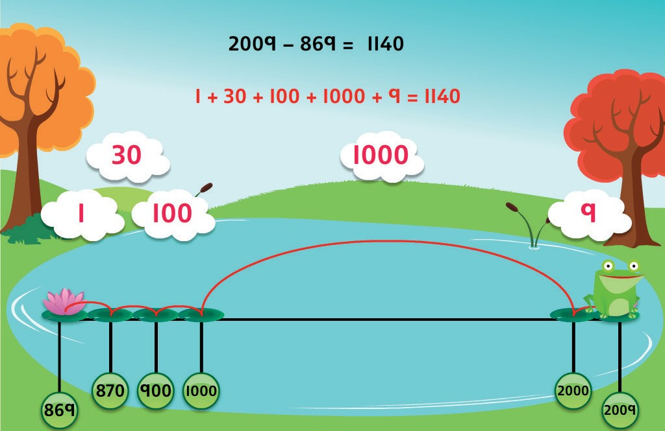 | Taking away  Use place value to subtract decimals e.g. 7·782 – 0·08  e.g. 16·263 – 0·2  Take away multiples of powers of 10 e.g. 132 956 – 400  e.g. 686 109 – 40 000  e.g. 7·823 – 0·5  Partitioning or counting back e.g. 3964 – 1051  e.g. 5·72 – 2·01  Subtract near multiples of powers of 10 e.g. 360 078 – 99 998  e.g. 12·831 – 0·99

Mental Subtraction | Year 5 | Year 6
Mental Subtraction | Find change using shopkeepers’ addition  e.g. Buy a toy for £6·89 using £10·00  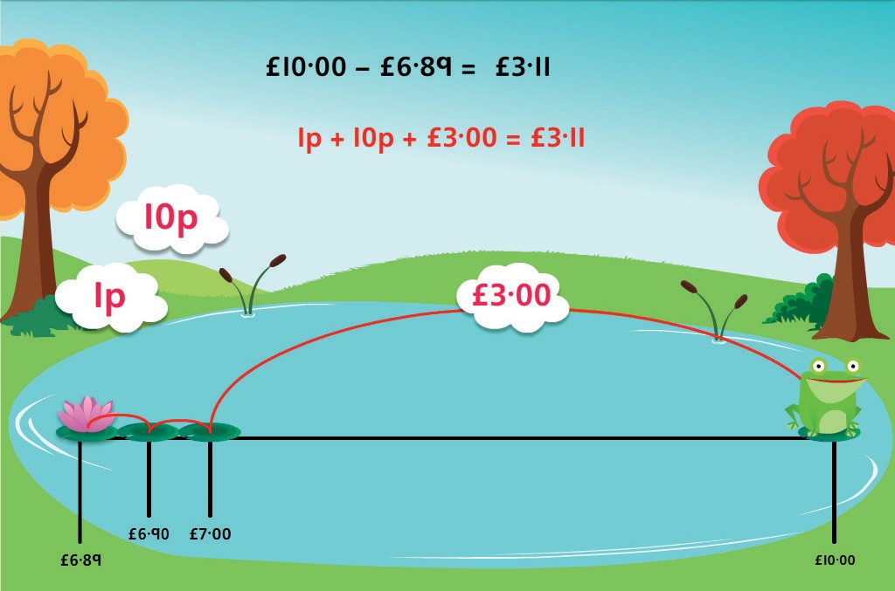  Find a difference between two amounts of money by counting up  Using number facts  Derived facts from number bonds to 10 and 100 e.g. 2 – 0·45 using 45 + 55 = 100  e.g. 3 – 0·86 using 86 + 14 = 100  Number bonds to £1, £10 and £100 e.g. £4·00 – £3·86  e.g. £100 – £66 using 66 + 34 = 100 | Counting up  Find a difference between two decimal numbers by counting up from the smaller to the larger  e.g. 1·2 – 0·87  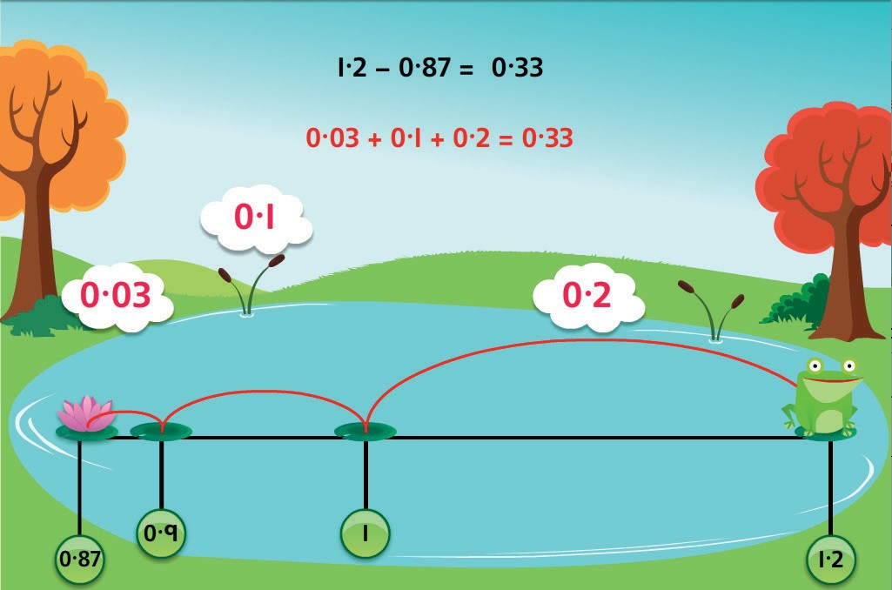  Using number facts  Derived facts from number bonds to 10 and 100 e.g. 0·1 – 0·075 using 75 + 25 = 100  e.g. 5 – 0·65 using 65 + 35 = 100  Number bonds to £1, £10 and £100 e.g. £7·00 – £4·37  e.g. £100 – £66·20 using 20p + 80p = £1 and £67 + £33 = £100

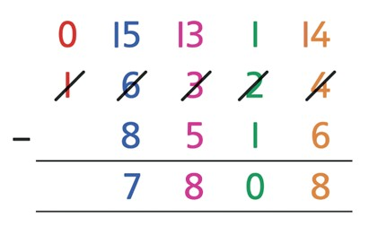
Written Subtraction | Year 5 | Year 6
Written Subtraction | Compact column subtraction for numbers with up to 5 digits e.g. 16 324 – 8516  Continue to use counting up subtraction for subtractions involving money, including finding change  e.g. £50 − £28·76  4p 20p £1 £20  £29 £30  Use counting up subtraction to subtract decimal numbers  e.g. 4·2 – 1·74 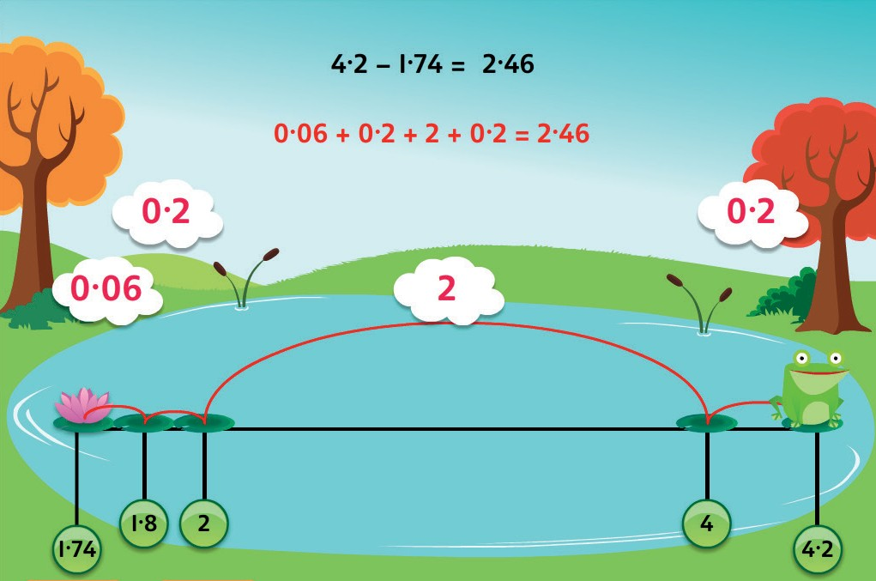  Subtract related fractions  e.g. 3/4 – 1/8 = 5/8  NB Counting up subtraction provides a default method for ALL children | Compact column subtraction for large numbers e.g. 34 685 – 16 458  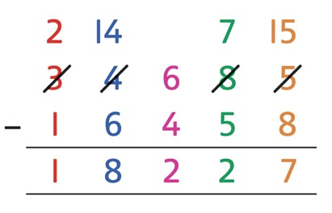  Use counting up for subtractions where the larger number is a multiple or near multiple of 1000 or 10 000  Use counting up subtraction when dealing with money e.g. £100 – £78·56  e.g. £45·23 – £27·57  £10  3p 40p £2 £5 23p  £28 £30 £40 £45  Use counting up subtraction to subtract decimal numbers e.g. 13·1 – 2·37 10  3 13  Subtract unlike fractions, including mixed numbers  e.g. 3/4 – 1/3 = 5/12  e.g. 2 3/4 – 1 1/3 = 1 5/12  NB Counting up subtraction provides a default method for ALL children

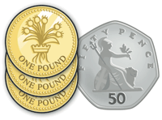
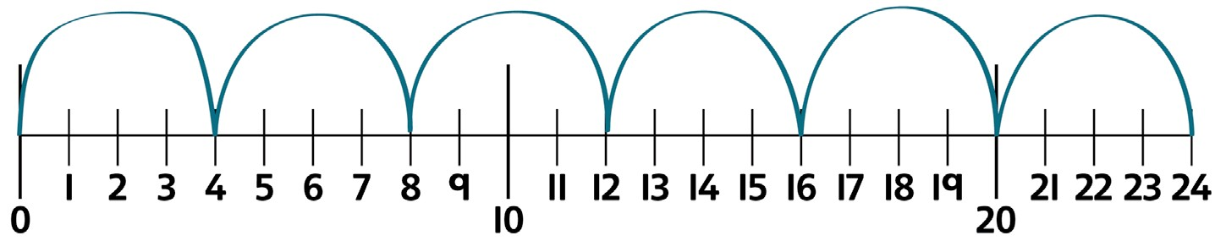
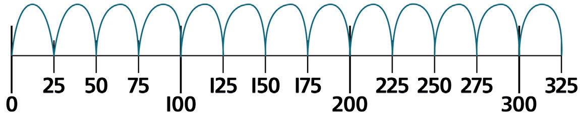
1 | 2 | 3 | 4 | 5 | 6 | 7 | 8 | 9 | 10
11 | 12 | 13 | 14 | 15 | 16 | 17 | 18 | 19 | 20
21 | 22 | 23 | 24 | 25 | 26 | 27 | 28 | 29 | 30
31 | 32 | 33 | 34 | 35 | 36 | 37 | 38 | 39 | 40
41 | 42 | 43 | 44 | 45 | 46 | 47 | 48 | 49 | 50
51 | 52 | 53 | 54 | 55 | 56 | 57 | 58 | 59 | 60
61 | 62 | 63 | 64 | 65 | 66 | 67 | 68 | 69 | 70
71 | 72 | 73 | 74 | 75 | 76 | 77 | 78 | 79 | 80
81 | 82 | 83 | 84 | 85 | 86 | 87 | 88 | 89 | 90
91 | 92 | 93 | 94 | 95 | 96 | 97 | 98 | 99 | 100

 | Year 3 |  |  | Year 4
Mental Multiplication | Counting in steps (‘clever’ counting)  Count in 2s, 3s, 4s, 5s, 8s and 10s  4 4 4 4 | 4 | 4 | Counting in steps (sequences)  Count in 2s, 3s, 4s, 5s, 6s, 7s, 8s, 9s, 10s, 11s, 12s, 25s, 50s, 100s and 1000s  25 25 25 25 25 25 25 25 25 25 25 25 25  Doubling and halving  Find doubles to double 100 and beyond using partitioning  e.g. double 126  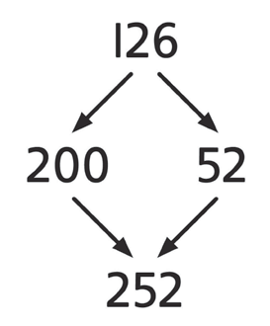  Begin to double amounts of money  e.g. £3·50 doubled is £7  Use doubling as a strategy in multiplying by 2, 4 and 8  e.g. 34 × 4 is double 34 (68) doubled again = 136

 | Year 3 | Year 4
Mental Multiplication | Doubling and halving  Find doubles of numbers to 50 using partitioning  e.g. double 48  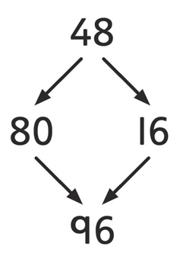  Use doubling as a strategy in multiplying by 2  e.g. 18 × 2 is double 18 = 36  Grouping  Recognise that multiplication is commutative e.g. 4 × 8 = 8 × 4  Multiply multiples of 10 by 1-digit numbers e.g. 30 × 8 = 240  Multiply ‘friendly’ 2-digit numbers by 1-digit numbers  e.g. 13 × 4  Using number facts  Know doubles to double 20  e.g. double 15 is 30  Know doubles of multiples of 5 to 100  e.g. double 85 is 170  Know ×2, ×3, ×4, ×5, ×8, ×10 tables facts | Grouping  Use partitioning to multiply 2-digit numbers by 1-digit numbers  e.g. 24 × 5  ×5 ×5  Multiply multiples of 100 and 1000 by 1-digit numbers using tables facts  e.g. 400 × 8 = 3200  Multiply near multiples by rounding e.g. 24 × 19 as (24 × 20) – 24 = 456  Using number facts  Know times-tables up to 12 × 12
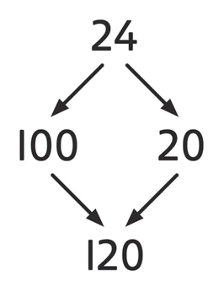
× | 1 | 2 | 3 | 4 | 5 | 6 | 7 | 8 | 9 | 10 | 11 | 12
1 | 1 | 2 | 3 | 4 | 5 | 6 | 7 | 8 | 9 | 10 | 11 | 12
2 | 2 | 4 | 6 | 8 | 10 | 12 | 14 | 16 | 18 | 20 | 11 | 24
3 | 3 | 6 | 9 | 12 | 15 | 18 | 21 | 24 | 27 | 30 | 22 | 36
4 | 4 | 8 | 12 | 16 | 20 | 24 | 28 | 32 | 36 | 40 | 33 | 48
5 | 5 | 10 | 15 | 20 | 25 | 30 | 35 | 40 | 45 | 50 | 44 | 60
6 | 6 | 12 | 18 | 24 | 30 | 36 | 42 | 48 | 54 | 60 | 55 | 72
7 | 7 | 14 | 21 | 28 | 35 | 42 | 49 | 56 | 63 | 70 | 66 | 84
8 | 8 | 16 | 24 | 32 | 40 | 48 | 56 | 64 | 72 | 80 | 77 | 96
9 | 9 | 18 | 27 | 36 | 45 | 54 | 63 | 72 | 81 | 90 | 88 | 108
10 | 10 | 20 | 30 | 40 | 50 | 60 | 70 | 80 | 90 | 100 | 99 | 120
11 | 11 | 22 | 33 | 44 | 55 | 66 | 77 | 88 | 99 | 110 | 121 | 132
12 | 12 | 24 | 36 | 48 | 60 | 72 | 84 | 96 | 108 | 120 | 132 | 144

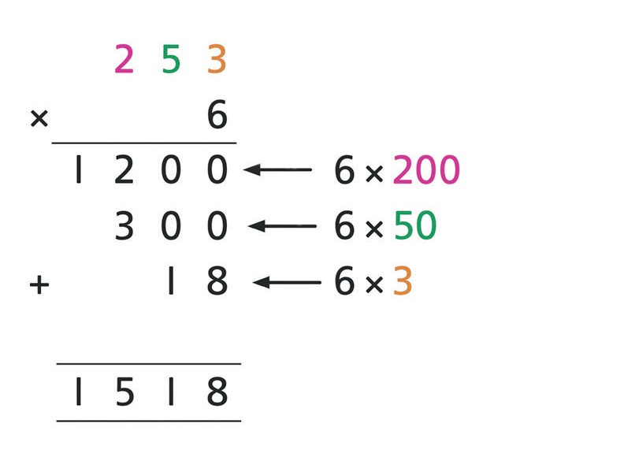
 | Year 3 | Year 4
Written Multiplication | Build on partitioning to develop grid multiplication  e.g. 23 × 4  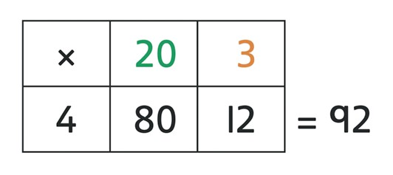 | Use grid multiplication to multiply 3-digit numbers by 1-digit numbers  e.g. 253 × 6  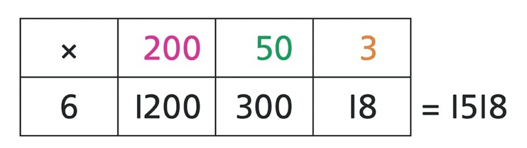  Use a vertical written algorithm (ladder) to multiply 3-digit numbers by 1-digit numbers  e.g. 253 × 6  Use grid multiplication to multiply 2-digit numbers by 2-digit numbers  e.g. 16 × 48  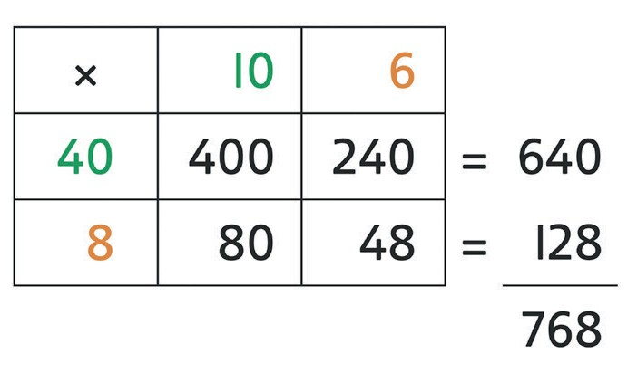

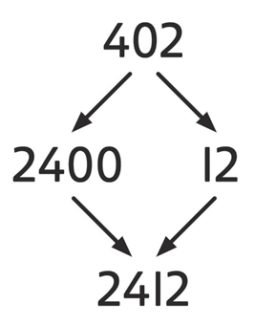
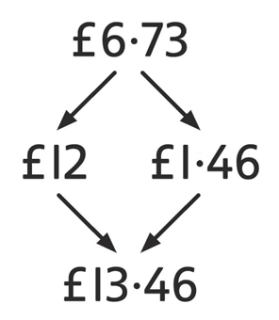
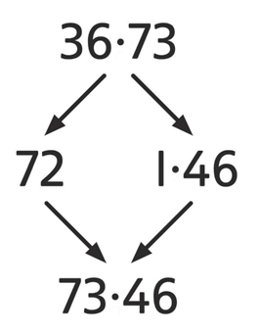
 | Year 5 | Year 6
Mental Multiplication | Doubling and halving  Double amounts of money using partitioning  e.g. double £6·73  Use doubling and halving as a strategy in multiplying by 2, 4, 8, 5 and 20  e.g. 58 × 5 is half of 58 × 10 (580) = 290  Grouping  Multiply whole numbers and decimals by 10, 100, 1000  e.g. 3·4 × 100 = 340  Use partitioning to multiply ‘friendly’ 2- and 3-digit numbers by 1-digit numbers  e.g. 402 × 6 as 400 × 6 (2400) and 2 × 6 (12) = 2412  ×6 ×6  Use partitioning to multiply decimal numbers by 1-digit numbers e.g. 4·5 × 3 as 4 × 3 (12) and 0·5 × 3 (1·5) = 13·5  Multiply near multiples by rounding e.g. 32 × 29 as (32 × 30) – 32 = 928 | Doubling and halving  Double decimal numbers with up to 2 places using partitioning  e.g. double 36·73  Use doubling and halving as strategies in mental multiplication  Grouping  Use partitioning as a strategy in mental multiplication, as appropriate  e.g. 3060 × 4 as 3000 × 4 (12 000) and 60 × 4 (240) = 12 240  e.g. 8·4 × 8 as 8 × 8 (64) and 0·4 × 8 (3·2) = 67·2  Use factors in mental multiplication  e.g. 421 × 6 as 421 × 3 (1263) doubled = 2526  e.g. 3·42 × 5 as half of 3·42 × 10 = 17·1  Multiply decimal numbers using near multiples by rounding e.g. 4·3 × 19 as (4·3 × 20) – 4·3 = 81·7

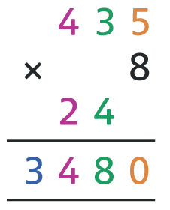
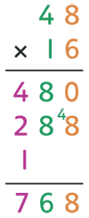
 | Year 5 | Year 6
Mental Multiplication | Using number facts  Use times-tables facts up to 12 × 12 to multiply multiples of 10/100 of the multiplier  e.g. 4 × 6 = 24 so 40 × 6 = 240 and 400 × 6 = 2400  Use knowledge of factors and multiples in multiplication  e.g. 43 × 6 is double 43 × 3  e.g. 28 × 50 is half of 28 × 100 (2800) = 1400  Know square numbers and cube numbers  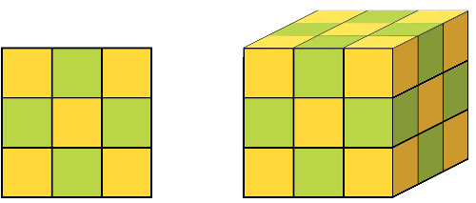 | Using number facts  Use times-tables facts up to 12 × 12 in mental multiplication of large numbers or numbers with up to 2 decimal places  e.g. 6 × 4 = 24 and 0·06 × 4 = 0·24
Written Multiplication | Short multiplication of 2-, 3- and 4-digit numbers by 1-digit numbers  e.g. 435 × 8  Long multiplication of 2-, 3-and 4-digit numbers by ‘teen’ numbers  e.g. 48 × 16 | Short multiplication of 2-, 3- and 4-digit numbers by 1-digit numbers  e.g. 3743 × 6  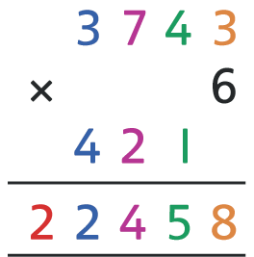  Long multiplication of 2-, 3- and 4-digit numbers by 2-digit numbers  e.g. 456 × 38 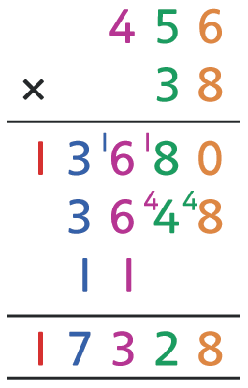

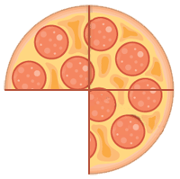
 | Year 5 | Year 6
Written Multiplication | Grid multiplication of numbers with up to 2 decimal places by 1-digit numbers  e.g. 1·34 × 6  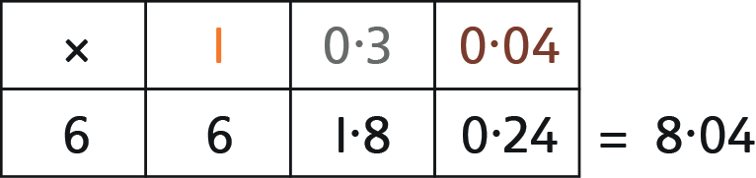  Multiply fractions by 1-digit numbers  e.g. 3/4 × 6 = 18/4 = 4 2/4 = 4 1/2  NB Grid multiplication provides a default method for ALL children | Short multiplication of decimal numbers using × 100 and ÷ 100 e.g. 13·72 × 6 as (1372 × 6) ÷ 100 = 82·32  Short multiplication of money e.g. £13·72 × 6  £ 1 3 7 2  × 6  2 4 1  £ 8 2 3 2  Grid multiplication of numbers with up to 2 decimal places by 1-digit numbers  e.g. 6·76 × 4  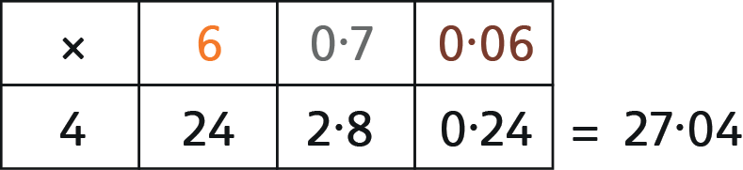  Multiply simple pairs of proper fractions  e.g. 1/2 × 1/4 = 1/8  NB Grid multiplication provides a default method for ALL children

1 | 2 | 3 | 4 | 5 | 6 | 7 | 8 | 9 | 10
11 | 12 | 13 | 14 | 15 | 16 | 17 | 18 | 19 | 20
21 | 22 | 23 | 24 | 25 | 26 | 27 | 28 | 29 | 30
31 | 32 | 33 | 34 | 35 | 36 | 37 | 38 | 39 | 40
41 | 42 | 43 | 44 | 45 | 46 | 47 | 48 | 49 | 50
51 | 52 | 53 | 54 | 55 | 56 | 57 | 58 | 59 | 60
61 | 62 | 63 | 64 | 65 | 66 | 67 | 68 | 69 | 70
71 | 72 | 73 | 74 | 75 | 76 | 77 | 78 | 79 | 80
81 | 82 | 83 | 84 | 85 | 86 | 87 | 88 | 89 | 90
91 | 92 | 93 | 94 | 95 | 96 | 97 | 98 | 99 | 100

 | Year 3 |  |  | Year 4
Mental Division | Counting in steps (‘clever’ counting)  Count in 2s, 3s, 4s, 5s, 8s and 10s  4 4 4 4 | 4 | 4 | Counting in steps (sequences)  Count in 2s, 3s, 4s, 5s, 6s, 7s, 8s, 9s, 10s, 11s, 12s, 25s, 50s, 100s and 1000s  25 25 25 25 25 25 25 25 25 25 25 25 25  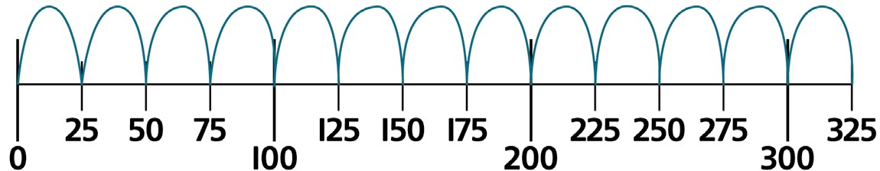


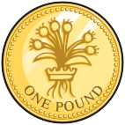







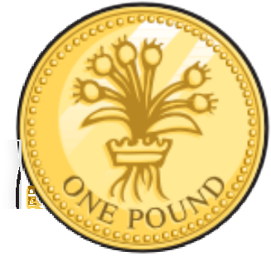








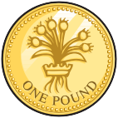










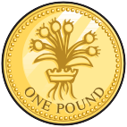











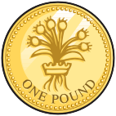









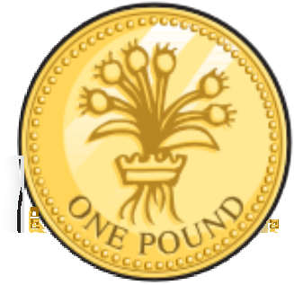






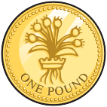











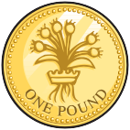








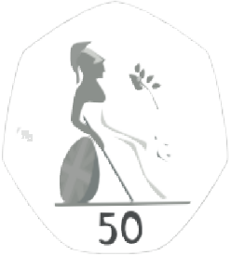

 | Year 3 | Year 4
Mental Division | Doubling and halving  Find half of even numbers to 100 using partitioning  e.g. ﬁnd half of 48  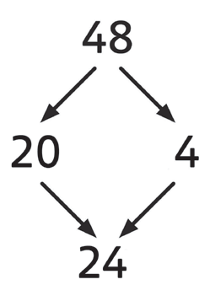  Use halving as a strategy in dividing by 2  e.g. 36 ÷ 2 is half of 36 = 18  Find half of odd numbers | Doubling and halving  Find half of even numbers to 200 and beyond using partitioning  e.g. ﬁnd half of 258  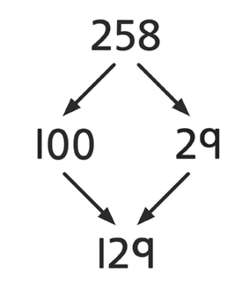  Begin to halve amounts of money  e.g. £9 halved is £4·50  Use halving as a strategy in dividing by 2, 4 and 8  e.g. 164 ÷ 4 is half of 164 (82) halved again = 41


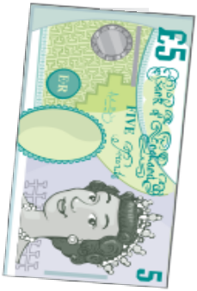
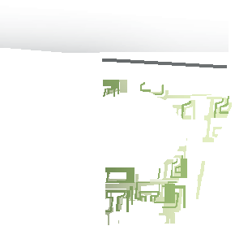





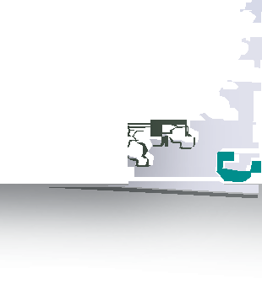

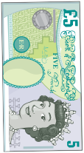









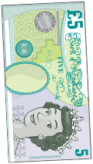





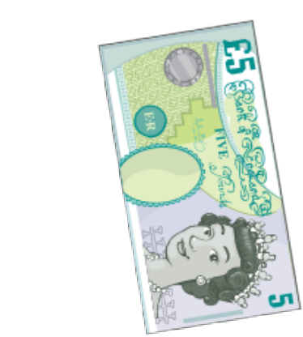



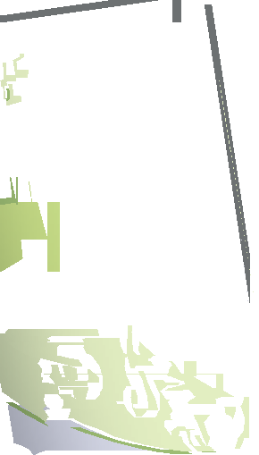





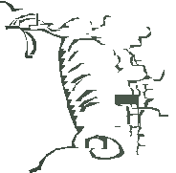


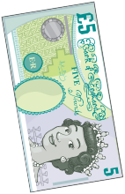




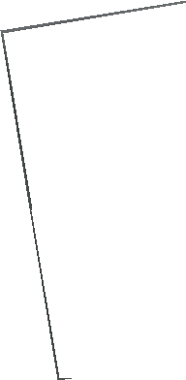


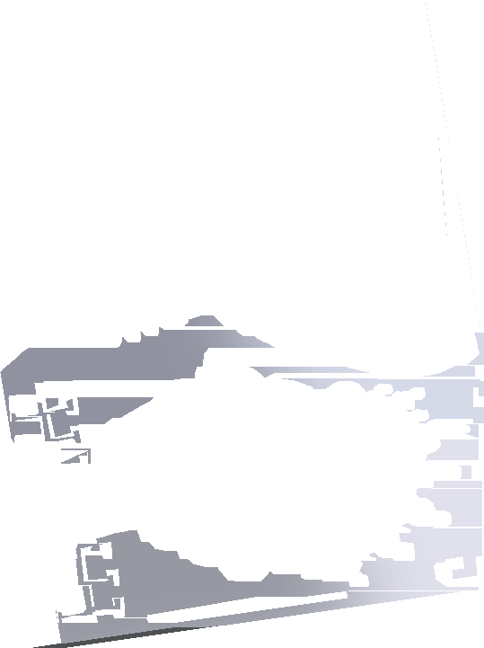
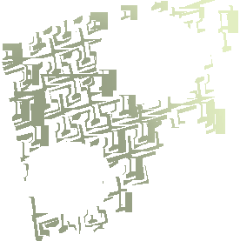
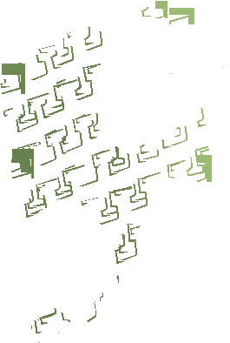


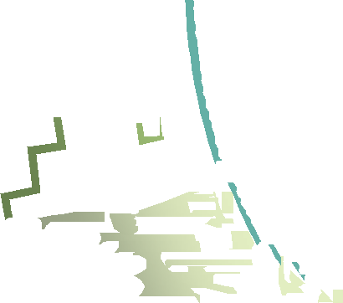













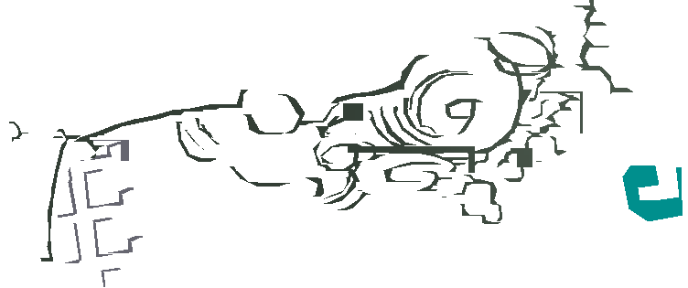






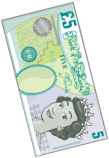
 | Year 3 | Year 4
Mental Division | Grouping  Recognise that division is not commutative  e.g. 16 ÷ 8 does not equal 8 ÷ 16  Relate division to multiplications ‘with holes in’  e.g. _ × 5 = 30 is the same calculation as 30 ÷ 5 = _ thus we can count in 5s to ﬁnd the answer  _ × £5 = £30  Divide multiples of 10 by 1-digit numbers e.g. 240 ÷ 8 = 30  Begin to use subtraction of multiples of 10 of the divisor to divide numbers above the 10th multiple  e.g. 52 ÷ 4 is 10 × 4 (40) and 3 × 4 (12) = 13 | Grouping  Use multiples of 10 times the divisor to divide by 1-digit numbers above the tables facts  e.g. 45 ÷ 3 as 10 × 3 (30) and 5 × 3 (15)  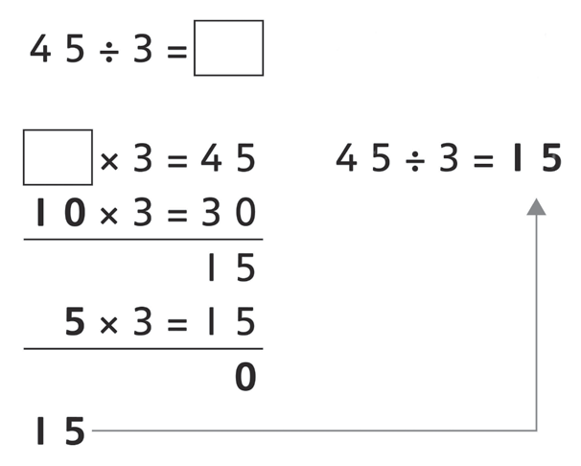  Divide multiples of 100 by 1-digit numbers using division facts e.g. 3200 ÷ 8 = 400

× | 1 | 2 | 3 | 4 | 5 | 6 | 7 | 8 | 9 | 10 | 11 | 12
1 | 1 | 2 | 3 | 4 | 5 | 6 | 7 | 8 | 9 | 10 | 11 | 12
2 | 2 | 4 | 6 | 8 | 10 | 12 | 14 | 16 | 18 | 20 | 11 | 24
3 | 3 | 6 | 9 | 12 | 15 | 18 | 21 | 24 | 27 | 30 | 22 | 36
4 | 4 | 8 | 12 | 16 | 20 | 24 | 28 | 32 | 36 | 40 | 33 | 48
5 | 5 | 10 | 15 | 20 | 25 | 30 | 35 | 40 | 45 | 50 | 44 | 60
6 | 6 | 12 | 18 | 24 | 30 | 36 | 42 | 48 | 54 | 60 | 55 | 72
7 | 7 | 14 | 21 | 28 | 35 | 42 | 49 | 56 | 63 | 70 | 66 | 84
8 | 8 | 16 | 24 | 32 | 40 | 48 | 56 | 64 | 72 | 80 | 77 | 96
9 | 9 | 18 | 27 | 36 | 45 | 54 | 63 | 72 | 81 | 90 | 88 | 108
10 | 10 | 20 | 30 | 40 | 50 | 60 | 70 | 80 | 90 | 100 | 99 | 120
11 | 11 | 22 | 33 | 44 | 55 | 66 | 77 | 88 | 99 | 110 | 121 | 132
12 | 12 | 24 | 36 | 48 | 60 | 72 | 84 | 96 | 108 | 120 | 132 | 144

 | Year 3 | Year 4
Mental Division | Using number facts  Know half of even numbers to 40 Know half of multiples of 10 to 200  e.g. half of 170 is 85  Know ×2, ×3, ×4, ×5, ×8, ×10 division facts | Using number facts  Know times-tables up to 12 × 12 and all related division facts
Written Division | Perform divisions just above the 10th multiple using written jottings, understanding how to give a remainder as a whole number  Use division facts to find unit and simple non-unit fractions of amounts within the times-tables  e.g. 3/4 of 48 is 3 × (48 ÷ 4) = 36 | Use a written version of a mental method to divide 2- and 3-digit numbers by 1-digit numbers  e.g. 86 ÷ 3 as 20 × 3 (60) and 8 × 3 (24), remainder 2  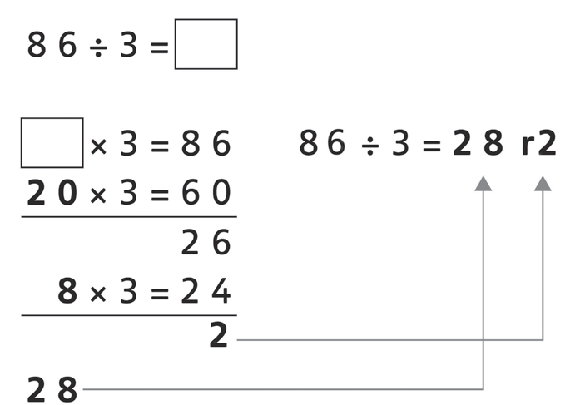  Use division facts to find unit and non-unit fractions of amounts within the times-tables  e.g. 7/8 of 56 is 7 × (56 ÷ 8) = 48

x 9 = 3 6 0
1 8
x 9 = 1 8
2

 | Year 5 | Year 6
Mental Division | Doubling and halving  Halve amounts of money using partitioning  e.g. half of £14·84 is half of £14 (£7) plus half of 84p (42p)  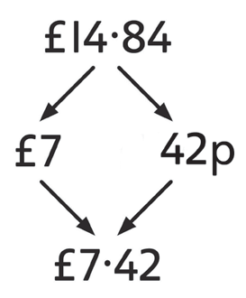  Use doubling and halving as a strategy in dividing by 2, 4, 8, 5 and 20  e.g. 115 ÷ 5 as double 115 (230) ÷ 10 = 23  Grouping  Divide numbers by 10, 100, 1000 to obtain decimal answers with up to 3 decimal places  e.g. 340 ÷ 100 = 3·4  Use the 10th, 20th, 30th … multiple of the divisor to divide ‘friendly’ 2- and 3-digit numbers by 1-digit numbers  e.g. 186 ÷ 6 as 30 × 6 (180) and 1 × 6 (6)  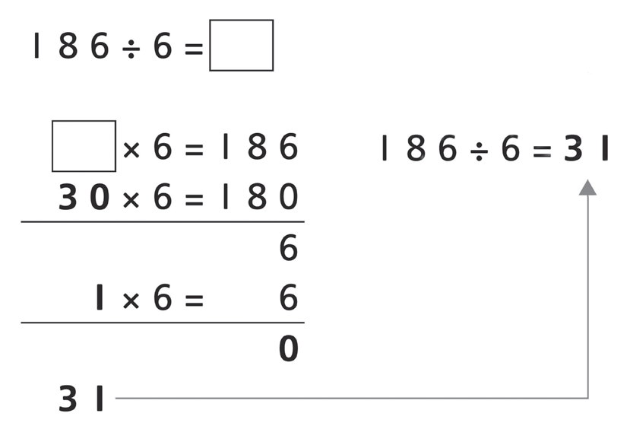 | Doubling and halving  Halve decimal numbers with up to 2 places using partitioning  e.g. half of 36·86 is half of 36 (18) plus half of 0·86 (0·43)  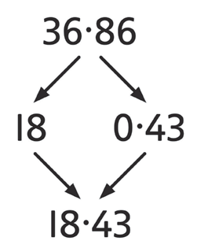  Use doubling and halving as strategies in mental division  Grouping  Use the 10th, 20th, 30th, … or 100th, 200th, 300th … multiples of the divisor to divide large numbers  e.g. 378 ÷ 9 as 40 × 9 (360) and 2 × 9 (18), remainder 2  3 7 8 ÷ 9 =  x 9 = 3 7 8 3 7 8 ÷ 9 = 42 r2  4 0  2  4 2  Use tests for divisibility  e.g. 135 divides by 3, as 1 + 3 + 5 = 9 and 9 is in the ×3 table

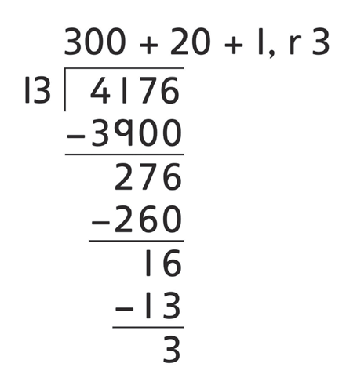
 | Year 5 | Year 6
Mental Division | Using number facts  Use division facts from the times-tables up to 12 × 12 to divide multiples of powers of 10 of the divisor  e.g. 3600 ÷ 9 using 36 ÷ 9  Know square numbers and cube numbers  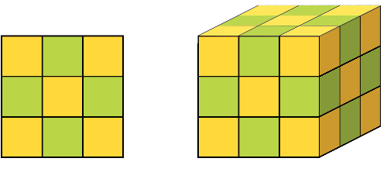 | Using number facts  Use division facts from the times-tables up to 12 × 12 to divide decimal numbers by 1-digit numbers  e.g. 1·17 ÷ 3 is 1/100 of 117 ÷ 3 (39)  Know tests of divisibility for numbers divisible by 2, 3, 4, 5, 9, 10  and 25
Written Division | Use a written version of a mental strategy to divide 3-digit numbers by 1-digit numbers  e.g. 326 ÷ 6 as 50 × 6 (300) and 4 × 6 (24), remainder 2  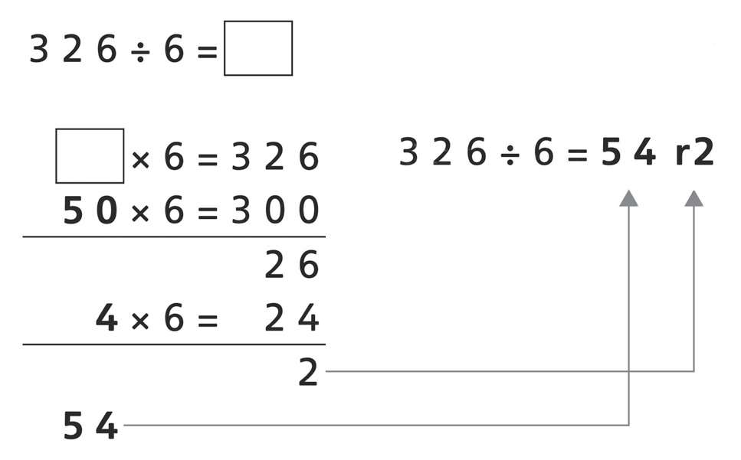 | Short division of 3- and 4-digit numbers by 1-digit numbers  e.g. 139 ÷ 3  4 6 r 1  3 1 3 19  Long division of 3- and 4-digit numbers by 2-digit numbers e.g. 4176 ÷ 13  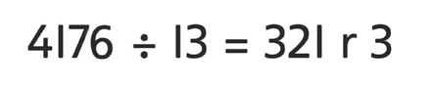

 | Year 5 | Year 6
Written Division | Short division of 3- and 4-digit numbers by 1-digit numbers  e.g. 139 ÷ 3  4 6 r 1  3 1 3 ¹9  Give remainders as whole numbers or as fractions Find unit and non-unit fractions of large amounts e.g. 3/5 of 265 is 3 × (265 ÷ 5) = 159  Turn improper fractions into mixed numbers and vice versa | Give remainders as whole numbers, fractions or decimals  Use place value to divide 1- and 2-place decimals by numbers ≤ 12 e.g. 3.65 ÷ 5 as (365 ÷ 5) ÷ 100 = 0·73  Divide proper fractions by whole numbers

