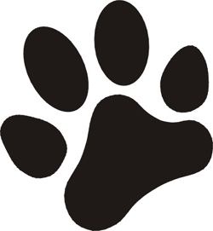

Sunday, 30th July

Entries taken from 10.00

Classes begin at 11.00

Edlingham, just off B6341

5 miles from Alnwick

NE66 2BL

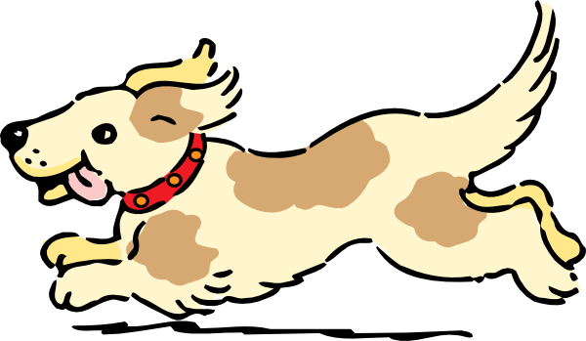**FUN Classes**

Main Sponsors: George F White

Northumbria Pets, Alnwick

Alnorthumbria Veterinary Group

**More details on: eca190.wordpress.com**

**Search Edlingham Dog Show**

Use of field by kind permission of Robert and Sally Lee

Edlingham Community Association CIO Charity Number 1172225